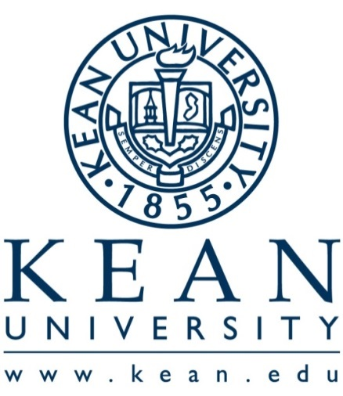  Introduction  This document’s purpose is to communicate the following:  - 2017-2018 Important Dates  - 2017-2018 Administrative Units Undergoing Program Review  - 2017-2018 Assessment Timeline  - Assessment support staff and resources  Guiding Principles  - Effective assessment processes are useful, cost-effective, reasonably accurate and truthful, carefully planned, and organized, systematic, and sustained¹.  - Assessment results:  - provide convincing evidence that the institution is achieving its mission and goals, including key learning outcomes¹.  - are shared in useful forms and discussed widely with appropriate constituents¹.  - lead to appropriate decisions and improvements about curricula and pedagogy, programs and services, resource allocation, and institutional goals and plans¹.  ¹Developed by Middle States (2005) “Assessing Student Learning and Institutional Effectiveness: Understanding Middle States Expectations” pp.4-7. | Administrative Unit  Annual Assessment Report Guidelines  2017-2018  Important Dates  - Submit Administrative Unit Annual Assessment Report Template Part I - Mission, Vision, Strategic Plan Goals, Objective(s) (a-d) (DUE Dec. 15).  - Submit Administrative Unit Annual Assessment Report Template Part II – Objective(s) (e –h) showing evidence of "closing the loop" (DUE JUNE 30).  - Selected Administrative Unit Program Reviews (DUE JUNE 30).

2017 – 2018
ADMINISTRATIVE UNIT
PROGRAM REVIEW SCHEDULE

The following Administrative Unit Program Reviews are due June 30, 2018. Program Review Guidelines are located within “Accreditation and Assessment Resources” on the Office of Accreditation and Assessment website: http://www.kean.edu/offices/accreditation-and-assessment.

OFFICE OF THE PRESIDENT
- Human Rights/ Holocaust/ Diversity
- Institutional Research
- Office of Affirmative Action Programs
ACADEMIC AFFAIRS

- International Studies
- Kean Ocean

ENROLLMENT SERVICES

- Scholarship Services

INSTITUTIONAL ADVANCEMENT

- Foundation

OPERATIONS

- Athletics
- Purchasing
- Student Accounting Services
- University Counsel

2017-2018  Assessment Timeline  December 15: Submit PART I of the Annual Administrative Unit Assessment Report Template to: assessment@kean.edu  December 21: Collect Fall semester data.  May 11: Collect Spring semester data.  JUNE 30: Submit Part II of the Annual Administrative Unit Assessment Report Template showing evidence of "closing the loop" to: assessment@kean.edu  JUNE 30: For specified Administrative Units, complete Program Review Template and submit a copy to OAA. email: assessment@kean.edu  What Should Kean Document Regarding Assessment?  When submitting information on their assessment efforts to the [Middle States] Commission, institutions are expected to document:  - clear statements of key goals, including expected student learning outcomes;  - an organized and sustained assessment process (referred to in some Commission documents as an “assessment plan”) including:  - institutional guidelines, resources, coordination, and support for assessment;  - assessment activities and initiatives that are presently underway;  - plans to develop and implement future assessment activities and initiatives;  - assessment results demonstrating that the institution and its students are achieving key institutional and program goals;  - uses of assessment results to improve student learning and advance the institution. (Middle States SLA, 2007, p. 56) |  |  | Assessment Support  The Office of Accreditation and Assessment (OAA)  is located in Townsend 126 (T-126)  Ms. Susan DeMatteo, Director  T: 908-737-3356, F: 908-737-7035, sdematte@kean.edu  Ms. Karolina Wolfe, Associate Director  T: 908-737-3352, F: 908-737-7035, agwolfe@kean.edu  Mr. Mukul Acharya, Associate Director  T: 908-737-3350, F: 908-737-7035, macharya@kean.edu  OAA Website  http://www.kean.edu/KU/Office-of-Accreditation-and-Assessment  Resources  - AAC&U Assessment Website: http://www.aacu.org/resources/assessment/index.cfm  - Assessment Update: Free Articles: http://www.assessmentupdate.com/article-directory.aspx  - Internet Resources for Higher Education Outcomes Assessment Website: http://www2.acs.ncsu.edu/UPA/archives/assmt/resource.htm  - Middle States Website: https://www.msche.org/  - Middle States Commission on Higher Education (2006). Characteristics of Excellence in Higher Education: Requirements of Affiliation and Standards for Accreditation. Philadelphia, PA: Middle States Commission on Higher Education.  - Middle States Commission on Higher Education (2007). Student Learning Assessment: Options and Resources. Second Edition. Philadelphia, PA: Middle States Commission on Higher Education.

