Department of Occupational Therapy
Student Fieldwork Manual
Master’s Program

Patricia Higgins MS, OTR/L
Academic Fieldwork Coordinator
(908) 737-5853
Fax (908) 737-5855 otfieldwork@kean.edu

Kean University
Department of Occupational Therapy
1000 Morris Avenue East Campus 224D
Union, NJ 07083
(908) 737-5850

Table of Contents
INTRODUCTION TO FIELDWORK.............................................................................................................................4 Level I Fieldwork.........................................................................................................................................................4
Level II Fieldwork.......................................................................................................................................................4
Fieldwork Participants.....................................................................................................................................................5 You...............................................................................................................................................................................5 Fieldwork Educator......................................................................................................................................................5
Level I Fieldwork Educator....................................................................................................................................5
Level II Fieldwork Educator..................................................................................................................................5
Seminar Instructor........................................................................................................................................................6
Academic Fieldwork Coordinator...............................................................................................................................6
Facility Sites.....................................................................................................................................................................6
Level I Fieldwork Courses...............................................................................................................................................6 Attendance....................................................................................................................................................................7
Site Visits.....................................................................................................................................................................7
Grades..........................................................................................................................................................................7
Supervision..................................................................................................................................................................7
Level I Fieldwork Requirements......................................................................................................................................7
Summary of Processes and Timelines for Level I Fieldwork..........................................................................................8
Level II Fieldwork...........................................................................................................................................................9 Level II Fieldwork Scheduling.....................................................................................................................................9
Registration................................................................................................................................................................10
Financial Aid and Financial Planning........................................................................................................................11
Level II Fieldwork Objectives-Kean University.......................................................................................................11
Level II- Site Specific Learning Objectives.............................................................................................................12
Attendance................................................................................................................................................................13
Site Visits...................................................................................................................................................................13
Supervision...............................................................................................................................................................14
On-campus Meetings................................................................................................................................................14
Blackboard Participation............................................................................................................................................14
Grades...................................................................................................................................................................... 14
Conflict Resolution....................................................................................................................................................15
Professional Behaviors..............................................................................................................................................15
Withdrawal or Failure.............................................................................................................................................. 15
Termination................................................................................................................................................................15
Infection Control Policy............................................................................................................................................16
Safety Policy.............................................................................................................................................................16
Student Privacy..........................................................................................................................................................16
Requesting Accommodations and ADA...................................................................................................................16
Learning Styles and Learning Contracts...................................................................................................................16
Learning Styles......................................................................................................................................................16
Learning Contracts................................................................................................................................................17
Fieldwork Requirements................................................................................................................................................17 Site Interviews...........................................................................................................................................................17
Personal Data Sheet...................................................................................................................................................17
Student Clinical Agreement Form............................................................................................................................18
Health Requirements.................................................................................................................................................18
Health Insurance........................................................................................................................................................18
Health Insurance Portability and Accountability Act (HIPPA).................................................................................18
Background Checks...................................................................................................................................................19
Fingerprinting............................................................................................................................................................19
Drug Screen...............................................................................................................................................................19
Liability Insurance.....................................................................................................................................................19
Medical Insurance......................................................................................................................................................20
Summary of Processes and Timelines for Level II Fieldwork.......................................................................................20
Moving Forward........................................................................................................................................................... 21 Graduation..................................................................................................................................................................21
National Board of Occupational Therapy Certification Examination.......................................................................21
Licensure....................................................................................................................................................................22
Continuing Education................................................................................................................................................23
Alumni Relations...........................................................................................................................................................23

APPENDICES
Appendix A: Kean University Contract Information
Appendix B: Fieldwork level I Educator's Midterm Assessment of Student Performance
Appendix C: Fieldwork Level I Educator's Final Assessment of Student Performance
Appendix D: Fieldwork Deferment Form
Appendix E: AOTA Fieldwork Performance Evaluation
Appendix F: Student Evaluation of Fieldwork Performance (SEFWE)
Appendix G: Student Exposure/Injury Report
Appendix H: Level I Personal Data Form Appendix I: AOTA Personal Data Sheet
Appendix J: Student Clinical Agreement
Appendix K: Health Records Requirement
Appendix L: Annual Update of Health Records
Appendix M: Criminal Background Check Resources
Appendix N: Release and Waiver

Updated 8/2020

INTRODUCTION TO FIELDWORK

In this handbook you will find valuable information regarding your level 1 and level 2 fieldwork experiences. Please keep it with you throughout the program. Fieldwork experiences are an integral part of occupational therapy education and critical to your development from a student to an entry level occupational therapist. It is not just about what you learn in the classroom or how well you perform on a test. During the fieldwork experiences, you will be mentored by a qualified professional as you begin to integrate and apply all of the knowledge learned while in the OT program. Fieldwork is also a requirement of the graduate program and the Accreditation Council for Occupational Therapy Education (ACOTE, 2018), and is required for eligibility for licensure to practice occupational therapy.
The purpose of this handbook is to:
- Introduce you to the two different types of fieldwork experiences (what we call level I and level II fieldwork).
- Describe the process of fieldwork requirements and selection
- Outline your responsibilities as a student- and there are MANY
- Detail what the faculty and staff do to support your learning during these fieldwork experiences
- Give you information about how you will be evaluated and graded in fieldwork.
You must complete all prerequisite courses and enroll in the specific fieldwork course to attend your fieldwork placements. During your fieldwork experiences, you are responsible for self-directed learning with guidance from your fieldwork educator and support from your course instructor or academic fieldwork coordinator. You are expected to engage in proactive professional communication and problem solving throughout your fieldwork experiences. Self-awareness and self-reflection are an important part of learning and are required to complete your fieldwork successfully.

Level I Fieldwork
During your second year in the program, you will be required to complete three Level I fieldwork experiences in three distinct practice areas. These experiences are embedded in the seminar courses: Seminar in Psychosocial Practice, Seminar in Adult Rehabilitation and Seminar in Pediatric Practice. Your level 1 seminar instructor and/or academic fieldwork coordinator will work collaboratively to provide you with fieldwork learning experiences to provide depth and a greater understanding of your didactic coursework. Level I fieldwork may be met through one or more of the following instructional methods: simulated environments, standardized clients, faculty practice, faculty-led site visits, or supervision by a fieldwork educator in a practice environment.

Level II Fieldwork
After successfully completing all of the required academic coursework, you will begin your level II fieldwork experiences. You are required to complete a minimum of 24 full time equivalent weeks of level II fieldwork to satisfy your degree requirements and establish your eligibility to take the Certification Exam administered by National Board for the Certification of Occupational Therapists, Inc. (NBCOT). You must complete your fieldwork requirements within 24 months following completion of all academic work. The ACOTE Standards for an Accredited Program for Occupational Therapy Education (ACOTE, 2018) recommends that you be exposed to more than one practice area. Fieldwork may take place in traditional, nontraditional, and emerging areas of practice settings. Emerging areas of practice may include, but are not limited to: design and accessibility consulting and home modification, ergonomics consulting, health and wellness consulting, private practice community health services, psychosocial needs of children and youth, or a community and social practice model such as a well elderly program or working with the homeless population. You will complete two level II fieldwork experiences in different areas of practice.

Fieldwork Participants

You

Fieldwork experiences allow you to apply classroom knowledge, reflect on your strengths and areas for growth, while developing your professional identity. A successful experience is dependent on your initiation and active participation.

Fieldwork Educator

Level I Fieldwork Educator
In accordance with ACOTE standards (ACOTE, 2018), Level I fieldwork educators may be an occupational therapist or another allied health professional (social worker, physical therapist, nurse, speech language pathologist, physician assistant, psychologist, teacher, occupational therapy assistant, etc.). The level I fieldwork educator’s role is to provide supervised learning experiences to increase your awareness and comfort in a clinical or professional setting, with clients, and therapeutic interventions. There are no minimum experience requirements for level I fieldwork educators.

Level II Fieldwork Educator
ACOTE requires your level II fieldwork educator to be a licensed (or state accredited) occupational therapist and have at least one year of practice experience. You must have onsite supervision at least 8 hours per week, with a second assigned supervisor to provide onsite supervision when the OT is out. The fieldwork educator provides guided active learning experiences to allow students to cross the bridge from classroom to practice, student to entry level professional. Fieldwork educators must consider the student(s) learning style and pace of learning opportunities to facilitate a progressive increase in professional responsibilities culminating in the student(s) demonstrating entry level competence by experience end.

Seminar Instructor
Your seminar instructors collaborate with the level I fieldwork educators to implement well integrated learning experiences that are aligned with the curriculum and program design. Your level I midterm and final evaluations are handed in to your seminar instructor.

Academic Fieldwork Coordinator
The academic fieldwork coordinator (AFWC) is a Kean University staff member responsible for all policies and processes related to fieldwork experiences. The AFWC identifies and secures fieldwork sites, maintains student and site files, and collaborates with fieldwork educators and students. The AFWC is also responsible for ensuring Kean University is in compliance with ACOTE fieldwork education requirements. The AFWC assists you in the selection of fieldwork placements that match your learning style and needs. The AFWC or a college-appointed designee is considered your course instructor for OT 6960 and OT 6961 and is responsible for inputting grades (See Appendix A) as well as monitoring and guiding all Blackboard learning experiences.

Facility Sites
There are facilities that have established contracts for fieldwork placements with Kean University. These sites are closely aligned to our philosophy, mission, and teaching content. The academic fieldwork coordinator collaborates with the faculty to determine the fieldwork sites for each student. The determination is based on many factors including your learning style, interests, areas for growth and the site’s case load, supervision structure and availability. Although every effort will be made to schedule all your affiliations within 90 minutes travel time, each way, this may not be possible due to circumstances beyond the department's control. Students are responsible for all transportation to and from the fieldwork site. Currently the department does not offer fieldwork sites outside of the United States, but some out of state placements are available. The AFWC must be notified by September of the second year of the program if the student is planning on going out of state. Logistics in relation to current federal and state education laws will be discussed and explored. An out of state placement cannot be guarantee.
If a student is planning on moving during Level II fieldwork, the AFWC must be notified by September of the second year of the location change.
You may do an optional third placement if you are interested, but please discuss further with the AFWC. Information about fieldwork sites can be found in a departmental file and for student review in the black file drawers in the department.

Level I Fieldwork Courses
As stated above in the second year of the program, you will take three seminars in three distinct practice areas, each with a level I fieldwork experiences.
- OT 6920 - Seminar in Psychosocial Practice
- OT 6921 - Seminar in Adult Rehab Practice
- OT 6923 - Seminar in Pediatric Practice
Your seminar instructor will outline the specific fieldwork objectives and assignments in your syllabi and the fieldwork manual for that course. The sequence of your level I experiences is dependent on the schedule provided by the department. Part time students may take seminars on a customized off-track schedule as determined by the chairperson.

Your seminar instructors will notify you of your placement site, start date, contact information and requirements prior to the beginning of the semester. Failure to complete the required fieldwork experiences as scheduled will result in failure of the course and need to repeat the seminar. This will necessitate postponement of level II placement, graduation and subsequently the date when you will be eligible to take the NBCOT Certification Examination.

Attendance
You are required to attend each level I fieldwork for a total of 12 days. You are responsible for requesting time off as needed for religious observances, personal issues etc. to both the seminar instructor and fieldwork educator on the first day of fieldwork. Any missed days of fieldwork, must be made up.

Site Visits
Site visits are only conducted on level I experiences if there is a concern regarding the student learning process.

Grades
Your course syllabus outlines course grading. Your performance on each level I experience is graded on Fieldwork Level I Educator’s Assessment of Student Performance at Midterm (Appendix B) and Final (Appendix C). Because professional behavior and fieldwork are integral to your learning experience you must score 70% or above on your final fieldwork assessment in order to pass the related seminar course. Failure to achieve a 70% will result in the need to repeat the related seminar and delay graduation. If you are asked to withdraw, are suspended, voluntarily withdraw or fail a level I fieldwork experience, it will result in a grade of incomplete (IN) or failure (F) in the seminar. A new fieldwork placement cannot be guaranteed to begin within a specific time and graduation may be delayed. Please refer to the department’s retention policy in your student handbook for additional information.

Supervision
Seminar instructors are responsible for ensuring that qualified personnel supervise level I students in each of the three seminar courses and communicate with supervisors as needed.

Level I Fieldwork Requirements
You will need to complete and demonstrate proof of all the fieldwork requirements
(health screen, immunization, background checks, etc.) prior to starting your level I fieldwork experience. Each site has different requirements. Please refer to the fieldwork requirements section after level II information for more information.

Summary of Processes and Timelines for Level I Fieldwork

When | Task
September (1st year) | You submit address and geographic preference for Level I and Level II to AFWC
September (1st year) | You submit health requirements for University to Student Health Services

January to April (1st year) | - Arrange for physical  - Verify Immunizations  - Obtain PPD  - CPR Certification  - Complete Department of Occupational Therapy Health Requirement Form
April (1st year) | You will meet with the AFWC for the first meeting to discuss Level II fieldwork planning
May 15 (1st year) | Submit Completed Health Requirement Form to AFWC
May – August (1st year) | You contact fieldwork I site/ educator to complete site requirements prior to fall fieldwork I experience
September (First Wednesday of Classes) (2nd year) | Attend mandatory FW meeting including: HIPPA, Infection Control In-Service prior to starting Level I following week
October (2nd year) | You meet with AFWC to discuss fieldwork placements and verify address and learning needs for Level II fieldwork
Mid October (2nd year) | You meet with your fieldwork educators for midterm evaluation
Late November- December  (2nd year) | - Level I students meet with Fieldwork Educators for final evaluation  - Submit Level I final evaluation to course instructor  - Contact FW sites for spring level I placements
January (first Wednesday of the semester (2nd year) | Attend a mandatory fieldwork in-service on campus
Mid-March (2nd year) | You meet with fieldwork educators for midterm evaluation
March- May (2nd year) | In preparation for Level II Fieldwork:  - Contact fieldwork educator to verify site requirements and schedule interview if required  - Complete Personal Data Form  - Obtain physical  - Update health records and immunization  - PPD (as required)  - Ensure CPR certification is valid  - Complete drug screen (if required)  - Complete Background check (if required)  Complete Fingerprinting (if required)
Late April- Early May (2nd year) | Level I students meet with fieldwork educators for final evaluation
May 15 (2nd year) | Submit updated annual health requirement form to AFWC

Level II Fieldwork
You are required to participate in a minimum of 24 weeks full-time Level II fieldwork. On rare occasions this may be completed on a part-time basis as defined by the fieldwork site and as it is at least 50% of a full-time equivalent at that site. To meet this requirement, you will enroll in at least two Advanced Fieldwork Seminars. OT 6960 Advanced Fieldwork Seminar I is your first level II placement and OT 6961 Advanced Fieldwork Seminar II is your second. You have the option of enrolling in a third (8-12 week) specialty fieldwork experience (hands, driver rehabilitation, administration, etc.). Please inform the AFWC as soon as possible if you are requesting a third optional placement.

Level II Fieldwork Scheduling
Your fieldwork placements are selected based on your learning style, personal needs, faculty input, and availability. All members of the department discuss recommendations for placement with the AFWC each semester. Level II experiences are a crucial part of the learning experience and will reflect different areas of practice that supplement classroom learning, not personal areas of interest. As stated earlier, you meet with the AFWC in your first year to discuss your goals, perceived strengths and areas for improvement, practice interests, and geographic preferences. You are responsible for updating the AFWC if your personal situation or preferences change. Any out of state requests must be submitted to the AFWC by September 10 of your second year. Viability for out of state fieldwork may vary by state due to impending state-adopted education laws.
Students often request to assist in the placement process. Students may not contact sites to request fieldwork placements. You can supply the AFWC with the name and location of a desired site so the AFWC can begin the site development process.
Level II fieldwork placements can begin after you complete your classroom work. OT 960 is the first Level II experience, while OT 6961 is the second Level II experience. Part time students and off-track students will have a customized schedule. You may also elect to defer your Level II fieldwork in order to attend to personal commitments, including personal travel and family obligations. If personal obligations impact the start date or any dates set forth by the academic institution or by the fieldwork site, fieldwork will need to be deferred. If you wish to pursue a deferment, please fill out the form as provided in Appendix D. Please see the AFWC as soon as possible to make arrangements for deferment. If you refuse placement at a presented fieldwork site, you will automatically be choosing to defer completion of your Level II fieldwork in the originally scheduled timeframe. You will be required to wait until the next semester or when a secondary appropriate fieldwork assignment is obtained after placement of all designated students for the semester. Please note that Level II fieldwork must be completed within 24 months of the completion of academic course work. Typical start times are:

- Summer - Mid/late May to Mid/late August or June to late August
- Fall- Early/mid-September to Early/Mid December
- Winter- January to Late March or early April
- Spring- April to June
PLEASE NOTE: Sites determine the ability to accommodate students. Scheduled start dates and times may need to change to meet facility needs. Sites reserve the right to include weekend, evening and/or holiday hours as part of your schedule. For example, do not assume that you will be off the day after Thanksgiving. You will need to talk to your fieldwork educator to finalize your schedule. Please be prepared to work at least 1 weekend day a week and/or modified hours (i.e. late nights, early mornings). Successful completion of fieldwork is a priority and if personal or work commitments prevent a student from this obligation, the student will be asked to defer until the next fieldwork cycle.

The AFWC will notify you of your level II fieldwork placement site, start date, contact information, and fieldwork site requirements. Failure to complete the site requirements may result in the delay or cancellation of your fieldwork experience. Delayed placements may result in the postponement of graduation and/or the date when you will be eligible to take the NBCOT Certification Examination.

Registration
During fieldwork, you will continue to maintain your student status within the
University. Students are responsible for knowing the academic calendar deadlines and checking their Kean University email account daily. Students are required to register for:

- OT 6960 Advanced Fieldwork Seminar I (1st FW experience/4 credits)

- OT 6961 Advanced Fieldwork Experience II (2nd FW experience/4 credits)

Students who desire a third level II placement should contact the AFWC to obtain course number.

Financial Aid and Financial Planning
Since you register for 4 credits for fieldwork, the university recognizes you as having full time status. The registrar can provide you with a letter for your financial aid providers. You must consult KU financial aid services to learn if your loan programs recognize the full time status. You may receive less financial assistance or be ineligible for some loans during your fieldwork placements. It is your responsibility to plan for this change in financial aid. If student withdraws from a fieldwork placement, it may impact tuition costs and financial aid.

Level II Fieldwork Objectives-Kean University
Kean University’s Department of Occupational Therapy’s Level II fieldwork objectives are designed so that upon completion of this course, the student will be able to:

  - Maintain safety of self and others throughout the occupational therapy process.
  - Adhere to appropriate regulatory standards for ethical decision making in all interactions.
  - Articulate the scope of occupational therapy practitioners to clients and interdisciplinary partners.
  - Collaborate with client, or significant other, to gather data for occupational profile.
  - Select and administer relevant holistic assessment procedures based upon the Occupational Therapy Practice Framework (OTPF).
  - Modify assessment procedures and employ therapeutic use of self-based upon client’s needs, behavior, culture and contexts to plan intervention.
  - Apply theoretical guidelines to interpret data, and establish and document intervention plans.
  - Utilize best available evidence to support the use of preparatory, purposeful and occupation based treatment intervention.
  - Evaluate and document client response to intervention.
  - Modify activities and environment to maximize client’s performance in meaningful occupation.
  - Modify and/or terminates the intervention plan as needed.
  - Demonstrate clinical reasoning throughout the process of service delivery in order to facilitate occupational performance.
  - Understand the roles and responsibilities of occupational therapist, occupational therapy assistant and/or aide and delegate duties as applicable.
  - Demonstrate understanding of the costs and funding related to occupational therapy services at the site.
  - Meet treatment and documentation responsibilities in accordance with ethical and regulatory standards for entry level practice.
  - Communicate professionally with others.
  - Demonstrate autonomy in learning by setting learning objectives and collaboratively working with others to achieve them.
  - Incorporate constructive feedback provided by others for professional growth.
  - Demonstrate positive interpersonal skills and respect for diversity in all communication and interactions.
  - Identify and integrate relevant psychosocial factors and the impact they have throughout the service delivery process

Level II- Site Specific Learning Objectives
Additional site specific learning objectives are developed collaboratively by the professional site representative and the academic faculty. You are responsible for reviewing these as well as previous students’ assessment of the sites prior to beginning your fieldwork experience. Please ask your fieldwork educator any questions regarding site specific objectives on your first day of fieldwork.
It is expected that during your fieldwork experience you will progress from a novice to a competent entry level practitioner in the area of practice. Site specific objectives should demonstrate increasing responsibility each week until the student is safely managing a caseload by the experience end.
For example:
- Week 1- Orientation to Facility including safety procedures, orientation to interprofessional team, build Rapport with FW Educator, establish weekly meeting time, supervision schedule, and format, staff, clients and other stakeholders, review scheduling procedures, review charts, observer staff with clients, assume responsibility for treating one client already on Fieldwork Educator’s caseload.
- Week 2 – Perform first evaluation with supervisor support. Submit treatment plan for first client evaluated. Treat original client and implement treatment plan.
- Week 3- Continue to perform evaluations, treatment planning and interventions to an increasing number of clients with graded support. Report in interdisciplinary meeting.
Discuss project with supervisor. Assume approximately 1/4 of expected caseload.
- Week 4 - Continue to perform evaluations, treatment planning and interventions to an increasing number of clients with graded support. Observe special evaluation (kitchen, vision, driving, home evaluations).
- Week 5 - Continue to perform evaluations, treatment planning and interventions to an increasing number of clients with graded support.
- Week 6 Midterm – student should be carrying 50% of an entry level caseload with support. Written midterm evaluation by supervisor (AOTA form)
- Week 7 - Continue to perform evaluations, treatment planning and interventions to an increasing number of clients with decreasing support.
- Week 8 - Continue to perform evaluations, treatment planning and interventions to an increasing number of clients with decreasing support.
- Week 9 – Provide services (evaluation and interventions) to 75% of an entry level caseload with minimal support.
- Week 10- Provide services (evaluation and interventions) and increasing percentage of an entry level caseload with minimal support.
- Week 11- Provide services (evaluation and interventions) and increasing percentage of an entry level caseload with minimal support. Present project.
- Week 12 Final- Student should be carrying 100% of an entry level caseload independently. Final AOTA Fieldwork evaluation completed and sent to Kean’s AFWC.

Additional learning experiences (observing other settings, surgery, driver’s rehab, etc) should be scheduled only if your learning is on track for successful completion or exceeding expectations.

Attendance
While completing fieldwork, students are expected to abide by the policies, guidelines, and procedures established by that organization. Policies regarding attendance and work hours are determined by the clinical coordinator and director at the fieldwork site.
Tardiness is unacceptable, except in times of emergency. Students typically arrive to the site much earlier than the suggested time in order to prepare for the day. You must contact your fieldwork educator, prior to the start of the work day if you are late.
You are required to attend each level II fieldwork full time for 12 weeks. You are responsible for notifying the AFWC and your fieldwork educator of time off needed, for personal reasons or religious observances, on the first day of fieldwork. All absences are to be made up during times that are mutually agreeable to you and your fieldwork educator. Your fieldwork educator is in close communication with the KU AFWC and will discuss any requests for schedule time changes/days off and how the time will be made up. Chronic lateness and/or absences may result in a failure of your level two experiences.
Travel plans, outside of religious obligations or family emergencies, are not permitted. Students requesting days off to travel will be asked to defer the start of the Level II fieldwork to the next available time frame. Please do not schedule vacation immediately before or immediately after fieldwork as start and end dates do change quite frequently.

Site Visits
If possible, site visits are made during one of your level II fieldwork experiences to discuss your progress. All three parties (you, your fieldwork educator and the AFWC) will be involved in the meeting. If issues arise visits may be scheduled more frequently. The scheduling of site visits is also dependent on time, distance, and funding.

Supervision
You are expected to be an active participant in the supervisory process. This may include reflection on your performance and goal setting. According to New Jersey licensure laws and ACOTE standards, the level II fieldwork educator is responsible for your educational and professional growth within the clinical setting. This individual must be licensed in the state where he/she is practicing, have a minimum of one year of practice experience subsequent to the requisite initial certification. A Level II student must be supervised by an OTR with a year or more of experience for a minimum of 8 hours a week. In the State of New Jersey, an OTR can supervise no more than 5 Students or a combination of 7 OT students and COTAs.

On-campus Meetings
During each of the level II experiences, you are required to return to campus for a mandatory meeting with the other students currently on level II fieldwork and faculty. Typically, these meetings are held in mid - October and mid-February. This is an opportunity for you to share information about your experiences with your peers and faculty. The meetings will also focus on upcoming documents that you will need to complete and procedural deadlines for graduation, NBCOT testing and other professional development issues.
You may also be asked to come to campus to meet individually with your advisor and/or other faculty if questions or challenges arise. If additional advisory meetings are required, the meeting must be scheduled so fieldwork responsibilities and hours are not impacted.

Blackboard Participation
In order to align to ACOTE standards that define the bridge between academic and clinical learning, Kean Level II students are required to participate in discussion-based assignments via Blackboard. Blackboard is a required portion of Level II fieldwork for both OT 6960 and OT 6961, as they are web-enhanced courses. Discussion topics and posting requirements will be addressed and defined by the course instructor within the first week of Level II fieldwork. Students will be required to fulfill the Blackboard course requirements in order to receive a passing grade for Level II fieldwork.

Grades
Upon the receipt of the original, hard, signed copies of the Fieldwork Performance Evaluation for the Occupational Therapy Student (Appendix E) and the Student Evaluation of Fieldwork Experience (SEFWE; Appendix F), the AFWC will submit your grade to the registrar. The department considers the final fieldwork evaluation completed by your fieldwork educator, professional behavior and safety standards in determining your final grade. The KUOT
Department utilizes a Credit Granted-Fail (CG/F) system of grading for Level II fieldwork. Timely delivery of the final evaluation from your supervisor directly to the AFWC is important for the timely submission of grades to the university registrar. Every semester has a deadline for which evaluations can be received and a grade determined. If your evaluation is not received prior to the deadline for submission of grades, you will receive a grade of Incomplete (IN). A change of grade form will be submitted to the registrar once the final fieldwork evaluation and SEFWE has been received. Students who need to repeat a fieldwork course due termination or failure must pay the usual tuition to enroll in the course that needs to be repeated.

Conflict Resolution
You are expected to be proactive in seeking supervision during the fieldwork experience. Regular supervision should be held to communicate expectations and your progress and plans to meet expectations. We do not expect problems, but they do sometimes arise. If there is a problem, it should be addressed professionally with your fieldwork educator as quickly as possible. If a successful resolution is reached, the process is completed. If you feel you have attempted to resolve the issue without success or require assistance, contact the AFWC for input and schedule a site visit.

Professional Behaviors
Students are expected to demonstrate and maintain the professional behaviors and ethics as set forth by the Department of Occupational Therapy. Professional behaviors include, but are not limited to, appropriate communication and interactions with supervisors and staff, maintaining facility-specific dress code, and completing assignments and facility-specific expectations as assigned. Failure to comply with professional behaviors can jeopardize successful completion of Level II fieldwork.

Withdrawal or Failure
We do not anticipate issues; however, at times, students are asked to withdraw, are suspended from or voluntarily withdraw or fail a fieldwork experience. In collaboration with the AFWC and program director, you will develop and implement a plan to address the issues in question. During this process, you must demonstrate a working understanding of the action plan and demonstrate ways in which the issues have been addressed and resolved. You will not be placed for another fieldwork experience until the issues have been addressed and successfully resolved. If it was a voluntary withdrawal, you may then either complete the original fieldwork or a new fieldwork site will be sought. Please note that repeated fieldwork placements cannot be guaranteed to begin within a specific time and graduation may be delayed. Failure of a fieldwork experience may also lead to dismissal from the OT program.

Termination
Termination of a fieldwork experience may occur if your professional behavior, safety awareness or competencies indicate that you will not meet entry level requirements in twelve weeks. If your experience is terminated, you will receive a failing grade (F) and may need to repeat the course. At times, termination of a fieldwork experience may also result in dismissal from the program. This determination can be made at any point during the 12-week experience. Please see the Department of Occupational Therapy’s retention policy for additional information.

Infection Control Policy
You are required to attend a MANDATORY in-service on infection control in September of your second academic year prior to starting your level I fieldwork experiences. You are responsible for both the fieldwork site’s specific infection control policy and Kean University Department of Occupational Therapy’s Infection Control Policy (see page 27-31 of your Student Handbook). If you exposed to an infectious agent, your fieldwork educator must be notified immediately and immediately follow the site policy and KUOT infection control policy. The Student Exposure Incident/Injury Report form (Appendix G) from the Infection Control Policy must be completed and forwarded to the AFWC within 24 hours of the incident.

Safety Policy
Students must adhere to the safety policies of Kean University’s
(https://www.kean.edu/offices/university-police/annual-campus-security-and-fire-safety-report the fieldwork site’s and KUOT policy (see page 36-39 of your student handbook). Failure to comply with safety policies may result in failure of the fieldwork experience, the need to repeat the class if eligible and delay graduation. If you are injured, your fieldwork educator must be notified immediately, site policy and the Student Exposure Incident/Injury Report form must be completed and forwarded to the AFWC within 24 hours of the incident.

Student Privacy
According to the Family Education and Privacy Act (FERPA) students have explicit privacy rights with respect to their educational records. Kean University is not authorized to disclose information to fieldwork educators regarding a student’s academic performance or disability status, including earlier fieldwork placements. In some instances, fieldwork sites will ask for information to be directly provided from the school. You may be asked to fill out and provide permission for release of records via the “Fieldwork Release and Waiver” form (Appendix N).

Requesting Accommodations and ADA
Under ADA, fieldwork sites are required to make reasonable accommodations for a
student with a documented disability that requires accommodations if the following conditions apply:
- The student requests an accommodation
- The requested accommodation does not impact services provided at the site.
- The requested accommodation does not cause undue hardship to site operation. Whether to disclose a disability and to request accommodations is solely the student’s decision. The fieldwork site is expected to maintain any request for accommodation as confidential information.

Learning Styles and Learning Contracts

Learning Styles
You are encouraged to discuss your learning style with your fieldwork educator at the start of each fieldwork experience. This communication is intended to facilitate the supervision process. If you are unaware of your learning style you can explore your style using learning profiles online.

Learning Contracts
You may require additional structure or support for the successful completion of the fieldwork experience. When that is the case, a specific learning contract is developed to facilitate the development of professional behavior and competency. Learning contracts are developed collaboratively by you, your fieldwork educator, and the AFWC. Learning contracts should specify specific learning objectives, the resources or strategies needed to achieve the objective, methods for assessing if learning objectives are met, and a target timeline for accomplishing the learning objectives. If you are unable to meet the behavioral objectives outlined in the learning contract, you may be asked to extend or be terminated from fieldwork.

Fieldwork Requirements
Fieldwork sites require compliance with organizational policies, health and immunization standards, background checks, fingerprinting, etc. You are responsible for completion of all testing and all related costs. Fieldwork sites reserve the right to deny a student a fieldwork placement for:
- the refusal to complete requirements
- a positive criminal background check
If you cannot complete any of the mandatory student fieldwork placements due to any issues regarding the criminal background check, fingerprinting, or any other requirements, you may not be able to participate in fieldwork experience and this will impact on your ability to successfully complete the OT program, take the NBCOT exam and obtain an OT license.

Site Interviews
Most sites require an interview with the potential student prior to confirming the placement. The interview is usually non-competitive but used to determine if the site selection will be a good match for both the student and fieldwork educator. It is your responsibility to arrange for the interview with the fieldwork educator at the facility and to notify the AFWC as to the outcome of any interview. If the site does not feel there is a good match it can refuse the student placement. Please notify the AFWC immediately if you do not feel it is a good match after participating in the interview process.

Personal Data Sheet
Prior to visiting your fieldwork sites, you will need to complete a personal data sheet. The personal data sheet provides valuable information which will be helpful to your fieldwork educator when structuring your fieldwork experience. Please see Appendix H for the personal data sheet for level I and Appendix I for the AOTA Personal Data Sheet used for level II.

Student Clinical Agreement Form
You must read and sign Kean University’s Student Clinical Agreement Form (Appendix J) on the first day of both OT 7960 and OT 7961. The form must be signed by both you and your fieldwork educator and faxed or scanned/ emailed to the fieldwork coordinator. The document is then placed in your secured file within the department.

Health Requirements
New Jersey state law mandates Kean University comply with the Department of Health and Senior Services immunization regulation. Students must submit their immunization records to student health service by September 30 of the year they are enrolled. Failure to comply with may result in the inability to register for classes or receive grades. Copy of university health forms can be found at https://www.kean.edu/offices/student-health-services/health-forms There may be additional health requirements to participate in level I and level II fieldwork experiences. Often the requirements are site specific. In an effort to facilitate the timely compliance with health requirements, the Department of Occupational Therapy requires all students to health record requirements be verified on the department’s Health Record Requirements form (See Appendix K) and submitted to the AFWC by May 15th of their first academic year. Student health requirements must be updated annually using the Annual Update of Health Records form (Appendix L). You will need to have your healthcare provider complete the health record annual update form and the health record update completion form. This annual update must be submitted to the academic fieldwork coordinator (AFWC) by May 15 of the second academic year. Your health record must remain current through the last day of your last fieldwork experiences.
The department does not store student health records to protect your confidentiality. You are to make an appointment with the AFWC to provide verification of having completed these health requirements. The AFWC will place the verification form and annual update forms only in your student file.

Health Insurance
Kean University no long requires health insurance for its full time students. However, all clinical contracts with fieldwork sites make it mandatory to carry health insurance. You will need to provide proof of health insurance to your academic fieldwork coordinator before starting fieldwork. It is mandatory that you carry health insurance throughout your Level I and Level II affiliations. Fieldwork start dates may be delayed if you are unable to provide proof of a current policy.

Health Insurance Portability and Accountability Act (HIPPA)
HIPPA regulations require that all students must comply with client confidentiality. You will learn more about HIPPA in your Administration and Supervision course. You are also required to attend an in-service on HIPPA prior to the start of your level I fieldwork experiences.
Protecting your clients’ rights to confidentiality is taken very seriously in healthcare. Additionally, individual sites may require you to sign a confidentiality agreement prior to starting fieldwork. Failure to comply with confidentiality issues may result in dismissal from the fieldwork experience.

Background Checks
Some fieldwork sites require that students complete a background check prior to beginning the fieldwork experience. Certain sites prefer a particular agency conduct the background check. The AFWC will inform you of your site’s requirements. Please communicate with your fieldwork educator to verify your site’s preference. A list of agencies that complete criminal background checks is supplied in Appendix M. Failure to pass a background check or a felony conviction may prevent you from being able to participate in fieldwork and therefore complete the OT program, take the NBCOT exam and obtain a license.

Fingerprinting
Some sites may require fingerprinting. Local police stations may help with fingerprinting. Failure to comply may prevent you from being able to participate in fieldwork and therefore complete the OT program, take the NBCOT exam and obtain a license.

Drug Screen
You may be required to have a drug screen. Each site may have a specific number of panels (5, 9, 11) they would like the drug screen to cover. The AFWC will inform you of your site’s requirements. Students must verify with your fieldwork educator how many panels and if the site prefers the testing be done by their lab or an outside agency. Failure to pass the drug screen may prevent the student from be able to participate in fieldwork, and therefore complete the OT program take the NBCOT exam and obtain a license.

Liability Insurance
For your protection, you are required to purchase your own personal malpractice insurance prior to the start of your level II placements. You are required to renew annually in order to maintain the coverage throughout your level II placements. An application for insurance coverage should be submitted at least 1-2 months prior to the start of your fieldwork, to allow enough time for the processing of your policy. It is also your responsibility to forward a copy of your policy to your fieldwork educator. Kean University also purchases a memorandum of insurance that covers you during both your level I and level II experiences. Student liability insurance can be obtained through:

Marsh Affinity Group Services,
Division of Seabury & Smith
332 S. Michigan Avenue, Suite 1400
Chicago, Il, 60604
1.800.621.3008
online: www.proliability.com

NOTE: This only a suggestion and KU does not endorse any companies. Please research other options to obtain insurance. Currently, clinical facilities are requiring that you have $2,000,000.00 liability insurance per incident with an aggregate amount of $ 4,000,000.00.

Medical Insurance
It is recommended that you consider and make arrangements for medical insurance coverage for the time that you are on fieldwork. Most fieldwork sites require that you carry medical insurance during your fieldwork placements.

Summary of Processes and Timelines for Level II Fieldwork

When | Task
September 10 (2nd year) | - Last day to request an out of state placement for  Level II  - If you wish to defer summer level II fieldwork you must complete deferment form (Appendix D)
May 15 | Submit updated annual health requirement form to AFWC
May – August or June- Sept | - Enroll and attend first level 2 experience OT 6960: Advanced Fieldwork Seminar I (if not deferred)
June -mid | - Mandatory on campus fieldwork II meeting
Sept- December | - Attend fieldwork experience  - Enroll in OT 6961 if this is your second level II  - Enroll in OT 6960 is this is your first level II experience
Mid October | - Mandatory on campus fieldwork II meeting for students on all placements
November -December | - Fieldwork educators send final fieldwork evaluation and the Student Evaluation of the Fieldwork Experience to AFWC.  - Submit all paper work for NBCOT examination  - Apply for graduation adhering to Kean University’s Academic Calendar
December | - Students taking fieldwork experiences off track register for spring courses
January- end of March | - Attend first or second level II experience if deferred previously
April to end of June | - Attend fieldwork experience if deferred previously

Moving Forward

Graduation
Depending on your academic and clinical educational sequence, you may graduate from Kean University in May, August, or January. It is your responsibility to coordinate anticipated completion of your fieldwork with the deadline for application for graduation. The date of this deadline is found on Kean’s academic calendar https://www.kean.edu/offices/registrars-office/academic-calendar
Please note that the deadline to apply for graduation may be earlier than you anticipate (December for May graduation). This will help determine when you will participate in the graduation ceremony. Graduation information is available on the Nathan Weiss Graduate College Website at https://www.kean.edu/academics/nathan-weiss-graduate-college .

National Board of Occupational Therapy Certification Examination

After successful completion of academic coursework Level II fieldwork experiences, and doctoral residency, you will be eligible to take the National Board for Certification in Occupational Therapy (NBCOT) registry examination. The exam administration is computerized and offered on a continuous and on demand basis. Information about the NBCOT examination is available at https://www.nbcot.org/ KUOT hosts an NBCOT preparation course each Winter semester. Information regarding this course will be sent to you Kean email account, so check your account often. If you attend the course given here at Kean, you will receive a discount

Before you can take the NBCOT exam you must:
- Ensure all fieldwork performance evaluations and Student Evaluation of Fieldwork
Experience forms are received by the AFWC
- Verify OT 6961 Advance Fieldwork Seminar II grade is posted to KeanWise
- Verify course transcript that all required courses have been completed
- Settle all financial responsibilities to KU (library fees, parking tickets, etc.)
- Order official transcripts to be sent to NBCOT verifying academic record and degree (If you graduate in December your transcripts may not reflect your degree until mid- January, please schedule your exam accordingly).
Please note that you may apply to take the NBCOT exam after you fulfilled all of your coursework but before your final transcripts have been compiled by submitting an Academic Credential Verification Form (ACVF), which can be found on the NBCOT website. Although this will allow you to schedule and take the exam, you will not be able to receive the results of your exam and apply for licensure until the degree is conferred from Kean. This form will require a signature from the occupational therapy program director. Please email the AFWC to make an appointment to complete this paperwork. ACVF will be signed after the appropriate graduation date with proof of completing through informal transcripts obtained by the student from KeanWise. Please note that for August graduation, transcripts will be available at the end of September.

Licensure
Most states, including New Jersey, require you to hold a valid license in order to practice as an occupational therapist. In New Jersey: The Occupational Therapy Licensing Act was passed in 1993, with the licensure process initiated in 1999 with the establishment of the Occupational Therapy Advisory Council. According to this Act, you are not lawfully able to practice occupational therapy or represent yourself as an occupational therapist unless you hold a valid license to practice in New Jersey. Upon completion of an accredited occupational therapy program and meeting requirements for the NBCOT certification examination, you are eligible to apply for a temporary license. A temporary license allows you to practice only under the direct supervision of a licensed occupational therapist. This license will automatically expire if you fail the certification examination, but can be renewed for an additional period until you receive the results of the next examination. Licensure information for NJ can be found at https://www.njconsumeraffairs.gov/ot

The application for licensure requires verification of fieldwork. The Occupational
Therapy Department will forward this verification to the Occupational Therapy Advisory Council as a letter indicating dates of completion of fieldwork experience and indication of completion of at least 24 weeks of supervised fieldwork experience for Occupational Therapists. The licensure board also requires your transcript (separate from the fieldwork letter from the department), which should indicate that you have successfully graduated from an accredited program. In order to receive an application for licensure, contact the Occupational Therapy Advisory Council at:

State of New Jersey
Division of Consumer Affairs
Occupational Therapy Advisory Council P.O. Box 45037
Newark, NJ 07101
(973) 504-6570
online: www.njconsumeraffairs.com/occup/otpacket.pdf

In New York: In order to receive an application for licensure, contact:
The State Education Department
Office of the Professions
Division of Professional Licensing Services
Cultural Education Center
Albany, NY 12230
(518) 474-3817
online: http://www.op.nysed.gov/prof/ot/

For information on licensure in other states, visit the NBCOT website: www.nbcot.org and enter licensure in the search window.
Please Note:
Licensure boards have very specific guidelines for application completion. Follow instructions precisely in order to obtain your license in a timely manner.

Continuing Education
To remain current in best practice all students are encouraged to seek continuing education after graduation. NBCOT requires 36 professional development units in 36 months to renew registration. Some states require continuing education credits to renew OT licenses. The state of New Jersey currently does not require continuing education for license renewal, however the State of New York does. Each professional is responsible to read, understand and abide by the continuing education required by the state they practice in.

Alumni Relations
KUOT would like to maintain its relationship with you after graduation. Please send an email address and any changes in contact information so we can communicate upcoming professional development seminars, events, programs, alumni news and events.

References

American Occupational Therapy Association. (2010). Standards of practice. American Journal of Occupational Therapy, 52, 866–869.

American Occupational Therapy Association. (2010). Occupational Therapy Code of Ethics and Standards. American Journal of Occupational Therapy, 64, S17-S26. Retrieved from https://ajot.aota.org/article.aspx?articleid=1865183.

American Occupational Therapy Association. (2019). 2018 Accreditation Council for Occupational Therapy Education (ACOTE®) Standards and Interpretive Guide [PDF document]. Retrieved from https://www.aota.org/Education-Careers/Accreditation/StandardsReview.aspx.

National Board for Certification in Occupational Therapy. (2013). Eligibility requirements.
Retrieved from https://www.nbcot.org/Students/get-certified

National Board for Certification in Occupational Therapy. (2009). Certification Renewal. Retrieved from https://www.nbcot.org/en/Certificants/Certification

Appendix A: Kean University Contact Information

Issue or Question | Contact Person | Contact Information
Pediatric Level I | Patricia Higgins  Academic Fieldwork Coordinator  Department of  Occupational Therapy | 908 737 5853 otfieldwork@kean.edu
Psychosocial Level I | Dr. Laurie Knis-Matthews  Professor  Department of  Occupational Therapy | 908 737 5858 lknis@kean.edu
Adult Rehab Level I | Dr. Claire M. Mulry  Assistant Professor  Department of  Occupational Therapy | 908 737 5856 cmulry@kean.edu
Level II Fieldwork | Patricia Higgins  Academic Fieldwork  Coordinator  Department of  Occupational Therapy | 908 737 5853 otfieldwork@kean.edu

Department Contact Information:
Kimberly Burke
Administrative Assistant
908 737 5850 (main)
908 737 585(fax) ot@kean.edu
Kean University
Department of Occupational Therapy, EC 224
1000 Morris Avenue
Union, NJ 07083

Appendix B: Fieldwork Level I Educator’s Midterm Assessment of Student Performance

DEPARTMENT OF OCCUPATIONAL THERAPY

FIELDWORK LEVEL I EDUCATOR’S MIDTERM ASSESSMENT OF STUDENT’S PERFORMANCE

____ OT 6920 Seminar in Psychosocial Practice
____ OT 6921 Seminar in Adult Rehabilitation Practice
____ OT 6923 Seminar in Pediatric Practice

Student: ________________________________________________________________________

FW Educator name and credentials: __________________________________________________

FW Educator phone number: ________________________________________________________

FW Educator email address: _________________________________________________________

Facility name: ____________________________________________________________________

Facility address: __________________________________________________________________

Number of required days by midterm: 6

Number of absences: ______ Reason: _________________________ Dates made up: ________

Please check or fill in all items relevant to fieldwork placement
Hospital-based settings | Community-based settings | School-based settings | Age Groups: | Number of Staff:
- In-patient Acute 1.1  - In-patient Rehab 1.2  - SNF/Sub-Acute/Acute Long-Term Care 1.3  - General Rehab Outpatient 1.4  - Outpatient Hands 1.5  - Pediatric Hospital/Unit 1.6  - Pediatric Hospital Outpatient 1.7  - Inpatient Psychiatric 1.8 | - Peds Community 2.1  - Behavioral Health Community 2.2  - Older Adult Community Living 2.3  - Older Adult Day Program 2.4  - Outpatient/hand private practice 2.5  - Adult Day Program for DD 2.6  - Home Health 2.7  - Pediatric Outpatient Clinic 2.8 | - Early Intervention 3.1  - School 3.2  Other area(s)  Please specify:  ______________ | - 0-5  - 6-12  - 13-21  - 22-64  - 65+ | OTRs:  OTAs/COTAs:  Aides: __  PT:  Speech:  Resource Teacher:  Counselor/Psychologist:  Other:

INSTRUCTIONS FOR FIELDWORK EDUCATOR:

Please rate the student’s performance on his/her Fieldwork Level I experience. Please check each item using the following rating based on the number of opportunities the student has to perform the behavior:

Exceeds expectation Performance is highly skilled and self-initiated Points: 4
Meets expectations Performance is consistent and meets expectations Points: 3
Needs improvement Performance is progressing but still needs improvement Points: 2
Unsatisfactory Performance is unsatisfactory, little insight into student’s Points: 1
own behavior
Not applicable N/A

Scoring:
Professional Behavior score + Evaluation & Intervention score______+ ______ =_____% 60 + Evaluation & Intervention score possible ______ + ______

Note: This evaluation provides important feedback for the student and the instructor. The student must score 70% or above on their final fieldwork assessment in order to pass the course.

The behaviors below reflect the primary objectives for Level I fieldwork.

Professional Behavior | Exceeds expectation 4  Meets expectations 3  Needs improvement 2  Unsatisfactory 1
 | 1 | 2 | 3 | 4
    - Arrives on time and meets attendance requirements
- Dresses appropriately and professionally according to facility’s requirements.
- Demonstrates consistent work behaviors including initiative, preparedness, dependability, time management, and work site maintenance.
- Adheres consistently to safety regulations, and anticipates potentially hazardous situations and takes steps to prevent accidents.
- Conducts self in accordance with professional ethics and the facility’s code of conduct.
- Adheres to site-specific regulations and client’s right to confidentiality.
- Adequately prepares for clinical experiences and assignments (i.e. familiar with chart, assessment tools, or planned activities).
- Is able to recognize and discuss his/her own feelings, attitudes, and behavior
- Is aware of how his/her reactions impact performance and the therapeutic relationships in the practice setting.
- Demonstrates positive interpersonal skills including but not limited to cooperation, flexibility, tact, and empathy.
- Demonstrates respect for diversity including but not limited to sociocultural, socioeconomic, spiritual, and lifestyle choices
- Collaborates with supervisor(s) to maximize the learning experience.
- Is open to and incorporates feedback from fieldwork educator and others.
- Shows a positive attitude towards and is actively engaged in problem solving for self-directed learning.
- Demonstrates effective verbal and nonverbal communication including language appropriate to listener.
Professional Behavior Total earned ______
Comments: _______________________________________________________________________________
_______________________________________________________________________________
Evaluation and Intervention | Exceeds expectation 4  Meets expectations 3  Needs improvement 2  Unsatisfactory 1  Not applicable N/A
 | 1 | 2 | 3 | 4 | N/A
- Uses sound judgment in regard to safety of self and others during all fieldwork-related activities.
- Articulates, and provides support of, observations.
- Selects relevant screening and assessment methods while considering such factors as client’s priorities, context(s), theories, and evidence-based practice.
- Articulates a clear and logical rationale for the evaluation process.
- Determines client’s occupational profile and analysis of performance through appropriate assessment methods.
- Interprets evaluation results to determine client’s occupational performance strengths and challenges.
- Articulates a clear and logical rationale for the intervention process.
- Chooses activities and occupations that motivate and challenge clients to meet their goals.
- Adapts treatment plan based upon changing environmental demands and client capabilities.
- Is developing group leadership skills.
- Understands community resources and interprofessional relationships.
Total earned ______ Total available ( do not include N/A) ____
Comments: _______________________________________________________________________________
_______________________________________________________________________________
_______________________________________________________________________________

Please list student’s areas of Please list suggested areas for
Strength: continued learning:

In your opinion, is the student currently performing as expected? Yes No

Please indicate if a phone call is needed, with course instructor, to discuss student’s progress.
Yes No

Preferred phone number and times to call: __________________________________________

Fieldwork educator’s signature: _____________________________________ Date: ___________

Student’s signature: _______________________________________________ Date: ___________

Appendix C: Fieldwork Level I Educator’s Final Assessment of Student Performance

DEPARTMENT OF OCCUPATIONAL THERAPY

FIELDWORK LEVEL I EDUCATOR’S FINAL ASSESSMENT OF STUDENT’S PERFORMANCE

____ OT 6920 Seminar in Psychosocial Practice
____ OT 6921 Seminar in Adult Rehabilitation Practice
____ OT 6923 Seminar in Pediatric Practice

Student: ________________________________________________________________________

FW Educator name and credentials: ___________________________________________

FW Educator phone number: _____________________________________________

FW Educator email address: _______________________

Facility name: ______________________________________________________

Facility address: ____________________________________________________

Number of required days: 12

Number of absences: ______ Reason: ________________________Dates made up: _____

Please check or fill in all items relevant to fieldwork placement
Hospital-based settings | Community-based settings | School-based settings | Age Groups: | Number of Staff:
- In-patient Acute 1.1  - In-patient Rehab 1.2  - SNF/Sub-Acute/Acute Long-Term Care 1.3  - General Rehab Outpatient 1.4  - Outpatient Hands 1.5  - Pediatric Hospital/Unit 1.6  - Pediatric Hospital Outpatient 1.7  - Inpatient Psychiatric 1.8 | - Peds Community 2.1  - Behavioral Health Community 2.2  - Older Adult Community Living 2.3  - Older Adult Day Program 2.4  - Outpatient/hand private practice 2.5  - Adult Day Program for DD 2.6  - Home Health 2.7  - Pediatric Outpatient Clinic 2.8 | - Early Intervention 3.1  - School 3.2  Other area(s)  Please specify:  ______________ | - 0-5  - 6-12  - 13-21  - 22-64  - 65+ | OTRs:  OTAs/COTAs:  Aides: __  PT:  Speech:  Resource Teacher:  Counselor/Psychologist:  Other:
INSTRUCTIONS FOR FIELDWORK EDUCATOR:

Please rate the student’s performance on his/her Fieldwork Level I experience. Please check each item using the following rating based on the number of opportunities the student has to perform the behavior:

Exceeds expectation Performance is highly skilled and self-initiated Points: 4
Meets expectations Performance is consistent and meets expectations Points: 3
Needs improvement Performance is progressing but still needs improvement Points: 2
Unsatisfactory Performance is unsatisfactory, little insight into student’s Points: 1
own behavior
Not applicable N/A

Scoring:
Professional Behavior score + Evaluation & Intervention score ______+ ______ = _____%

60 + Evaluation & Intervention score possible ______ + ______

Note: This evaluation provides important feedback for the student and the instructor. The student must score 70% or above on their final fieldwork assessment in order to pass the course.

The behaviors below reflect the primary objectives for Level I fieldwork.

Professional Behavior | Exceeds expectation 4  Meets expectations 3  Needs improvement 2  Unsatisfactory 1
 | 1 | 2 | 3 | 4
    - Arrives on time and meets attendance requirements.
    - Dresses appropriately and professionally according to facility’s requirements.
    - Demonstrates consistent work behaviors including initiative, preparedness, dependability, time management, and work site maintenance.
    - Adheres consistently to safety regulations, and anticipates potentially hazardous situations and takes steps to prevent accidents.
    - Conducts self in accordance with professional ethics and the facility’s code of conduct.
    - Adheres to site-specific regulations and client’s right to confidentiality.
    - Adequately prepares for clinical experience and assignments (i.e. familiar with chart, assessment tools, or planned activities)
    - Is able to recognize and discuss his/her own feelings, attitudes, and behavior.
    - Is aware of how his/her reactions impact performance and the therapeutic relationships in the practice setting.
    - Demonstrates positive interpersonal skills including but not limited to cooperation, flexibility, tact, and empathy.
    - Demonstrates respect for diversity including but not limited to sociocultural, socioeconomic, spiritual, and lifestyle choices.
    - Collaborates with supervisor(s) to maximize the learning experience.
    - Is open to and incorporates feedback from fieldwork educator and others.
    - Shows a positive attitude towards and is actively engaged in problem solving for self-directed learning.
    - Demonstrates effective verbal and nonverbal communication including language appropriate to listener.
Professional Behavior Total earned ______
Comments: _______________________________________________________________________________
_______________________________________________________________________________
Evaluation and Intervention | Exceeds expectation 4  Meets expectations 3  Needs improvement 2  Unsatisfactory 1  Not applicable N/A
 | 1 | 2 | 3 | 4 | N/A
    - Uses sound judgment in regard to safety of self and others during all fieldwork-related activities.
    - Articulates, and provides support of, observations.
    - Selects relevant screening and assessment methods while considering such factors as client’s priorities, context(s), theories, and evidence-based practice.
    - Articulates a clear and logical rationale for the evaluation process.
    - Determines client’s occupational profile and analysis of performance through appropriate assessment methods.
    - Interprets evaluation results to determine client’s occupational performance strengths and challenges.
    - Articulates a clear and logical rationale for the intervention process.
    - Chooses activities and occupations that motivate and challenge clients to meet their goals.
    - Adapts treatment plan based upon changing environmental demands and client capabilities.
    - Is developing group leadership skills.
- Understands community resources and interprofessional relationships.
Total earned ______ Total available ( do not include N/A) ____
Comments:_____________________________________________________________________
_______________________________________________________________________________
_______________________________________________________________________________

Please list student’s areas of Please list suggested strength: for continued learning:

In your opinion, is the student ready for fieldwork level II in this area? Yes No Maybe

If your answer is “no” or “maybe”, please indicate your reasons below:

Fieldwork educator’s signature: _____________________________________ Date: ___________

Student’s signature: _______________________________________________ Date: ___________

Appendix D: Fieldwork Deferment Form

Department of Occupational Therapy
Fieldwork Deferment From

I, ________________________________ request to defer my Level II fieldwork placement for:

- _______Summer ______(Year)
- _______Fall ______(Year)
- ________Winter______(Year)
- ________Spring______(Year)

I understand the deferring this placement may delay my graduation. Furthermore, I understand the both OT 6960 Advance Fieldwork Seminar I and OT 6961 Advanced Fieldwork Seminar II and all related fieldwork requirements must be completed with 24 months of completion of the academic portion of my education.

I understand that I must register for these courses in the appropriate semester by the deadlines in Kean’s academic calendar.

I would like to begin my fieldwork placements in:
- ______Fall _____(year)
- ______Winter____(year)
- ______Spring____(year)
- ______Summer_____( year)

I understand that my specific fieldwork placements are subject to site and fieldwork educator availability.

Student Signature _________________________________________________Date_________

Academic Fieldwork Coordinator Signature _____________________________Date__________

Appendix E: AOTA Fieldwork Performance Evaluation: Fieldwork Performance Evaluation For The Occupational Therapy Student

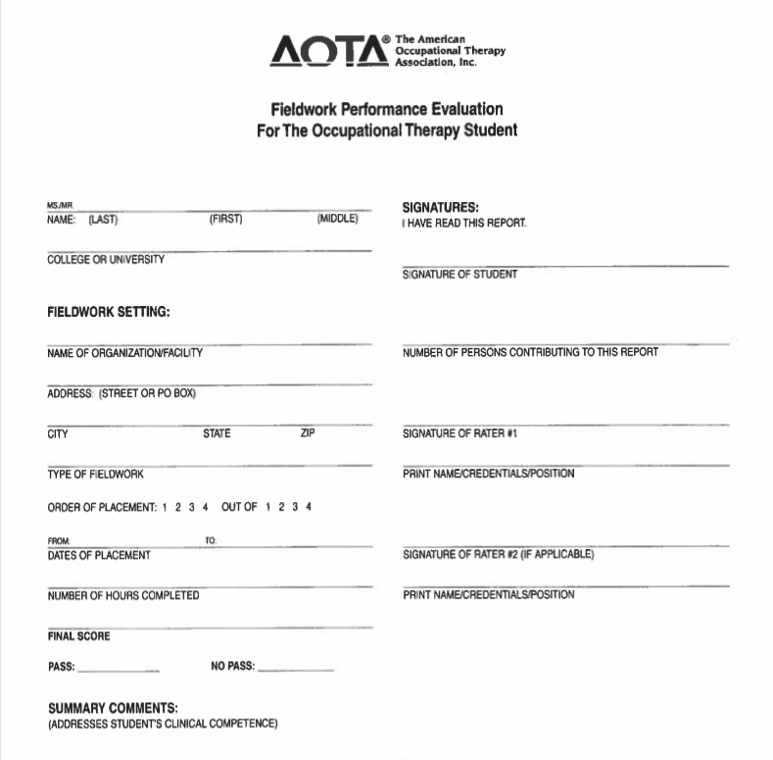

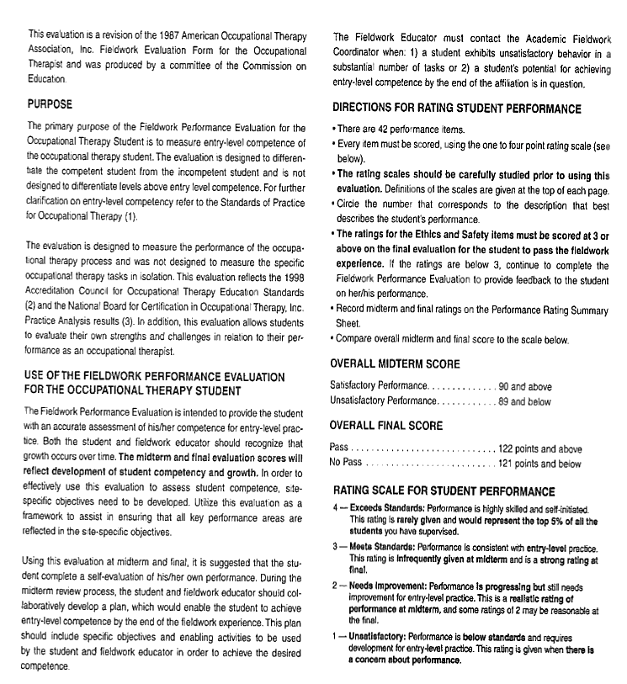
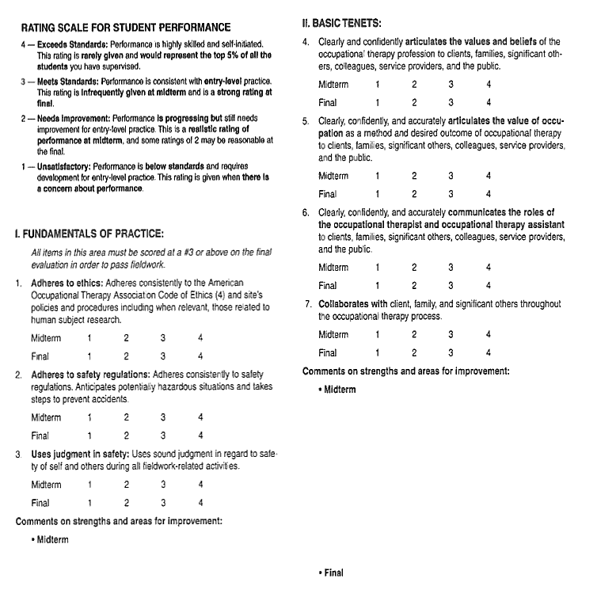

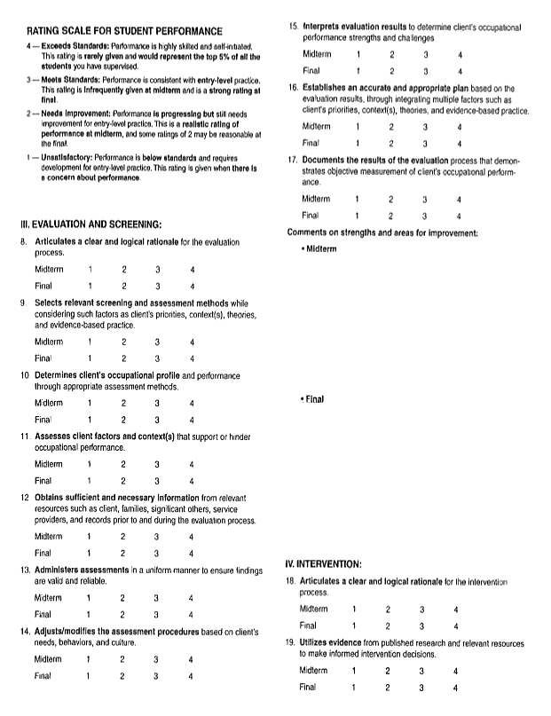

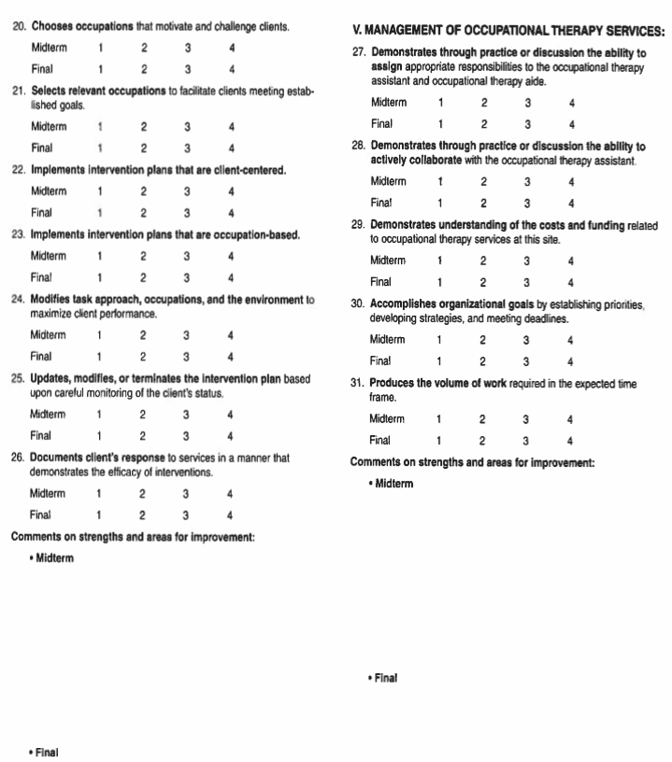
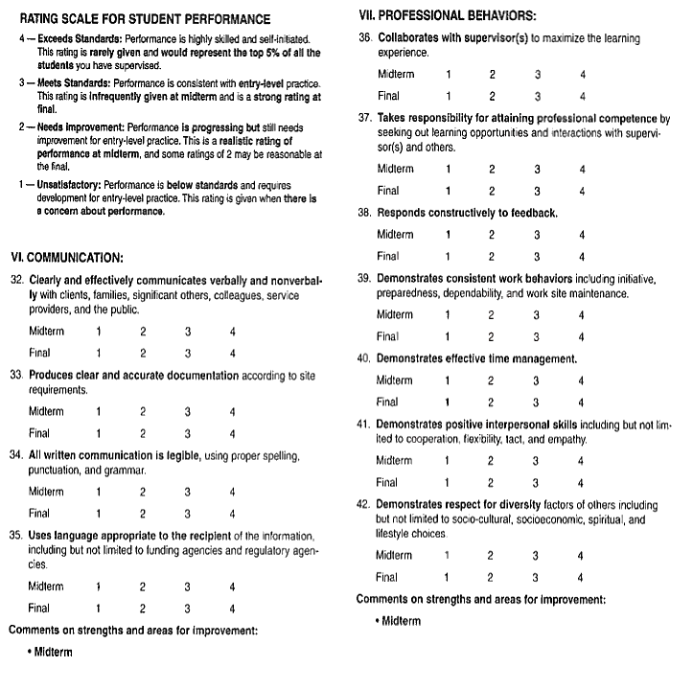
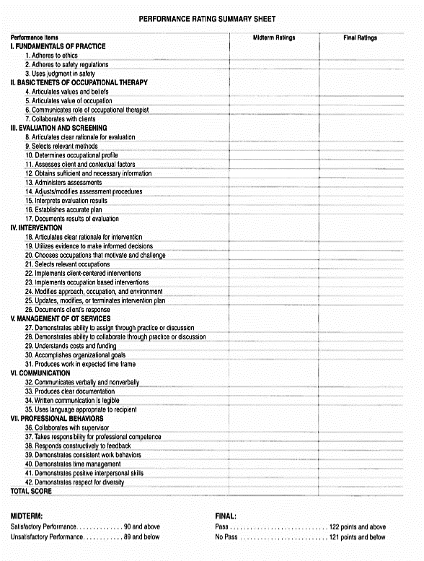
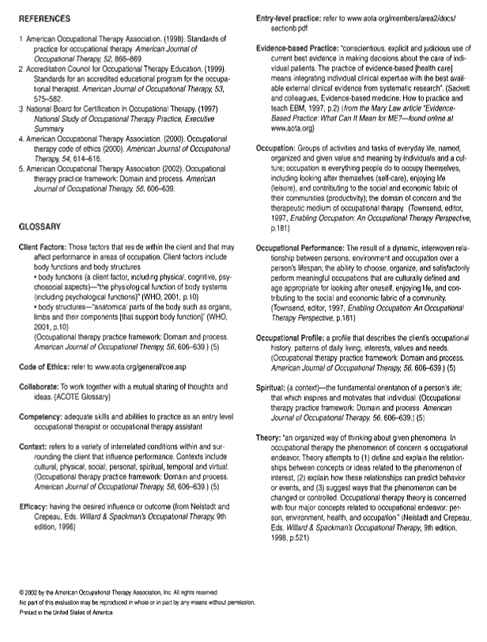
Appendix F: Student Evaluation of the Fieldwork Experience (SEFWE):

Purpose:
This evaluation serves as a tool for fieldwork sites, academic programs, and students. The main objectives of this evaluation are to:
- Enable the Level II fieldwork student who is completing a placement at the site to evaluate and provide feedback to the supervisor and fieldwork setting;
- Enable academic programs, fieldwork sites, and fieldwork educators to benefit from student feedback in order to develop and refine their Level II fieldwork programs;
- Ensure that all aspects of the fieldwork program reflect the sequence, depth, focus, and scope of content of the curriculum design;
- Provide objective information to students who are selecting sites for future Level II fieldwork; and
- Provide a means of evaluation to ensure that fieldwork is performed in settings that provide educational experiences applicable to the academic program.
This form is designed to offer each program the opportunity to gather meaningful and useful information. Sections outlined with thick black double borders are designed to be customized by your program as needed. Pages involving evaluation of individual fieldwork educators have been positioned at the end of the form to allow academic programs to easily remove these pages before making them available for student review, if they choose to do so.

STUDENT EVALUATION OF THE FIELDWORK EXPERIENCE (SEFWE)
Instructions to the Student:
Complete this STUDENT EVALUATION OF THE FIELDWORK EXPERIENCE (SEFWE) form before your final meeting with your fieldwork supervisor(s). It is imperative that you review the form with your supervisor and that both parties sign on page 1. Copy the form so that a copy remains at the site and a copy is forwarded to your Academic Fieldwork Coordinator at your educational program. This information may be reviewed by future students as well. The evaluation of the student (FWPE) should be reviewed first, followed by the student’s evaluation of the fieldwork experience (SEFWE), allowing the student to be honest and constructive.

Fieldwork Site _____________________________________ Site Code ________

Address ___________________________________________________________

Placement Dates: from _________________________ to _______________________

Order of Placement: [ ] First [ ] Second [ ] Third [ ] Fourth

Living Accommodations: (include type, cost, location, condition)

Public transportation in the area:
Please write your e-mail address here if you don’t mind future students contacting you to ask you about your experience at this site: ______________________________________
We have mutually shared and clarified this Student Evaluation of the Fieldwork Experience report.

_______________________________________ ________________________________________
Student's Signature FW Educator's Signature

_______________________________________ ________________________________________
Student's Name (Please Print) FW Educator’s Name and credentials (Please Print)
FW Educator’s years of experience ____________
ORIENTATION
Indicate your view of the orientation by checking "Satisfactory" (S) or "Needs Improvement” (I) regarding the three factors of adequacy, organization, and timeliness.

TOPIC | Adequate |  | Organized |  | Timely |  | NA
 | S | I | S | I | S | I
Site-specific fieldwork objectives
Student supervision process
Requirements/assignments for students
Student schedule (daily/weekly/monthly)
Staff introductions
Overview of physical facilities
Agency/Department mission
Overview of organizational structure
Services provided by the agency
Agency/Department policies and procedures
Role of other team members
Documentation procedures
Safety and emergency procedures
Confidentiality/HIPAA
OSHA—Standard precautions
Community resources for service recipients
Department model of practice
Role of occupational therapy services
Methods for evaluating OT services
Other

Comments or suggestions regarding your orientation to this fieldwork placement:
_____________________________________________________________________________________________
_____________________________________________________________________________________________
_____________________________________________________________________________________________

CASELOAD

List approximate number of each age List approximate number of each primary category in your caseload. Condition/problem/diagnosis in your caseload.
Age | Number
0–3 years old
3–5 years old
6–12 years old
13–21 years old
22–65 years old
> 65 years old
Condition/Problem | Number

OCCUPATIONAL THERAPY PROCESS
Indicate the approximate number of screenings/evaluations you did; also indicate their value to your learning experience by circling the appropriate number with #1 being least valuable and #5 being the most valuable.
 | REQU  Yes | IRED  No | HOW MANY | EDUCATIONAL VALUE
1. Client/patient screening |  |  |  | 1 2 3 4 5
2. Client/patient evaluations
(Use specific names of evaluations)
 |  |  |  | 1 2 3 4 5
 |  |  |  | 1 2 3 4 5
 |  |  |  | 1 2 3 4 5
 |  |  |  | 1 2 3 4 5
 |  |  |  | 1 2 3 4 5
 |  |  |  | 1 2 3 4 5
 |  |  |  | 1 2 3 4 5
 |  |  |  | 1 2 3 4 5
 |  |  |  | 1 2 3 4 5
3. Written treatment/care plans |  |  |  | 1 2 3 4 5
4. Discharge summary |  |  |  | 1 2 3 4 5

List major therapeutic interventions frequently used and indicate whether it was provided in group, individually, Co-Treatment, or consultation. List other professionals involved.

Therapeutic Interventions | Individual | Group | Co-Tx | Consultation
Occupation-based activity, i.e., play, shopping, ADL, IADL, work, school activities, etc. (within client’s own context with his or her goals)
1.
2.
3.
4.
Purposeful activity (therapeutic context leading to occupation)
1.
2.
3.
4.
Preparatory methods, i.e., sensory, PAMs, splinting, exercise, etc. (preparation for occupation-based activity)

1.
2.
3.
4.
THEORY—FRAMES OF REFERENCE—MODELS OF PRACTICE

Indicate frequency of theory/frames of reference used
 | Never | Rarely | Occasionally | Frequently
Model of Human Occupation
Occupational Adaptation
Ecology of Human Performance
Person–Environment–Occupation Model
Biomechanical Frame of Reference
Rehabilitation Frame of Reference
Neurodevelopmental Theory
Sensory Integration
Behaviorism
Cognitive Theory
Cognitive Disability Frame of Reference
Motor Learning Frame of Reference
Other (list)

FIELDWORK ASSIGNMENTS

List the types of assignments required of you at this placement (check all that apply), and indicate their educational value (1 = not valuable ------- 5 = very valuable)

Case study applying the Practice Framework 1 2 3 4 5 N/A

Evidence-based practice presentation: 1 2 3 4 5 N/A

Topic:

Revision of site-specific fieldwork objectives 1 2 3 4 5 N/A

Program development 1 2 3 4 5 N/A

Topic:

In-service/presentation 1 2 3 4 5 N/A

Topic:

Research 1 2 3 4 5 N/A

Topic:

Other (list) 1 2 3 4 5
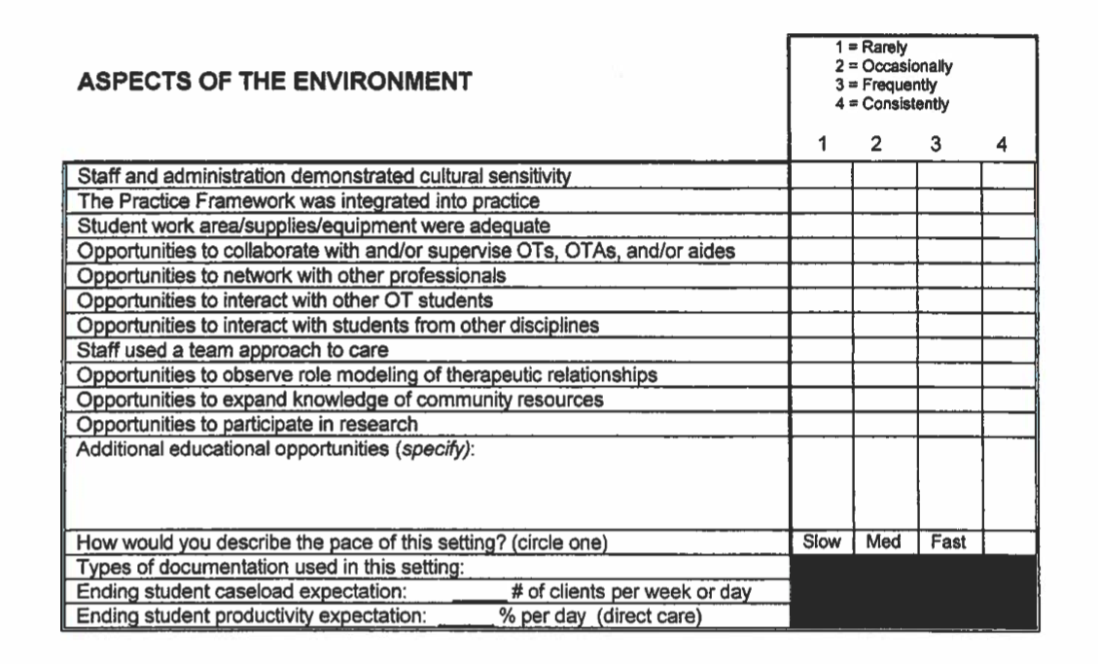
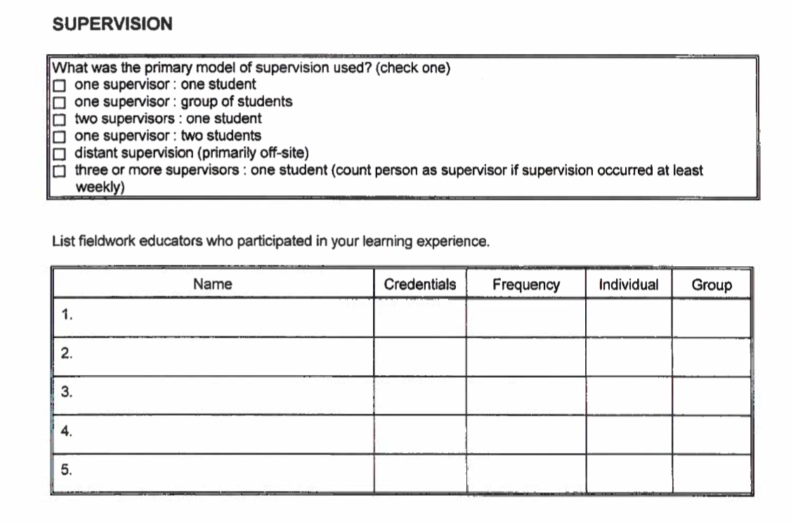
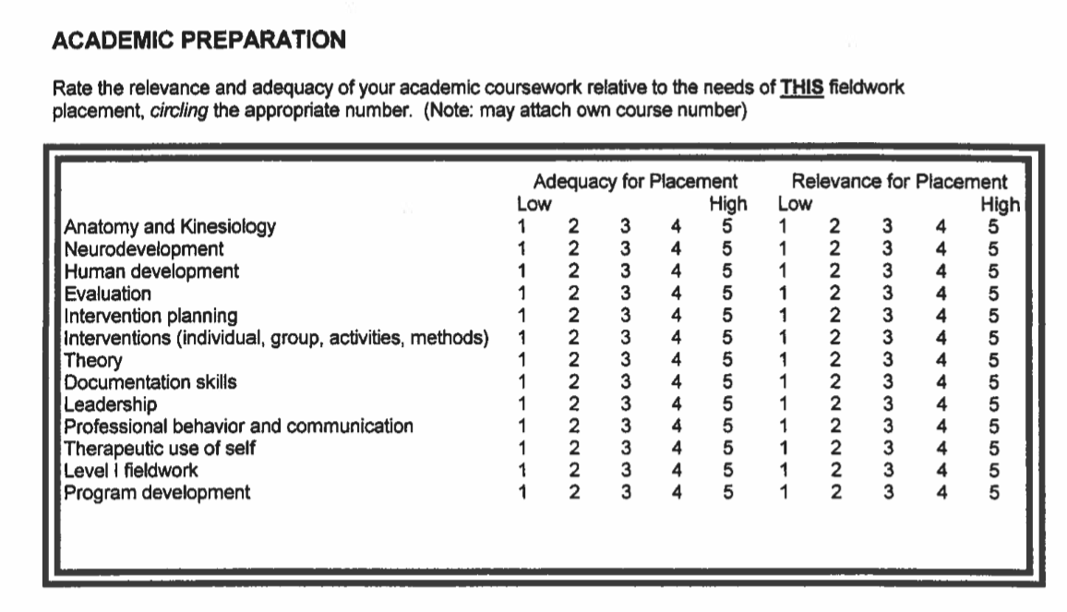
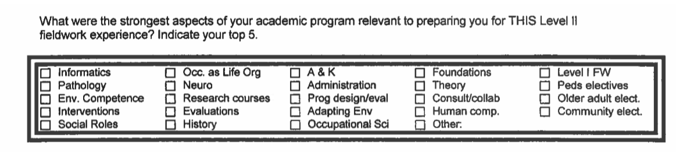
What changes would you recommend in your academic program relative to the needs of THIS Level II fieldwork experience?
____________________________________________________________________________________
____________________________________________________________________________________
___________________________________________________________________________________

SUMMARY | - = Strongly disagree  - = Disagree  - = No Opinion  - = Agree  - = Strongly agree  1 2 3 4 |  |  |  | 5
Expectations of fieldwork experience were clearly defined
Expectations were challenging but not overwhelming
Experiences supported student's professional development
Experiences matched student's expectations
What particular qualities or personal performance skills do you feel that a student should have to function successfully on this fieldwork placement?
________________________________________________________________________________________________________________________________________________________________________________________________________________________________________________________________________________________________________________________________________________

What advice do you have for future students who wish to prepare for this placement?

Study the following evaluations:
________________________________________________________________________________________________________________________________________________________________________
____________________________________________________________________________________
____________________________________________________________________________________

Study the following intervention methods:
____________________________________________________________________________________________________________________________________________________________________________________________________________________________________________________________
____________________________________________________________________________________

Read up on the following in advance:
____________________________________________________________________________________________________________________________________________________________________________________________________________________________________________________________
__________________________________________________________________________________________________________________________________________________________________________

Overall, what changes would you recommend in this Level II fieldwork experience?
________________________________________________________________________________________________________________________________________________________________________
________________________________________________________________________________________________________________________________________________________________________

Please feel free to add any further comments, descriptions, or information concerning your fieldwork at this center.
________________________________________________________________________________________________________________________________________________________________________
________________________________________________________________________________________________________________________________________________________________________
____________________________________________________________________________________

Indicate the number that seems descriptive of each fieldwork educator. Please make a copy of this page for each individual.  FIELDWORK EDUCATOR NAME:___________________________________  FIELDWORK EDUCATOR YEARS OF EXPERIENCE: __________ | - = Strongly Disagree  - = Disagree  - = No opinion  - = Agree  - = Strongly agree  1 2 3 4 5
Provided ongoing positive feedback in a timely manner
Provided ongoing constructive feedback in a timely manner
Reviewed written work in a timely manner
Made specific suggestions to student to improve performance
Provided clear performance expectations
Sequenced learning experiences to grade progression
Used a variety of instructional strategies
Taught knowledge and skills to facilitate learning and challenge student
Identified resources to promote student development
Presented clear explanations
Facilitated student’s clinical reasoning
Used a variety of supervisory approaches to facilitate student performance
Elicited and responded to student feedback and concerns
Adjusted responsibilities to facilitate student's growth
Supervision changed as fieldwork progressed
Provided a positive role model of professional behavior in practice
Modeled and encouraged occupation-based practice
Modeled and encouraged client-centered practice
Modeled and encouraged evidence-based practice

Frequency of meetings/types of meetings with supervisor (value/frequency):
________________________________________________________________________________________________________________________________________________________________________
________________________________________________________________________________________________________________________________________________________________________
General comments on supervision: ________________________________________________________________________________________________________________________________________________________________________________________________________________________________________________________________________________________________________________________________________________

Appendix G: Student Exposure/Injury Report

Department of Occupational Therapy
Student Exposure Incident/Injury Report
Student name: _______________________________________________DOB:______________ Date incident occurred: _________ Time incident occurred: ________ Time reported: _________
Has the student completed the hepatitis B vaccination series? [ ] yes [ ] no
If yes, dates of vaccination: 1st __________ 2nd __________ 3rd __________
Post-vaccination HBV antibody status, if known: [ ] positive [ ] negative [ ] unknown
Date of last tetanus vaccination: ___________________________
Date of last tuberculin test: ______________________________ Exposure Incident Information:
Agency/site where incident occurred (include specific unit):_____________________________
Type of incident:
[ ] needle stick
[ ] instrument puncture
[ ] burn laceration
[ ] injury from other sharp object _____________________________________________
[ ] blood/other body fluid splash or spray
[ ] human bite
[ ] other ________________________________________________________________
Area of body exposed: ___________________________________________________________
Type of body fluid/tissue/airborne pathogen exposed to: _______________________________
Describe incident in detail: ____________________________________________________________________________
____________________________________________________________________________
What barriers were being used by the student when the incident occurred? [ ] gloves [ ] mask
[ ] eye wear [ ] gown [ ] other ___________________ Source Patient Information:
Review of source patient medical history: [ ] yes [ ] no
Verbally questioned regarding:
History of hepatitis B, hepatitis C, or HIV infection [ ] yes [ ] no
High risk history associated with these diseases [ ] yes [ ] no
Patient consents to be tested for HBV, HCV, and HIV [ ] yes [ ] no Referred to (name of evaluating healthcare professional/facility): __________________________
Incident report completed by:____________________________________________________
Student Signature: _____________________________Date: ___________________________

Appendix H: Level I Personal Data Form

OCCUPATIONAL THERAPY DEPARTMENT

_______ O.T. 6920 SEMINAR I: PSYCHOSOCIAL PRACTICE
_______ O.T. 6921 SEMINAR II: ADULT REHABILITATION PRACTICE
_______ O.T. 6922 SEMINAR III: PEDIATRIC PRACTICE

FIELDWORK PERSONAL DATA FORM

Name: _________________________________________________________________________________________
Current Address: ______________________________________________________________________________
Email Address_________________________________________________________________________________
Phone number where you can be reached Home/Cell/Work: ___________________________ Emergency contact information: _______________________________________________________________ Describe your goals for this fieldwork experience:
_________________________________________________________________________________________________________
_________________________________________________________________________________________________________
_________________________________________________________________________________________________________ Describe your learning style (how you learn best):
_________________________________________________________________________________________________________
_________________________________________________________________________________________________________
_________________________________________________________________________________________________________ Describe your interests outside of the OT profession:
_________________________________________________________________________________________________________
_________________________________________________________________________________________________________
_________________________________________________________________________________________________________ Describe life experiences that may be helpful to this fieldwork placement:
________________________________________________________________________________________________________
_________________________________________________________________________________________________________
_________________________________________________________________________________________________________
Appendix I: AOTA Personal Data Sheet:

AOTA Personal Data Sheet

PERSONAL DATA SHEET

This form is completed by the student and is sent to the student’s fieldwork educator prior to the start of the fieldwork experience.

PERSONAL DATA SHEET
FOR STUDENT FIELDWORK EXPERIENCE

PERSONAL INFORMATION

Name _______________________________________________________________________________________

Permanent Home Address ______________________________________________________________________
___________________________________________________________________________________________

Phone number and dates that you will be available at that number

Phone Number _____________________________ Dates __________________________________________

Name, address, and phone number of person to be notified in case of accident or illness:

___________________________________________________________________________________________
___________________________________________________________________________________________
___________________________________________________________________________________________EDUCATION INFORMATION

- Expected degree (circle one)
OTA:
Associate Baccalaureate Masters Doctorate Certificate
OT:
Baccalaureate Masters Doctorate Certificate

- Anticipated year of graduation ________________________

- Prior degrees obtained _______________________________

- Foreign languages read ______________________________ spoken ___________________________

- Do you hold a current CPR certification card? Yes _____ No _____
Date of expiration ________________________

HEALTH INFORMATION

- Are you currently covered under any health insurance? Yes _____ No _____

- If yes, name of company _________________________________________________________________
Group # _________________________________ Subscriber # _________________________________

- Date of last Tine Test or chest x-ray: _____________________________
(If positive for TB, tine test is not given)

PREVIOUS WORK/VOLUNTEER EXPERIENCE

____________________________________________________________________________________________
____________________________________________________________________________________________
____________________________________________________________________________________________
Over. . .
PERSONAL PROFILE

- Strengths:
_____________________________________________________________________________________________

_____________________________________________________________________________________________

- Areas of growth:
_____________________________________________________________________________________________

_____________________________________________________________________________________________

- Special skills or interests:
____________________________________________________________________________________________

____________________________________________________________________________________________

- Describe your preferred learning style
_____________________________________________________________________________________________
_____________________________________________________________________________________________

- Describe your preferred style of supervision:
_____________________________________________________________________________________________

_____________________________________________________________________________________________

- Will you need housing during your affiliation? Yes _____ No _____

- Will you have your own transportation during your affiliation? Yes _____ No _____

- (Optional) Do you require any reasonable accommodations (as defined by ADA) to complete your fieldwork? Yes _____ No _____. If yes, were there any reasonable accommodations that you successfully used in your academic coursework that you would like to continue during fieldwork?
If so, list them. To promote your successful accommodation, it should be discussed and documented before each fieldwork experience.

FIELDWORK EXPERIENCE SCHEDULE

 | CENTER | TYPE OF FW SETTING | LENGTH OF FW EXPERIENCE
Level I Exp.
Level II Exp.

ADDITIONAL COMMENTS

AOTA Commission on Education (COE) and Fieldwork Issues Committee (FWIC)
Amended and Approved by FWIC 11/99 and COE 12/99 fieldwork\miscell\persdatasheet.12

Appendix J: Student Clinical Agreement

DEPARTMENT OF OCCUPATIONAL THERAPY
STUDENT CLINICAL AGREEMENT

I, _______________________________ agree to honor my commitment to Level II fieldwork placement at:

Name of Facility: _______________________________________________________________________

Address of Facility: _____________________________________________________________________

______________________________________________________________________________________

Scheduled dates: _______________________________________________________________________

Name of Clinical Supervisor: _____________________________________________________________

Contact Information: Email _____________________________________________________________

Office Phone (__________) __________________ Cell Phone (_________) _________________

Other Info: ___________________________________________________________________
I agree to be responsible for:
- Following the administrative policies, rules, standards, and practices of the Facility and the University as it pertains to the responsibilities of student work.
- Following Infection Control Policies and Standard Precautions.
- Adhering to Patient’s Rights and confidentiality and all HIPAA regulations.
- Maintaining Malpractice Insurance throughout the Level II Fieldwork Experience.
- Maintaining current health requirements and providing other medical information as required by facility. (Records to be current within 1 year of FW Experience end date).
- Complying with the American Occupational Therapy Association’s Code of Ethics.
- Providing the necessary and appropriate uniforms required if not provided by the Facility.
- Providing my own transportation and living arrangements if not provided by the Facility.
- Reporting to the fieldwork Supervisor as instructed and on time daily.
- Obtaining prior written approval of the Facility and Kean University before publishing any materials relating to the Clinical Education Experience.
- Providing the highest caliber of service of which I am capable to the individuals entrusted to my care.
Student’s Signature: ___________________________________________ Date: _______________
Supervisor Signature: _________________________________________ Date: _______________

Reflecting the policy of Kean University, the facilities selected for the fieldwork experiences do not discriminate because of age, sex, marital status, race, color, creed, national origin, handicap, or sexual orientation. Please mail, email, or fax completed copy to of this document to:
Kean University – Department of Occupational Therapy
East Campus 224D
Union, New Jersey 07083
Attention: Patricia Higgins
Phone 908.737.5853 Fax: 908.737.5855
otfieldwork@kean.edu

Appendix K: Health Records Requirement

DEPARTMENT OF OCCUPATIONAL THERAPY
HEALTH RECORD REQUIREMENTS

Name: Date:

Please note: This information is required by May 15 of the 1st academic year, prior to starting Fieldwork Level I

IMMUNIZATIONS: 1. Hepatitis B
- Proof of having received all THREE doses of the Hepatitis B Vaccine

Dates: ______, ______, ______

OR
- Documentation of a positive Hepatitis Surface Antibody (HBSAB)
OR
- Vaccine Waiver Form

- Rubeola (Measles): (if born after 1950)
  - Proof of TWO doses of live measles (or MMR) vaccine, at least one month apart, on or after first birthday

OR
  - Documentation of a case of physician - diagnosed measles

OR
  - Measles Titer Results:

- Mumps: (if born after 1951 or prior to 1951 if does not recall having had mumps).
  - Proof of immunization with live mumps (or MMR) vaccine on or after first birthday

OR
  - Documentation of a case of physician-diagnosed mumps

OR
  - Mumps Titer Results

DEPARTMENT OF OCCUPATIONAL THERAPY
HEALTH RECORD REQUIREMENTS
Page 2 of 3
- Rubella (German Measles):
  - Rubella Titer Results

Varicella (Chicken Pox)
  - Documentation of a case of physician diagnosed chicken pox

OR
  - Results of previous titer

- Diptheria/tetanus: (must be within 10 years)

  - Date of Booster:
TUBERCULOSIS TESTING

- ____ A current PPD (Mantoux; within one year) has been completed
or
_____A current 2 step PPD has been completed

PPD date ______ Results Negative ______ Positive ______
PPD date ______ Results Negative ______ Positive ______

If PPD is positive, a chest x-ray is required. If a chest x-ray is not completed, the reason must be documented.
Chest x-ray results: ___________________________________________________________________
A chest x-ray was not completed because:_________________________________________________
PHYSICAL EXAMINATION

- A physical exam on certifies that ______________________is in
satisfactory health and free from any communicable diseases

OR
- The following health problems exist:

If your health status changes, the school must be notified as soon as possible. Failure to comply may result in the suspension or cancellation of fieldwork placements.

_________________________________ Date________________
Physician's Signature

_________________________________ Date________________
Student's Signature

DEPARTMENT OF OCCUPATIONAL THERAPY
HEALTH RECORD REQUIREMENTS
Page 3 of 3
HEALTH RECORD COMPLETION VERIFICATION

This must be completed and signed by the healthcare provider and the student after the physical exam is completed. This must be submitted to Patricia Higgins by May 15 of first academic year prior to beginning fieldwork.

I, _____________________ verify that my health record is complete. I understand that I am required to provide show my health records to my seminar instructor(s) on the first day of each seminar class, and may be asked to provide my health records to the fieldwork site(s). I understand that failure to comply with this regulation will delay my fieldwork start date and jeopardize my grade.

Student signature: __________________________________

TO HEALTHCARE PROVIDER: Please complete below. If no medical condition exists, please indicate by writing “not applicable”.

The student has a medical condition, including pregnancy and allergies, but does not have limitations for working with clients during fieldwork.

The student has a medical condition, including pregnancy or allergies, which results in the following limitation(s). (Please be specific):

Condition Specific Limitations

I, ______________________ verify that to the best of my knowledge that the information provided above is true.

_________________________ Date: ___________
Student signature

_________________________________ Date: _____________ Physician's Signature

Physician Name: __________________________________________
Address: _________________________________________
Phone number: ______________________________________________

Please note: This form will not be accepted if physician name, address, and phone number above are illegible.
Appendix L: Annual Update of Health Records

DEPARTMENT Of OCCUPATIONAL THERAPY
Annual Update of Health Records
(To be completed by healthcare provider)

Student Name:
Address:
Telephone number:
Please complete this health record update.

I, have no change(s) in my health status to report.
I, have had the following health changes .

- ____ Completion of a physical examination indicates that this student is in satisfactory health and free of any communicable diseases.
OR
- ____ The following health problems exist:

_________________________________________________________________________________

_________________________________________________________________________________

3.____ A current PPD (Mantoux within one year) has been completed
or
_____A current 2 step PPD has been completed

PPD date ______ Results Negative ______ Positive ______ PPD date ______ Results Negative ______ Positive ______

If PPD is positive, a chest x-ray is required. If a chest x-ray is not completed, the reason must be documented.
Chest x-ray results: ___________________________________________________________________
A chest x-ray was not completed
Because: ______________________________________________________________________________
___________________________________ __________________
Physician’s Signature Date

___________________________________ ___________________
Student's Signature Date

Appendix M: Criminal Background Check Resources
Criminal Background Checks

Our suggestion: Once you have a placement confirmed by the fieldwork coordinator, call the fieldwork site, and ask if a background check is required for that facility.
PLEASE BE SURE TO ASK THE COORDINATOR IF THERE IS AN AGENCY THAT IS PREFERRED BY THE FACILITY BEFORE YOU COMPLETE THIS REQUIREMENT.

If the facility does NOT use a specific agency, here are agencies which have been suggested to us.
Adam Safeguard
1187 Washington Street
Suite 2
Toms River, New Jersey 08753
732.506.6100 www.adamsafeguard.com

Sagem Morpho, Inc www.morpho.com www.bioapplicant.com
877.503.5981

Certified Background.com
888-666-7788
www.certifiedbackground.com

TABB, Inc
PO Box 10
555 E. Main St.
Chester, NJ 07930
TELEPHONE (908) 879-4816 FAX (908) 879-8675 www.tabb.net

STATE RESOURCES
New Jersey State Police www.njsp.org
Follow instructions for New Jersey Criminal History Record

New York Unified Court System www.courts.state.ny.us
Follow instructions for criminal history record search
Criminal Records
Division of State Police
Records and Identification
PO Box 7068
West Trenton NJ 08628-0068
(689) 882-2001
(689) 530-5780 (fax)

NEW JERSEY STATE INFORMATION HOT LINE:
(609) 292-2121
NEW JERSEY STATE WEB SITE:
www.state.nj.us
These are other agencies which have been used by students in the past.

Accu-Screen 5303
S. MacDill Ave.
Tampa, Florida 33611
Phone: 800-689-2228

BackgroundFerret.com
200 Great Road Bedford, MA 01730 email: support@backgroundferret.com phone: (866) 598-9100

SentryLink LLC
Maryland Trade Center I
7500 Greenway Center Drive Greenbelt, MD 20770 ccorders@sentrylink.com

Live Scan www.livescan.com

APPENDIX N: RELEASE AND WAIVER

Release and Waiver
I, ______________________, hereby authorize Kean University to release the following information requested by _______________________ (Facility) concerning my clinical placement starting on ____________________ to _________________________. I understand that this information has been requested by ________________________ and is necessary for my clinical placement experience.
 | Health screening reports o Physical examination (within past ___ months) o Baseline PPD  o Rubella titer/vaccination o Rubeola titer/vaccination o Measles titer/vaccination o Mumps titer/vaccination o Hepatitis B titer/vaccination series  - Varicella  - Flu vaccine status ____ Accept or ____ Decline  - Other: ____________________________________________________ o Other: ____________________________________________________
 | Criminal Background Check report  o Sex offender registry search  o Screening against the Office of the Inspector General List of Excluded Individuals List o Screening against the General Services Administration's Excluded Parties List  o Professional license checks  o Social security trace
 | Drug Screening
 | Educational transcripts provided by the student
 | Certificate of Professional liability
I understand that Kean University will be forwarding all copies or results to
__________________________and will return the originals to me.
_______________________________ ________________________________
Student Signature Witness Signature
_________________________ ________________________
Date Date

