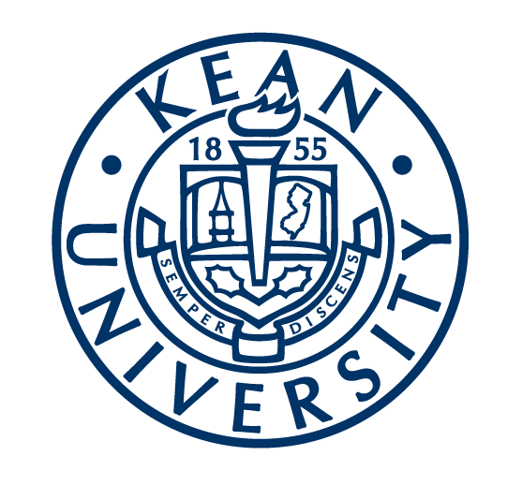
Kean University
Nathan Weiss Graduate College

This has been a year of positive change and growth at Kean University. We received candidacy status from ACOTE and are fully immersed in our self-study for our entry-level doctoral program. The first cohort of doctoral students started Summer 2018 and we recently selected our second cohort who will begin the program in Summer 2019. Mariann Moran has been serving as the Interim Program Chairperson since September 2018. We wish Thais Petrocelli and Geraldine Pagaoa-Cruz best wishes as they pursue new adventures out of state in Florida and Las Vegas and thank them for their contributions to the continued success of our program. We welcome Patricia Higgins as the new Academic Fieldwork Coordinator and Kelly Sullivan as a lecturer.

The Kean University Occupational Therapy Community Cares Clinic (KUOT-CCC) is moving into its 6th full year of business. Over the last year, clinic programming has expanded, leading to our ability to host more fieldwork students and better reach the community at large. The clinic continued its partnership with Prevention Links, a local non-profit community organization and provided intervention services in the Senator Lesniak Experience, Strength, Hope Recovery High School. In addition, a pilot OT group was started in our university's child care and development center and our clinic staff and fieldwork students hosted an event in the dorms for freshman students at Kean. We held our 5th annual Steps to Your Future camp in which students aged 18-22 experience an immersion experience into college life. They were provided the opportunity to spend one week on Kean's campus including 2 overnights in the freshman dorms. Additionally, the clinic participated in various vendor tables at state-level events to promote OT, as well as our clinic services offered.

Claire Mulry received a grant for Fall 2018 and 2019 for “Let’s Go”, AARP Home Fit, and Fall Prevention to bring to seniors living in federally sponsored housing. She also contracted for $10,000 to provide federal literacy, planning, and work skills to older adults in Roselle. Jennifer Gardner recently had a systematic review article accepted for publication entitiled “Effective Interventions to Improve and maintain Occupational Performance and Participation for Individuals with Serious Mental Illness: A Systemic Review”, which will be published in an upcoming edition of AJOT. Laurie Knis-Matthews continues to spearhead our interprofessional education committee on campus and recently published a manuscript with six other colleagues from various health professions emphasizing the importance of interprofessionalism in the Perspectives of ASHA Special Interest Group. She is currently leading KU graduate students in data collection to understand how fathers, who are drug dependent, make meaning of fatherhood using the KAWA model as a guide. Mariann Moran continues her involvement with the Board of Directors of NJOTA as State Liaison. Patricia Higgins continues community outreach through her position as the fieldwork coordinator and will work to develop innovative fieldwork placements throughout the state. Since being hired Kelly Sullivan has really succeeded in stepping up to continue the programming and success of KUOT-CCC, has worked on three interprofessional projects with SLP, PysD, EdD, and PT, as well as collaborating with local schools to provide an OT led group for students.

Our faculty continues to publish and present their works for the healthcare community, including at the NJOTA conference in October 2018, which was sponsored at Kean, and at the recent AOTA conference in New Orleans. Our SOTA organization recently held their 7th annual Best Friend Breakfast for children with autism and their families with over 60 attendees! SOTA was also first runner up for Kean University funded organization of the year! We are grateful to our adjunct professors and clinicians for sharing their talents and expertise with us. Thank you: Stephanie Blodgett, Michael Camacho, Chris Hildeman, Kevin Nelson, Ilana Unger, Mary Jo Zinnie, Brocha Stern, Christine Bodzioch, Tarah Romano, Lois Menkin and all of our fieldwork educators.

