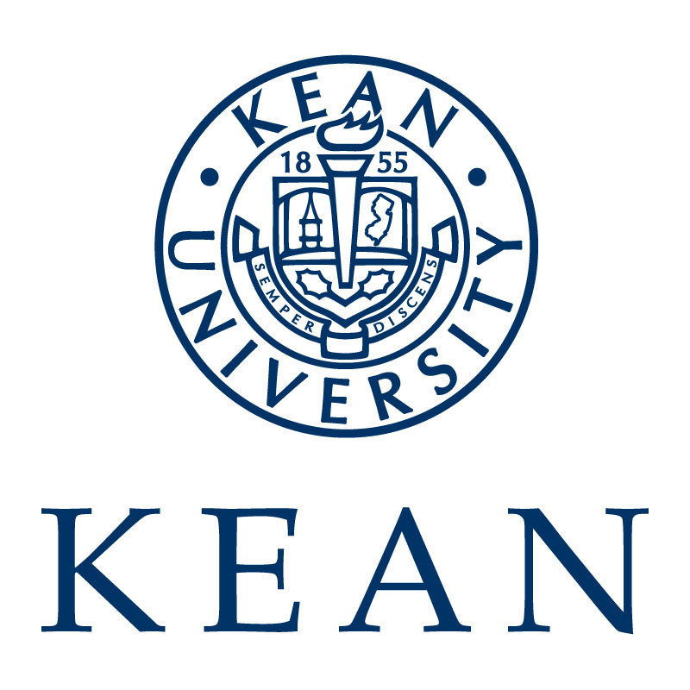
Department of Occupational Therapy
Articulation of Academic and Fieldwork Experiences – Level I

Introduction
In an effort to improve the articulation between academic and clinical learning experiences the Kean University Department of Occupational Therapy is providing this information regarding our academic curriculum and learning objectives. We appreciate and support the efforts of our clinical educators and want to ensure that those same clinical educators understand and support the focus of our academic program.

Vision

By 2025, the graduates of our masters and doctoral degree programs will excel in entry-level practice. Through creative programming and active learning opportunities, students will become leaders who serve society. Our graduates will create change through evidence based innovative practice.

Mission

The mission of the Kean University Occupational Therapy Program is to develop entry-level occupational therapists who will utilize clinical reasoning skills to think creatively, critically, and holistically to deliver occupation-based practice to increase health, wellbeing and quality of life.

We promote professional growth, lifelong learning and interprofessionalism through leadership, scholarship, and/or creative works. Through collaboration with local, national and global community partners, we create unique learning and service opportunities to meet the needs of a changing social, economic and technological environment.

We seek to create excellence through a diverse and inclusive student body in support of a culturally competent workforce meeting the occupational needs of society.

Curriculum Threads
KUOT curriculum has four specific threads that are embedded in each course and within all aspects of the professional phase of the program.
- Clinical reasoning
- Professionalism
- Scholarship
- Community relationships

Clinical reasoning
The Occupational Therapy Practice Framework (OTPF) cites a definition of a clinical reasoning as “process used by practitioners to plan direct, perform, and reflect on client care” (Shell et al., 2013, P.231). Clinical reasoning is also defined as an interaction between the client and practitioner that is influenced by each party’s social/historical/cultural context and the practice context of the interaction (Higgs et al., 2018).
Our curriculum is designed to develop your clinical reasoning skills to the level of an entry level OT practitioner. In each class, you will be given the opportunity to reflect on your problem solving, decision making and performance. Case presentations will encourage you to experiment with new concepts and develop clinical reasoning skills in a safe, supportive environment. The community partnership and service course, Level 1 and Level 2 fieldwork experiences will provide opportunities to implement programs and interventions in real circumstances and then reflect on those performances.

Professionalism
Professionalism is defined as “internalized attitudes, perspectives, and personal commitment to the standards, ideals, and identity of a profession” (Spurill & Benshoff, 1996). Yerxa (1966) states that “professionalism is much more than appearance and intellectual accomplishments. It means being able to meet real needs. It means having and acting upon a philosophy. It also means being ‘authentic’” (p. 127).
The American Occupational Therapy Association (AOTA) outlines the expected professional behaviors for entry level practice in its Fieldwork Performance Evaluation for the Occupational Therapy Student form. These behaviors include, but are not limited to: collaboration with supervisor, responsibility for learning opportunities, ability to receive constructive criticism, positive interpersonal skills and respect for diversity. Upon completion of Level II fieldwork, students’ performance in professional behaviors must “meet standards,” which is defined as “consistent with entry-level practice.”
The faculty and staff are dedicated to modeling and shaping professionalism, as we believe this is one of the most important contributors to success in the classroom and clinical practice. In order to ensure each student is demonstrating professional behavior throughout his or her academic career and into entry level practice, every course has a mechanism for evaluation of professional behaviors (i.e., class participation, professionalism form, fieldwork I & II evaluations).

Scholarship
Scholarship encompasses activities that demonstrate your understanding the importance of seminal literature, current research evidence and how it supports, guides and develops new knowledge for the practice of occupational therapy; the ability to form a clinical question then search for the best and most current evidence, the ability to critically appraise the evidence and use it to make clinical decisions. AOTA’s Vision 2025 states “Occupational therapy maximizes health, well-being, and quality of life for all people, populations, and communities through effective solutions that facilitate participation in everyday living.” (AOTA 2017 p.71). Students in Kean’s program accomplish this through four guideposts and one is that “occupational therapy is evidence based, client centered, and cost-effective evidence” (Vision 2025, 2018b).
Our curriculum is designed to introduce, develop and foster the appreciation of, and ability to use research and scholarship to promote the efficacy and visibility of occupational therapy. In each course, research evidence and scholarship are woven into the readings, discussion and assignments to move from the level of recall to the higher cognitive level of creation (Anderson, 2001) of a scholarly project. You will learn to understand appropriate design issues and apply quantitative and/or qualitative scientific methodology to answer a research question or query. The scholarship of discovery will culminate in a research project demonstrating your ability to integrate the research process and disseminate the end product in a formal presentation. Scholarship entails integration of knowledge across disciplines, application of knowledge in practice and to meet societal needs at the community and organizational levels (contexts). You will use the evidence to learn about theory, protocols, and innovative treatment and use the evidence to enhance assessment and intervention in course work, and Level I and II fieldwork experiences. The focus of the integration of scholarship within each course is to cultivate your skills to appraise, use and contribute to the effectiveness of occupational therapy beyond graduation and serve as a foundation for lifelong inquiry and discovery to promote and support the profession.

Community Relationships
“The everyday life of a community, its mix of people, their needs, concerns, joys and struggles, offers an unparalleled opportunity to define our discipline, research its potential and extend its boundaries well beyond the current limits of our medically based practice” (Fidler, 2001, p.8). Occupational therapists have a unique skill set to discover the needs of people we serve and to facilitate positive client and community centered change towards meaningful participation in occupations (Fazio, 2008; Scaffa, 2001). We do so as individual practitioners, but most often with a variety of interprofessional partners, through the collaboration among the families in early intervention and home care, medical team members (nurses, physicians, physical and speech language therapists, social workers), in schools (teachers, paraprofessional, parents) and with community leaders and professionals (senior citizen housing directors, recreation professionals, business owners).
This curriculum is designed to provide the student with learning opportunities to develop the student’s active and contributory relationship to the community. Coursework will expose the students to a vast array of experiences in which service is provided to meet the needs of individuals, organization or populations within community settings. For example, guest lectures will be provided, throughout the curriculum, from experts in current and emerging practice areas (driving, low vision, NICU), and people with different abilities (disability awareness, perspectives from people with stroke, amputations, mental illness) will share their experience and insights into the influence of occupation and occupational therapy on their lives. Additionally, infused within many of the courses are assignments designed to provide you with an opportunity to research, create and deliver intervention with people from the university and local community. For example, many students will have the opportunity to provide educational courses for people with mental health issues within your first year in the program.

Curriculum Overview
The curriculum is divided into four stages. The first stage, The Basics, consists of the pre-professional level of the program. The last three, Foundations of Occupational Therapy, the Bridge from Theory to Practice, and Practice, comprise the professional level of education.
Throughout all phases of the professional program, the student is socialized into the role as a professional. This includes taking responsibility for one’s own personal and professional development, as well as understanding the commitment to lifelong learning. This commitment is fostered by active learning that requires students to apply their own interpretive framework and prior knowledge to the context of occupational therapy. Active learning requires students to use resources available to them to improve their clinical reasoning and self-reflection. The professional phase supports active learning by providing modeling and graded scaffolding, which allows students to succeed and view learning as an incremental process.

Educational Goals of the Program
All graduates of our program will:
- Exhibit the roles and responsibilities of an occupational therapist as defined by the American Occupational Therapy Association, consistent with state regulations:
  - Adheres to ethics and safety guidelines
  - Effectively articulates the value of occupation
  - Effectively communicates in both oral and written format
  - Understands costs and funding
- Utilize clinical reasoning skills to develop client centered assessment, goals, and intervention that facilitate participation in meaningful occupation across populations, settings and practice areas.
- Demonstrate professionalism throughout all phases of academic career and into entry level practice.
- Appraise research and other resources to evaluate efficacy and implement occupation based services supporting best practice.
- Collaborate with clients, community partners and inter-professional colleagues to meet society’s occupational needs.
- Demonstrate a professional commitment to the promotion and advancement of occupational therapy.
- Demonstrate respect for diverse life experiences and cultures.

Occupational Therapy Entry Level Doctoral students have additional educational goals:
- Demonstrates in-depth knowledge of practice models, policies and systems in current and emerging OT practice areas.
- Utilize a comprehensive knowledge of evidence based practice in assessment and intervention across current and emerging practice areas.
- Demonstrate active involvement in professional development, leadership, and advocacy.
- Demonstrate advanced knowledge and skills though in-depth experiences in one or more of the following areas: clinical practice skills, research skills, administration, leadership, program and policy development, advocacy, education, and theory development by completion of an accumulating doctoral residency.

Fieldwork Objectives – Level I
The objectives for Level I Fieldwork experiences are outlined in the corresponding seminar’s syllabus. Syllabi and Level I fieldwork manuals are provided by the course instructor to both the student and fieldwork educator.
Upon completion of the fieldwork portion of the course, the student will:
- Increase his/her own self-awareness and comfort in relation to reactions caused by exposure to various individuals
- Demonstrate a level of professional maturity by working with various ages and social and ethnic groups and respecting client confidentiality.
- Develop interpersonal skills by establishing and maintaining rapport with clients and staff.
- Use supervision as a resource for developing problem solving abilities, communication skills, and applying theory to clinical situations.
- Develop observation skills during evaluations and treatment and professionally analyze the behaviors observed.
- Develop skills in oral and written communication through reporting and recording pertinent observations and data.
- Integrate academic learning with clinical practice.

