A. Title Page

Master of Arts (M.A.) in Criminal Justice - Administration of Justice Option

School/Department Offering Academic Program:
Department of Criminal Justice & Public Affairs

Proposed Date of Implementation: Fall 2026

Date Submitted to University Curriculum Committee: December 2025

B. Table of Contents
C. Description, Objectives, and Student Learning Outcomes (SLOs) for the Academic Program
1. Description and Objectives ------------------------------------------------------------------------4
2. Evaluation and learning outcomes assessment plan for the program --------------------4
I. Program Student Learning Outcomes for the Master Program---------------------------4
II. Curriculum Plan ---------------------------------------------------------------------------------5
III. Assessment Plan ------------------------------------------------------------------------------5-8

3. Relationship of the program to institutional strategic plan and its effect on other

programs at the same institution------------------------------------------------------------------8

- Need – Justification of the need for this program-------------------------------------------9
I. National demands for graduate degrees-----------------------------------------------------9
II. National projections of the industry for MS in BA and SCM-----------------------9-11
III. NJ/NY local projections of the occupations -----------------------------------------11-14

- List similar programs within the state and in neighboring states and compare this program with those currently being offered-----------------------------------------------14

- Students – Estimate anticipated enrollments from the program's inception until a steady state or optimum enrollment is reached-------------------------------------14

- Program resources-------------------------------------------------------------------------------15
I. Full-time Faculty ------------------------------------------------------------------------------15
II. Part-time Adjunct Faculty -----------------------------------------------------------------15
- Degree Requirements----------------------------------------------------------------------------16
D. Admission Requirements-----------------------------------------------------------------------------16
E. Administrative Structure-----------------------------------------------------------------------------16
1. Cooperating Department -------------------------------------------------------------------------17
2. Licensure/Certification Requirements ---------------------------------------------------------17
F. References ----------------------------------------------------------------------------------------------17
Department Vote -----------------------------------------------------------18

C. Description, Objectives, and Student Learning Outcomes (SLOs) for the Academic Program
- Description and Objectives
The Department of Criminal Justice & Public Affairs at Kean University proposes the establishment of a new a program option - Master of Arts in Criminal Justice - Administration of Justice option.
A Master's in Criminal Justice - Administration of Justice option provides students with advanced knowledge and skills necessary to take on leadership roles within criminal justice and governmental entities. The program is structured to provide a solid academic foundation designed to meet the needs of today’s administrative environment that includes managing complex issues and analyzing, recommending, and implementing impactful policy changes.
The new program option serves several important strategic objectives. First, it aims to meet the growing demand for skilled professionals in criminal justice and governmental entities. It also attracts and supports a diverse student population that includes but is not limited to current students, recent graduates, and working professionals seeking to upskill or transition into this rapidly expanding field. Lastly, it serves an expanded community by fostering partnerships with local, state and federal criminal justice and governmental agencies by providing students with appropriate academic, practical, and networking opportunities.

Evaluation and learning outcomes assessment plan for the program

- Program Student Learning Outcomes for the Master in CJ – Administration of Justice Option (PSLOs)
Criminal Justice PSLOs
PLO1: Theoretical knowledge: Students will understand theoretical knowledge of the criminal justice system.
PLO2: Research analysis and methods: Students will demonstrate a mastery of published literature by conducting a research analysis and research methods on a topic related to the study of criminal justice.
PLO3: Ethical framework: Students will be able to identify the main ethical frameworks of the criminal justice system.
PLO4: Communication: Students will communicate effectively.

Public Affairs PSLOs
PSLO1: Lead and manage in public governance
PSLO2: Participate in and contribute to the policy process
PSLO3: Analyze, synthesize, think critically, solve problems and make decisions
PSLO4: Articulate and apply a public service perspective
PSLO5: Communicate and interact productively with a diverse and changing workforce and citizenry

- Curriculum Plan

Base Program
Degree Requirements
Foundation Courses 12-15
CJ 5670 | THEORIES IN CRIME AND DELINQUENCY | 3
MATH 5500 | STATISTICAL METHODS FOR ANALYZING DATA | 3
CJ 5610 | RESEARCH METHODS | 3
CJ 5630 | ETHICS IN CRIMINAL JUSTICE | 3
CJ 5620 | FOUNDATIONS OF CRIMINAL JUSTICE | 3
CJ 5620: waived for students with an undergraduate degree in Criminal Justice
Core Courses 12
CJ 5740 | POLICE IN SOCIETY | 3
CJ 5690 | CORRECTIONS | 3
CJ 5600 | AMERICAN LEGAL SYSTEM | 3
CJ 5650 | RACE, CLASS & GENDER IN CJ | 3
Elective Courses 9-12
Students may take a graduate class from another discipline as an elective with the approval of the graduate coordinator. Substitution forms must be signed before a student registers for the class.
CJ 5710 | COMPARATIVE CRIMINAL JUSTICE SYSTEMS | 3
CJ 5680 | VICTIMOLOGY | 3
CJ 5720 | GRADUATE INTERNSHIP IN CRIMINAL JUSTICE | 3
CJ 5730 | CRIMINAL LAW | 3
CJ 5640 | CONSTITUTIONAL THEORY | 3
ID 5801 | THESIS OPTION | 6

This new MA program option requires 36 credits to complete. The following is the curriculum plan required to complete the degree.

REQUIRED COURSES – CORE 30 CREDITS
 |  |  |  | Credits
PA5001 or CJ5620 |  | Global Foundations of Public Administration or Foundations of Criminal Justice *Take in your first semester* |  | 3
CJ5600 |  | American Legal System |  | 3
CJ5670 |  | Theories in Crime and Delinquency |  | 3
CJ5690 |  | Corrections |  | 3
CJ5740 |  | Police in Society |  | 3
CJ5610 |  | Research Methods |  | 3
PA5245 or PA5984 |  | Managing Information Systems in PA  AI, GIS, & Data Visualization |  | 3
PA5988 |  | Analytical Methods |  | 3
ID5801 |  | Thesis Option |  | 6
ELECTIVES – 6 CREDITS
Any other PA or CJ grad classes not listed above (e.g.PA5XXX or CJ5XXX) may be taken as an elective
 |  |  |  | 3
 |  |  |  | 3
*Students who do not have an undergraduate degree in criminal justice, must take CJ5620*
*Students who have an undergraduate degree in criminal justice, must take PA5001*

- Assessment Plan
This section outlines the structure of the assessment plan. Table 1 summarizes the courses used
for collecting assessment data to measure each program student learning outcome (PSLO). Table 2 lists the course student learning outcomes (CSLOs) under each PSLO. The assessment data will be collected using both direct and indirect measures as shown in table 3.

Tables 1 & 2: Course map with program student learning outcomes (PSLOs)
M=Topic is a Major EMPHASIS
S=some coverage of topic
A=Assessed
Required & Core Courses | PLO1  Theoretical Knowledge | PLO2  Research Analysis & Methods | PLO3  Ethical Frameworks | PLO4  Communication
CJ 5670 Theories of Crime & Delinquency | M,A | M,A | M,A | M,A
CJ5610 Research Methods in Criminal Justice | M,A | M,A | M,A | M,A
CJ5630 Ethics in Criminal Justice | M,A | M,A | M,A | M,A
CJ5620 Foundations in Criminal Justice | M,A | M,A | M,A | M,A
CJ5470 Policing in Society | M,A | M,A | M,A | M,A
CJ5690 Corrections | M,A | M,A | M,A | M,A
CJ5650 Race, Class, Gender | M,A | M,A | M,A | M,A
CJ5600 American Legal System | M,A | M,A | M,A | M,A

Student Learning Objectives | PA 5001  Global Foundations in Public Administration | PA 5021  Economic Issues in Public Administration | PA 5040/5850  Public Budgeting and Financial Management | PA 5050  Administrative Law | PA 5110  Human Resources Management | PA 5225  Strategic Planning | PA 5245 Managing Information Systems | PA 5250  Leadership and Management | PA 5960  Graduate Internship | PA 5988  Analytical Methods for Public Management | PA 5989  Research Methods and Design | PA 5990  Capstone Seminar
SLO 1  To be able to lead and manage in public governance | S | M | M | S | S | M | M | A | M
SLO 2  To participate in and contribute to the public policy process | S |  |  | A |  |  |  |  |  |  | S | A
SLO 3  To analyze, synthesize, think critically, solve problems, and make decisions | S | S | M |  |  |  | M |  | A | A | M | A
SLO 4  To articulate and apply a public service perspective | S | M | S |  | A | S | A | M |  | S
SLO 5  To communicate and interact productively with a diverse and changing workforce and citizenship | S |  | S |  | A | M |  | S | M | S

Tables 3 & 4: Course Student Learning Outcomes (CSLOs) associated with PSLOs
PSLO#1: Theoretical knowledge | CSLO1: Understand the concept of justice and how the system functions. (CJ5600 – American Legal System, CJ5690 - Corrections, CJ5740 – The Police in Society)
PSLO#2: Research analysis and methods | CSLO1: Demonstrate an understanding of the criminal justice system. (CJ5600 – American Legal System, CJ5670 – Theories in Crime and Delinquency, CJ5690 - Corrections, CJ5740 – The Police in Society)
PSLO#3: Ethical Framework | CSLO1: Develop and use data and research. (PA5988 – Analytical Methods, PA5990 – Capstone Seminar)  CSLO2: Use systematic research processes to novel problems and produce research in written format. (PA5988 – Analytical Methods)  CSLO3: Design a social science research and apply research methods. (PA5988 – Analytical Methods)  CSLO4: Formulate research questions and research hypotheses. (PA5988 – Analytical Methods)
PSLO#4: Communication | CSLO1: Discuss current issues as they relate to the criminal justice system. (CJ5600 – American Legal System, CJ5670 – Theories in Crime and Delinquency, CJ5690 - Corrections, CJ5740 – The Police in Society)

Outcome Title | Outcome Description
MPA_PSLO_1_Lead and manage in public governance | “To lead and manage in public governance,” means preparing Kean MPA students to:  1. Articulate the differences and similarities between managing in the public and nonprofit organizations as opposed to managing in private sector;  2. Distinguish between various theories and approaches to leadership;  3. Apply sound managerial practices that are conducive to motivating employees;  4. Build collaborative teams and manage organizational change;  5. Manage projects, people, budgets and information to advance the mission of their organization;  6. Demonstrate the capacity to understand governance structures of public, nonprofit and for -profit organizations.
MPA_PSLO_2_Participate in and contribute to the policy process | To Kean MPA program, “To participate in and contribute to the policy process means preparing our students to:  1. Identify the institutional, legal, economic , ethical and democratic context of policymaking at all levels of government;  2. Demonstrate an understanding of how public policies are formed and implemented;  3. Analyze policy options with the use of appropriate quantitative and or qualitative methods;  4. Identify relevant stakeholders for a given public problem;  5. Explain the importance of stakeholder engagement for successful policy;  6. Articulate policy and management implications from research.
MPA_PSLO_3_Analyze, synthesize, think critically, solve problems and make decisions | To the Kean MPA program, “To analyze, synthesize, think critically, solve problems and make decisions” means preparing our students to:  1. Analyze managerial issues and make policy recommendations to deal with the problem at hand;  2. Develop and use data and research;  3. Use systematic research processes to novel problems and produce research in written format;  4. Design a social science research and apply research methods; and  5. Formulate research questions and research hypotheses.
MPA_PSLO_4_Articulate and apply a public service perspective | To our MPA program “articulating and applying a public service perspective” means preparing our students to:  1. Explain the differences and similarities between public and business  Administration;  2. Identify the values and conflicts of public administrators and the complexity of their work;  3. Argue the need for public managers to respond to the desires, wants and demands of the public;  4. Identify the interactions of government, nonprofit and business in the implementation of public services;  5. Articulate and exemplify the ethics, values, obligations, and responsibilities as a member of the public administration profession.
MPA_PSLO_5_Communicate and interact productively with a diverse and changing workforce and citizenry | To the Kean MPA program, “To communicate and interact productively with a diverse and changing workforce and citizenry”, means preparing our students to:  1. Cultivate a flexible, collaborative work environment that leverages cultural competency;  2. Identify perceptions of diversity, inclusion and culture from the perspectives of different groups;  3. Identify the challenges of an increasing diverse workplace;  4. Assess the cultural competency of their communities and work environment;  5. Make clear concise oral presentations to different groups of people in the workplace as well as among the citizenry (age, gender, race etc.)

The assessment data will be collected by utilizing both direct and indirect measures as follows.

Table 5: Assessment Data
Direct Measures | Indirect Measures
Embedded exam questions, Written assignments/papers, Oral presentations, Research projects | Course evaluation surveys, Graduation rates, Student records: yearly from SADI  Focus groups/Testimonials & Exit Survey  Job placement rates: published by Career Services yearly

Relationship of the program to institutional strategic plan and its effect on other programs at the same institution
The proposed program aligns with Kean University’s Strategic Plan 2020-2025, specifically with the goals outlined in Beyond 2020: Kean University Strategic Plan. It supports the university’s mission to position itself as “a national center of excellence in human rights and civic engagement that builds upon our institutional commitment to equity, inclusivity, and social justice and models for our students their role as contributing citizens of the world” (Goal 5). Additionally, it contributes to the university’s commitment to “Encourage members of the Kean University communities to participate and assume leadership roles in local, regional and national associations”.
- Need – Justification of the need for this program
The CIP code that this program falls into is 43.0103 Criminal Justice / Law Enforcement Administration which is currently used for the Masters in Criminal Justice.
The Master of Criminal Justice - Administration of Justice option is to prepare students to be managers and professionals of policing, corrections, and law who are committed to public service and are globally aware and engaged in their communities.
I. National demands for graduate degrees
With the massive structural change expected in the workforce over the next decade, the demand for skilled professionals in criminal justice capacities and/or governmental entities with higher educational attainment is high.

II. National projections of the industry for MA in CJ - Administration of Justice Option

CIP 43.0103 - relevant occupations for Criminal Justice/Law Enforcement Administration
11-9199.00: Managers, All Other *Bright Outlook
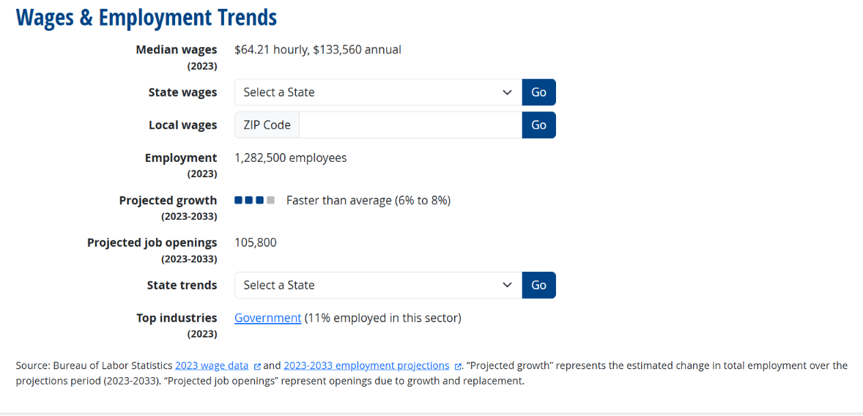

11-9199.01: Regulatory Affairs Managers *Bright Outlook
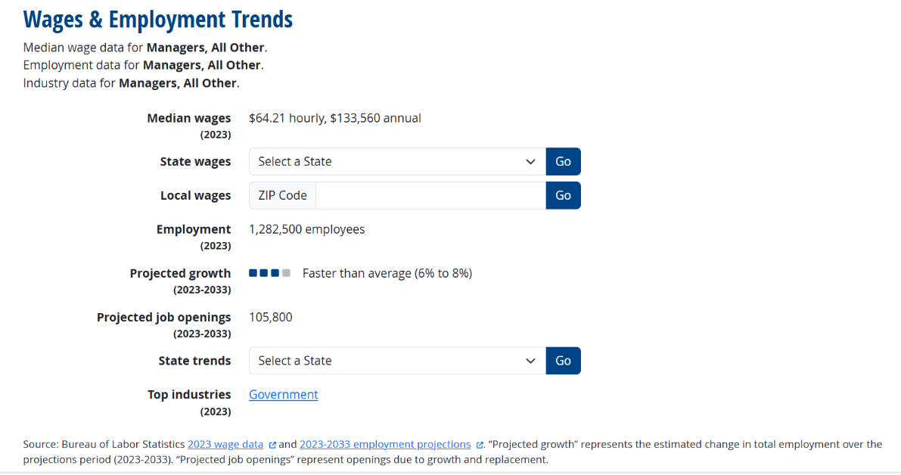
11-9199.02: Compliance Managers *Bright Outlook
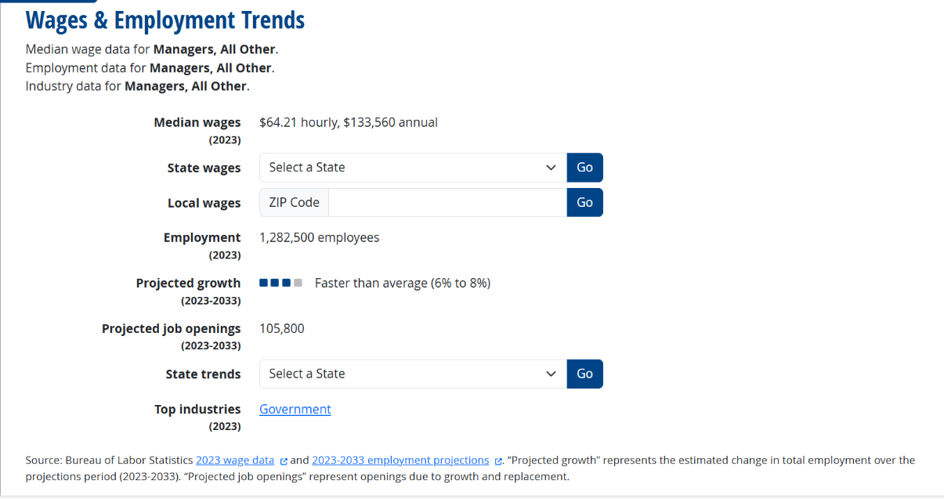

11-9199.08: Loss Prevention Managers *Bright Outlook
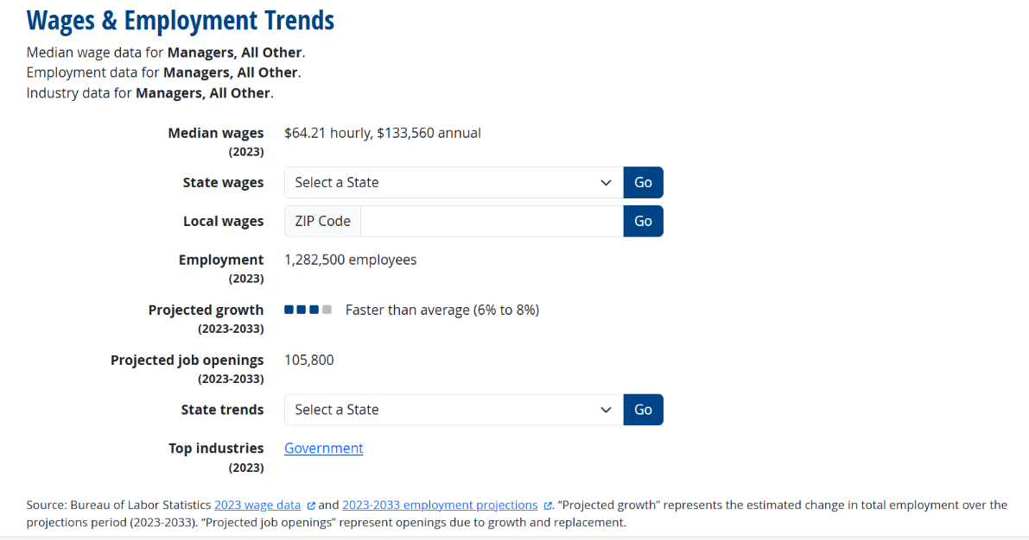
25-1111.00: Criminal Justice and Law Enforcement Teachers, Postsecondary
33-1012.00: First-Line Supervisors of Police and Detectives

Source: Bureau of Labor Statistics, Employment by major industry sector.
Retrieved from Education Crosswalk Search https://www.onetonline.org/crosswalk/CIP/?s=430103

III. NJ/NY local projections of the occupations
NJ Department of Labor & workforce development statewide industry & occupation employment projection will raise.

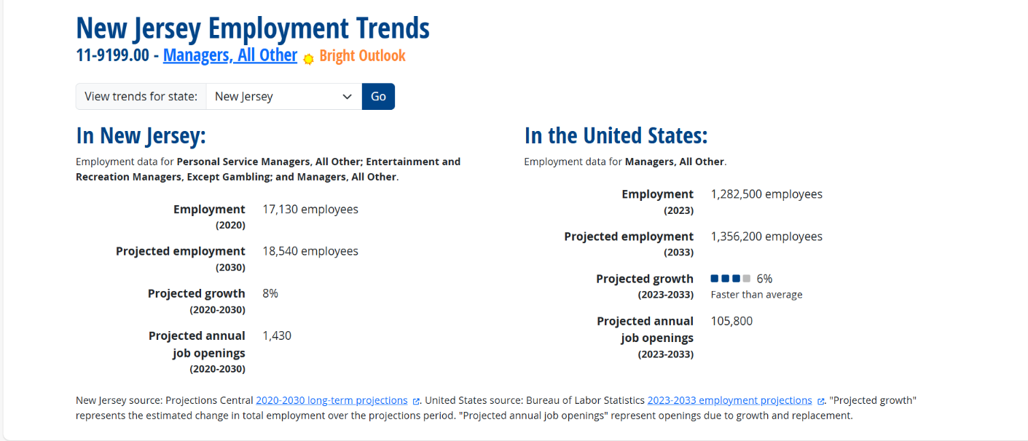

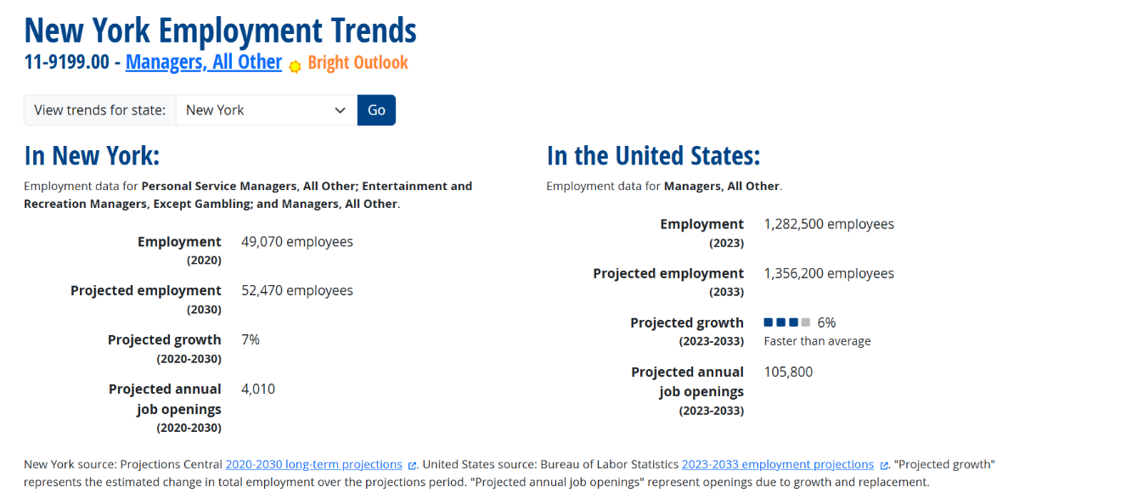

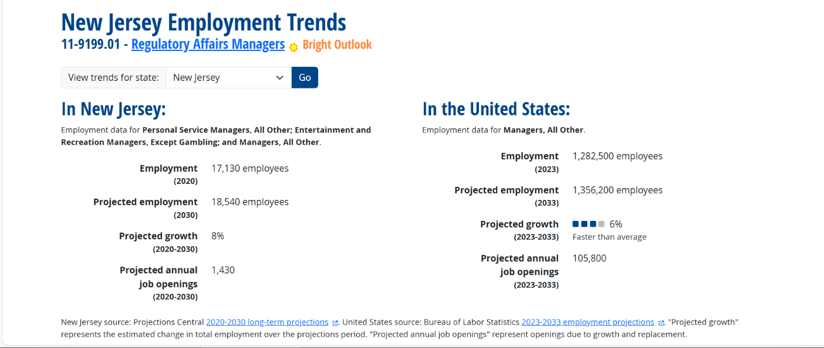

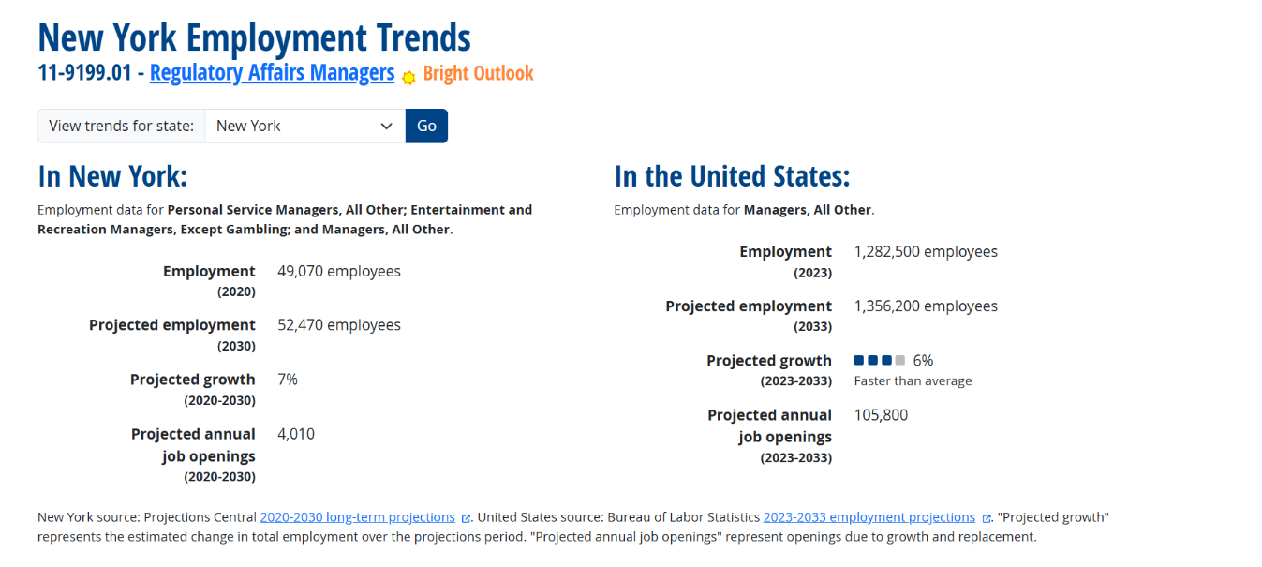

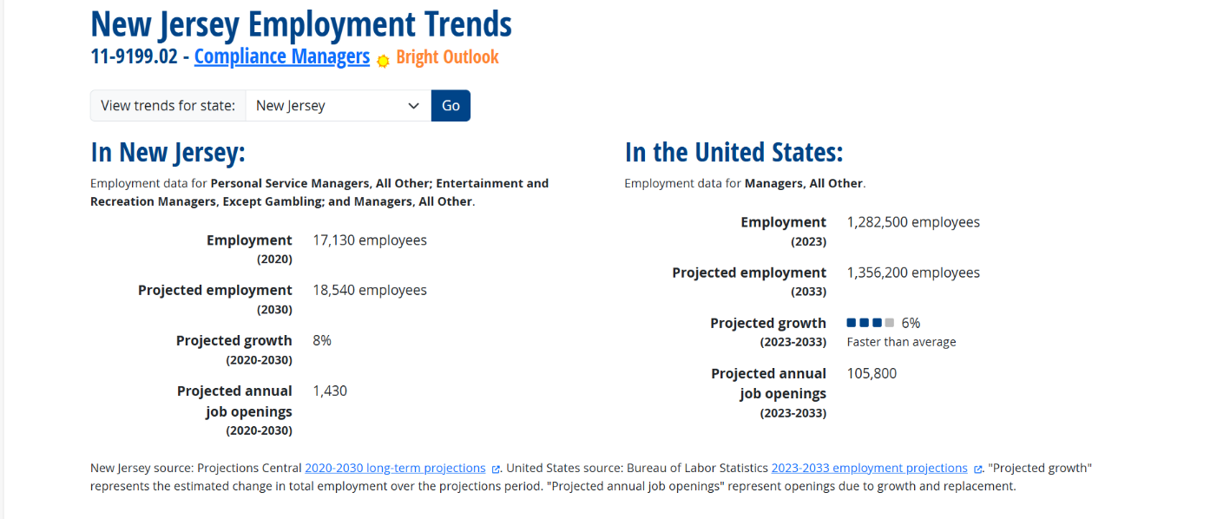

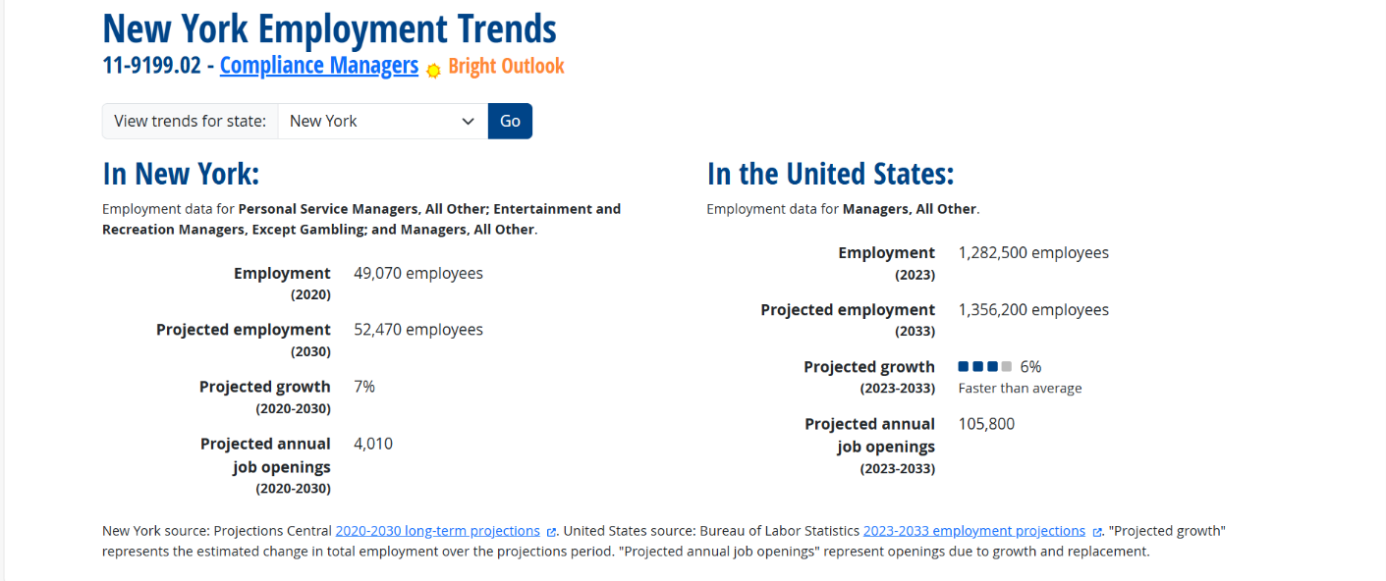

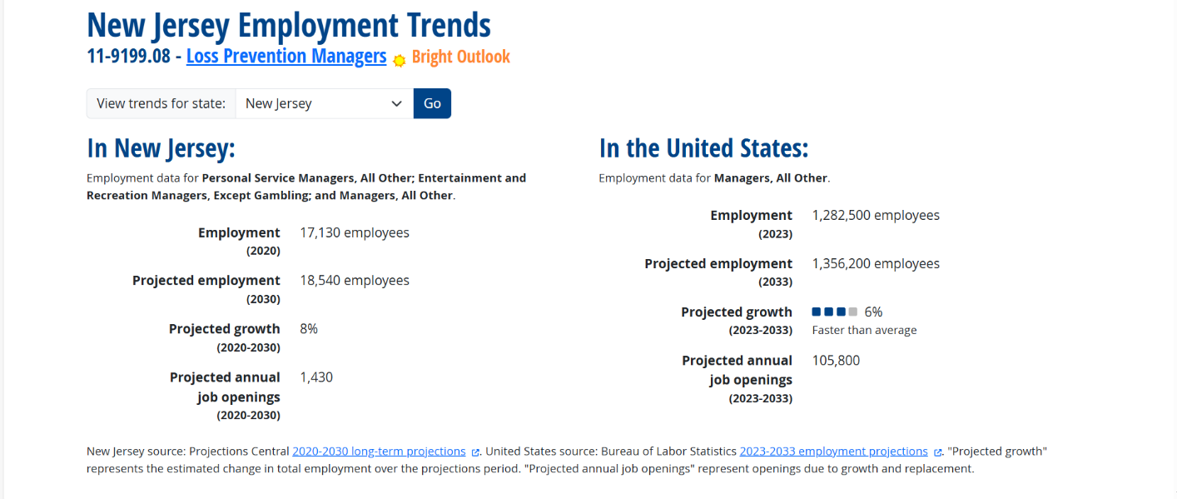

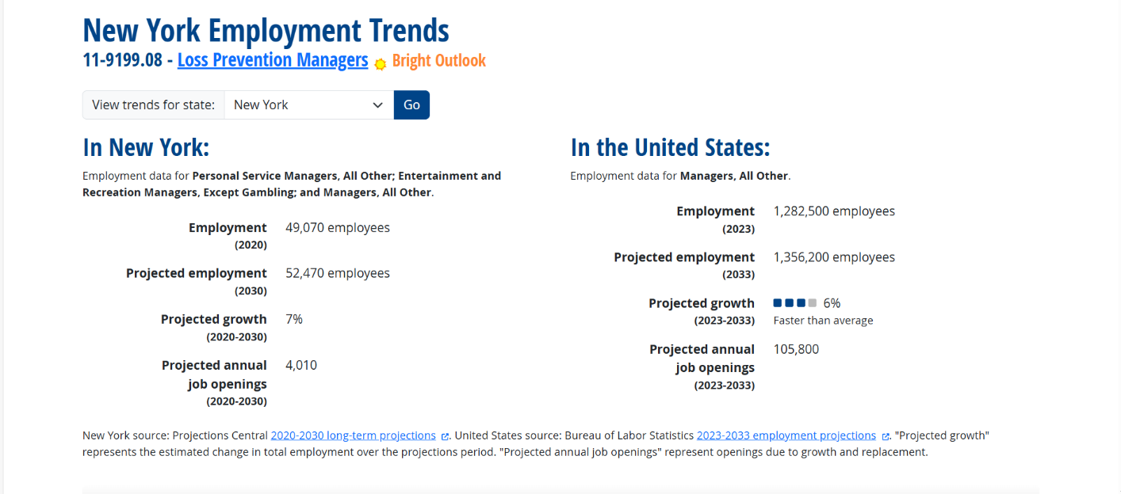

- List similar programs within the state and in neighboring states and compare this program with those currently being offered
Our new MA in CJ - Administration of Justice Option is unique because it focuses on a mix of criminal justice and public affairs courses.
Saint Elizabeth University (NJ) | M.A. in Justice Administration and Public Service
Penn State University (PA) | Administration of Justice, B.S.
University of Pittsburgh (PA) | Administration of Justice, BA
- Students – Estimate anticipated enrollments from the program's inception until a steady state or optimum enrollment is reached
We expect that the first and second cohorts will be 10-20 students. In two years, it is expected that the enrollment will reach 30-50, which would be the optimal enrollment with the existing resources. Within five years from the inception of the program, our goal is to have 75 students. By the time, we expect that additional resources will be supplied without difficulty.
We believe that active collaborations with the internal and external recruiting professionals and offices will make these estimations realistic figures.

7. Program resources
- Full-time faculty
There are 12 full-time faculty whose expertise is in criminal justice and public affairs under the Department of Criminal Justice and Public Affairs at the Union campus. Currently, they are heavily involved in teaching undergraduate and graduate courses.
All classes and curriculum related activities will be held in Hynes Hall, CBPM’s main building.
The following table lists the key full-time faculty who will be teaching the key courses for the program

Table 6: Full-time Faculty
Faculty | Specialty | Key Courses
Dennis Bogdan | Corrections, Policing | CJ5690, CJ5740
Ketty Fernandez | Theories | CJ5670
Thomas Lateano | Law | CJ5600
Patrick McManimon | Corrections, Theories | CJ5690, CJ5670
Alexander Sepulveda | Law | CJ5600
Roseanne Mirabella | Nonprofit, Community Engaged Learning | PA5001, PA5990
Greg Witkowski | Disaster Mgt, Philanthropy | PA5911
Bok Gyo Jeong | Nonprofit, Research Methods | PA5988, PA5990
Jung Ah (Claire) Yun | HRM, Leadership, Financial mgt | PA5250, PA5110
Ngoc Dao | Public Policy, Public Budgeting | PA5020, PA5040
Carey Brown | Policy Analysis, HRM | PA5110, PA5020
Yeonkyung Kim | MIS, AI, Data Visualization | PA5245, PA5984

II. Part-time Adjunct Faculty
We have a good number of adjunct professors who are qualified to teach both fields but to supplement the current full-time faculty, we expect to recruit more adjunct faculty who are equipped with modern industry trends in these two areas.

8. Degree Requirements
The program option requires 36 credits to graduate. Students will first complete PA5001 (Global Foundations of Public Administration) and finish with PA5990 (Capstone Seminar). Students are required to complete the PA5988 Analytical Methods in Public Management to equip students with knowledge and practical skills related to research methods before taking PA5990 Capstone Seminar course.

REQUIRED COURSES – CORE 30 CREDITS
 |  |  |  | Credits
PA5001 or CJ5620 |  | Global Foundations of Public Administration or Foundations of Criminal Justice *Take in your first semester* |  | 3
CJ5600 |  | American Legal System |  | 3
CJ5670 |  | Theories in Crime and Delinquency |  | 3
CJ5690 |  | Corrections |  | 3
CJ5740 |  | Police in Society |  | 3
CJ5610 |  | Research Methods |  | 3
PA5245 or PA5984 |  | Managing Information Systems in PA  AI, GIS, & Data Visualization |  | 3
PA5988 |  | Analytical Methods |  | 3
ID5801 |  | Thesis Option |  | 6
ELECTIVES – 6 CREDITS
Any other PA or CJ grad classes not listed above (e.g.PA5XXX or CJ5XXX) may be taken as an elective
 |  |  |  | 3
 |  |  |  | 3
*Students who do not have an undergraduate degree in criminal justice, must take CJ5620*
*Students who have an undergraduate degree in criminal justice, must take PA5001*

D. Admission Requirements
- Cumulative grade point average (GPA) of 3.2 (lower GPA’s will be considered based on overall strength of application)
- Two letters of recommendation (at least one from a previous professor)
- Departmental interview may be required
- Writing sample may be required

E. Administrative Structure
The Department of Criminal Justice and Public Affairs at Kean University is the primary department that will administer the MA in CJ - Administration of Justice Option. The main decision about the program will be made by the graduate admission committee under the Department of Criminal Justice and Public Affairs with the consultation of the College of Business and Public Management and the curriculum committee of the CBPM board of advisors.

1. Cooperating Department
N/A
2. Licensure/Certification Requirements
There are no licensure or certification requirements for this MA in CJ Administration of Justice Option.

F. References
Source: Bureau of Labor Statistics, Employment by major industry sector.
Retrieved from Education Crosswalk Search https://www.onetonline.org/crosswalk/CIP/?s=430103

Department of Criminal Justice and Public Affairs
Department Vote for New Program Option
Approvals for Master of Art in Criminal Justice Administration of Justice Option

Majority vote: 4
Master of CJ - Administration of Justice Option
Total Vote
Yes | 4
Yes w/ edits | 0
No | 0
Abstain | 0
Absent | 0

Last Name | First Name | email | Yes | Yes w / edits | No | Abstain | Initials | Date
Lateano | Thomas | tlateano@kean.edu | X |  |  |  | TL | 12/11/25
Yun | Jung Ah (Claire) | jyun@kean.edu | X |  |  |  | JY | 12/11/25
Dao | Ngoc | ndao@kean.edu | X |  |  |  | ND | 12/11/25
McManimon | Patrick | pmcmanim@kean.edu | X |  |  |  | PM | 12/11/25

