Fieldwork Educator’s Manual
Department of Occupational Therapy
Kean University
Patricia Higgins MS, OTR/L
Academic Fieldwork Coordinator
(908) 737-5853
fax (908) 737-5855
otfieldwork@kean.edu

Kean University
Department of Occupational Therapy
1000 Morris Avenue
East Campus 224D
Union, NJ 07083
(908) 737 5850

Contents
Dear Fieldwork Educator 4
Kean University’s Fieldwork Program- An Overview 5
Kean University Occupational Therapy Curriculum 7
Kean University Mission Statement Kean University (2007) 7
Nathan Weiss Graduate College Mission Statement 7
Department of Occupational Therapy Vision 8
Department of Occupational Therapy Mission 8
Curriculum Threads 10
Fieldwork Courses at Kean University 12
Level I Fieldwork Courses and Relationship to Curriculum Design 12
Level II Fieldwork Courses and Relationship to Curriculum Design 13
Fieldwork Participants 13
Fieldwork Course Objectives 15
Level I Fieldwork Objectives 15
Level II Fieldwork Objectives 15
Site Specific Learning Objectives 15
Getting Started 19
Fieldwork Site Development 19
Contracts and Memorandum of Understanding 20
Fieldwork Scheduling 20
Malpractice Insurance 20
Supervision and Licensure 20
Student Contact Information 21
Departmental Policies 21
Tardiness & Absences 21
Site Visits 21
On-campus Meetings 22
Conflict Resolution 22
Termination 22
Infection Control Policy 22
Safety Policy and Incident Reporting 22
Requesting Accommodations and ADA 22
Student Privacy 23
Learning Styles and Learning Contracts 23
Evidence Based Practice Error! Bookmark not defined.
Evaluation of Student and Fieldwork Site 23
Evaluation of Student Performance 23
Evaluation of Fieldwork Experience 24
Verification of Service as a Fieldwork Educator for Professional Development 24
Resources for Fieldwork Educators 24
References 24
Appendices 27
Appendix A: Kean University Program Contact Information 28
Appendix B: KUOT Program and Potential Fieldwork site Congruency Rating Scale 29
Appendix C: Articulation of Agreement 30
Appendix D: Student Clinical Agreement 31
Appendix E: Student Exposure Incident/Injury Report 33
Appendix F: Kean University Level I Fieldwork Educator Evaluation of Student Performance 33
Appendix G: AOTA’s Fieldwork Performance Evaluation for the Occupational Therapy Student 38
Appendix H: Kean University Level I Student Evaluation of Fieldwork Experience 42
Appendix I: AOTA Student Evaluation of Fieldwork Experience (SEWFE) 50

Rev. 12.2019

Dear Fieldwork Educator,
The faculty and staff at Kean University appreciate your time and dedication in fulfilling the role as fieldwork educator. In this role you will help develop a student’s professional identity and shepherd him or her through the evolution from student to entry –level practitioner. Your role as fieldwork educator helps to shape to the profession of occupational therapy and the American Occupational Therapy Association’s Vision of 2025: We envision that occupational therapy is an “inclusive profession” (para 1.) that “maximizes health, well-being, and quality of life for all people, populations, and communities through effective solutions that facilitate participation in everyday livings”; the pillars that define and communicate the Vision’s core include effective, leaders, collaborative, accessible, equity, inclusion, and diversity (American Occupational Therapy Association, 2019).
Faculty and the academic fieldwork coordinator collaborate with fieldwork educators to develop learning objectives to implement current assessment and treatment techniques to provide quality evidence based care. This collaboration facilitates communication to effectively integrate fieldwork experiences with Kean’s curriculum.
There are many benefits to being a KU fieldwork educator.
- The role encourages therapists to enhance their teaching, evidence based practice knowledge base, leadership and communications skill set.
- Fieldwork education also serves as a vehicle in improving clinical reasoning skills because as we teach others, we strengthen our understanding of knowledge and skills (Hanson, 2012).
- These experiences may provide a potential for future recruitment of quality employees and opportunity to give back to the educational community.
- You will be provided with access to our online databases and journals for a period of six months so you can access evidence to support your interventions and professional growth.
- Fieldwork supervision can also be counted as professional development credits for NBCOT or licensing bodies.
- You will be given advanced notice of future workshops and educational programs pertaining to fieldwork. At least one of the workshops will be free of charge for fieldwork educators who are currently accepting our fieldwork students.
We look forward to creating, and/or maintaining a strong collaboration with you as we view your contribution as a vital part of each student’s development. Please feel free to contact us as you have questions or concerns.
Thank you,

Patricia Higgins MS, OTR/L
Academic Fieldwork Coordinator
908 737 5853
otfieldwork@kean.edu

Kean University’s Fieldwork Program- An Overview
The Accreditation Council for Occupational Therapy Education (ACOTE, 2018) states fieldwork experiences are an integral part of occupational therapy education and critical for the development of students from their student role to that of an entry level practitioner. Kean University students are provided educational opportunities in professional settings under the supervision of a professional (level I) or a qualified occupational therapist role model (level I and level II). The Department of Occupational Therapy at Kean University views the fieldwork educators they collaborate with as an extension of the department faculty. As such, it is vital that both the fieldwork educator and faculty have mutual understanding of each other’s programs and goals.
We require that students participate in three level I fieldwork experiences and two level II fieldwork experiences. An optional third level II experience in a specialty area of practice is available for students who desire it. These fieldwork experiences provide students with opportunities to apply and integrate academic knowledge and theory in real world practice. These experiences will facilitate student development as a reflective, self-aware, self-directed entry-level occupational therapist.
Level I fieldwork experiences typically occur in the second year of our program in the bridge to practice curriculum stage (Figure 1). Students are required to take (1) Seminar in Psychosocial Practice (2) Seminar in Adult Rehab Practice and (3) Seminar in Pediatric Practice with a level experience embedded within each class. These level I experiences require a minimum of 60 hours, and are designed as once a week attendance at a professional site. Each seminar’s syllabus and fieldwork manual outlines the specific learning objectives and assignments for the level I experience.
After completing all of the required academic course work (end of the 2nd year of program) in the occupational therapy program curriculum, students are eligible to begin level II fieldwork experiences. The Standards for an Accredited Educational Program for the Occupational Therapist set forth by the Accreditation Council for Occupational Therapy Education (ACOTE, 2018) identify a minimum of 24 full time equivalent weeks of level II fieldwork. After successful completion of all level II experiences, the student is eligible for the National Certification Exam administered by National Board for the Certification of Occupational Therapists, Inc. (NBCOT, 2008). Students must complete fieldwork requirements within 24 months following completion of all academic work.
The ACOTE Standards for an Accredited Program for Occupational Therapy Education (2018) recommend that the student be exposed to a diverse group of people in multiple settings. Fieldwork may take place in traditional, nontraditional and/or emerging areas of practice. Emerging areas of practice may include a community and social practice model such as a psychosocial rehabilitation program, a well elderly program or working with the homeless population. Kean University students complete level II fieldwork experiences in two different areas of practice.

Figure 1: Department of Occupational Therapy Curriculum Stages

Kean University Occupational Therapy Curriculum

Kean University Mission Statement- Kean University (2018)
Kean University is a public cosmopolitan university serving undergraduate and graduate students in the liberal arts, the sciences, and the professions. The University dedicates itself to the intellectual, cultural, and personal growth of all its members — students, faculty, and professional staff. In particular, the University prepares students to think critically, creatively and globally; to adapt to changing social, economic, and technological environments; and to serve as active and contributing members of their communities.
Kean offers a wide range of demanding programs dedicated to excellence in instruction and academic support services necessary to assure its socially, linguistically, and culturally diverse students the means to reach their full potential, including students from academically disadvantaged backgrounds, students with special needs, and adults returning or entering higher education.
Kean is steadfast in its dedication to maintaining a student-centered educational environment in which diversity can flourish and an atmosphere in which mutual respect characterizes relations among the members of a pluralistic community. The University seeks to combine excellence with equity in providing opportunities for all students.
Kean is a teaching university, and Kean faculty dedicate themselves to student learning as well as academic rigor. The focus on teaching excellence is supported by a commitment to research, scholarship, creative work, and innovative uses of technology. The focus includes the advancement of knowledge in the traditional disciplines and the enhancement of skills in professional areas. Kean is committed to providing global educational opportunities for students and faculty.
Kean is an interactive university, and the University serves as a major resource for regional advancement. Kean collaborates with business, labor, government and the arts, as well as educational and community organizations and provides the region with cultural events and opportunities for continuous learning. Kean is also committed to providing students and faculty educational opportunities in national and international arenas.
Nathan Weiss Graduate College Mission Statement
The Nathan Weiss Graduate College supports the mission and goals of the University through graduate education, research and continuing education. Through comprehensive graduate programs, dedicated faculty promote the mastery of academic disciplines and their applications at an advanced level. We foster the development of ethical and effective leadership in the professions in an increasingly complex, diverse, and technological society. WE also provide research opportunities for faculty and students and are committed to meeting the changing education and professional developmental needs of the region.

Department of Occupational Therapy Vision
By 2025, the graduates of our masters and doctoral degree programs will excel in entry-level practice. Through creative programming and active learning opportunities, students will become leaders who serve society. Our graduates will create change through evidence based innovative practice.

Department of Occupational Therapy Mission
The mission of the Kean University Occupational Therapy Program is to develop entry-level occupational therapists who will utilize clinical reasoning skills to think creatively, critically, and holistically to deliver occupation-based practice to increase health, wellbeing and quality of life.

We promote professional growth, lifelong learning and interprofessionalism through leadership, scholarship, and/or creative works. Through collaboration with local, national and global community partners, we create unique learning and service opportunities to meet the needs of a changing social, economic and technological environment.

We seek to create excellence through a diverse and inclusive student body in support of a culturally competent workforce meeting the occupational needs of society.

Contact information for the Department of Occupational Therapy can be found in Appendix A.
Figure2: Kean University Department of Occupational Therapy Curriculum Threads

Curriculum Threads
Kean University’s Occupational Therapy (KUOT) curriculum has four specific threads that are embedded in each course and within all aspects of the professional phase of the program.
- Clinical reasoning
- Professionalism
- Scholarship
- Community Relationships
1. Clinical reasoning
The Occupational Therapy Practice Framework (OTPF) defines clinical reasoning as “a complex and multilevel cognitive process used by practitioners to plan, direct, perform and reflect on interventions” (AOTA, 2008, p.666). Clinical reasoning is also defined as an interaction between the client and practitioner that is influenced by each party’s social/historical/cultural context and the practice context of the interaction (Higgs & Jones, 2008).
Our curriculum is designed to develop our students’ clinical reasoning skills to the level of an entry level OT practitioner. In each class, students are given the opportunity to reflect on their problem solving, decision making and performance. Case presentations encourage students to experiment with new concepts and develop clinical reasoning skills in a safe, supportive environment. The service learning, Level 1 and Level 2 fieldwork experiences will provide opportunities to implement programs and interventions in real circumstances and then reflect on those performances.
2. Professionalism
Professionalism is defined as “internalized attitudes, perspectives, and personal commitment to the standards, ideals, and identity of a profession” (Spurill & Benshoff, 1996, as cited in Kasar & Clark, 2000). Yerxa (1966) states that “professionalism is much more than appearance and intellectual accomplishments. It means being able to meet real needs. It means having and acting upon a philosophy. It also means being ‘authentic’” (p. 127). The faculty and staff are dedicated to modeling and shaping professionalism, as we believe this is one of the most important contributors to success in the classroom and clinical practice. In order to ensure each student is demonstrating professional behavior throughout his or her academic career and into entry level practice, every course has a mechanism for evaluation of professional behaviors (i.e., class participation, professionalism form, fieldwork I & II evaluations).
The American Occupational Therapy Association (AOTA) outlines the expected professional behaviors for entry level practice in its Fieldwork Performance Evaluation for the Occupational Therapy Student form. These behaviors include, but are not limited to: collaboration with supervisor, responsibility for learning opportunities, ability to receive constructive criticism, positive interpersonal skills and respect for diversity. Upon completion of Level II fieldwork, students’ performance in professional behaviors must “meet standards,” which is defined as “consistent with entry-level practice.”

3. Scholarship
Scholarship encompasses activities that demonstrate students’ understanding the importance of seminal literature, current research evidence and how it supports, guides and develops new knowledge for the practice of occupational therapy; the ability to form a clinical question then search for the best and most current evidence, the ability to critically appraise the evidence and use it to make clinical decisions (AOTA, 2012). Vision 2025 calls for occupational therapists to be evidence based through the engagement of, and ongoing critical inquiry of research, to blend scientific evidence to promote occupation based practice (AOTA, 2018). In doing so we become widely recognized and valued among other healthcare professionals and to the people and society we serve (AOTA, 2007).
Our curriculum is designed to introduce, develop and foster the appreciation of, and ability to use research and scholarship to promote the efficacy and visibility of occupational therapy. In each course, research evidence and scholarship are woven into the readings, discussion and assignments to move from the level of recall to the higher cognitive level of creation (Anderson, 2001) of a scholarly project. Students learn to understand appropriate design issues and apply quantitative and/or qualitative scientific methodology to answer a research question or query. The scholarship of discovery culminates in a research project demonstrating students’ ability to integrate the research process and disseminate the end product in a formal presentation. Scholarship entails integration of knowledge across disciplines, application of knowledge in practice and to meet societal needs at the community and organizational levels (contexts). Students use the evidence to learn about theory, protocols, and innovative treatment and use the evidence to enhance assessment and intervention in course work, and Level I and II Fieldwork experiences. The focus of the integration of scholarship within each course is to cultivate students’ skills to appraise, use and contribute to the effectiveness of occupational therapy beyond graduation and as a foundation for lifelong inquiry and discovery to promote and support the profession.
4. Community Relationships
“The everyday life of a community, its mix of people, their needs, concerns, joys and struggles, offers an unparalleled opportunity to define our discipline, research its potential and extend its boundaries well beyond the current limits of our medically based practice” (Fidler, 2001, p.8). Occupational therapists have a unique skill set to discover the needs of people we serve and to facilitate positive client and community centered change towards meaningful participation in occupations (Fazio, 2008; Scaffa, 2001). We do so as individual practitioners, but most often with a variety of interprofessional partners, through the collaboration among the families in early intervention and home care, medical team members (nurses, physicians, physical and speech language therapists, social workers), in schools (teachers, paraprofessional, parents) and with community leaders and professionals (senior citizen housing directors, recreation professionals, business owners).
This curriculum is designed to provide the student with learning opportunities to develop the student’s active and contributory relationship to the community. Coursework will expose the students to a vast array of experiences in which service is provided to meet the needs of individuals, organization or populations within community settings. For example, guest lectures will be provided, throughout the curriculum, from experts in current and emerging practice areas (driving, low vision, NICU), and people with different abilities (disability awareness, perspectives from people with stroke, amputations, mental illness) will share their experience and insights into the influence of occupation and occupational therapy on their lives. Additionally, infused within many of the courses are assignments designed to provide you with an opportunity to research, create and deliver intervention with people from the university and local community. For example, many students will have the opportunity to provide educational courses for people with mental health issues within your first year in the program.

Fieldwork Courses at Kean University

Level I Fieldwork Courses and Relationship to Curriculum Design
OT 6920/7920 Seminar in Psychosocial Practice – Level I
Course Description:
Students will apply foundational knowledge gained in the first year of the occupational therapy program. Students will use clinical reasoning to select practice models and/or frames of references pertaining to psychosocial practice to guide screening, assessment, and intervention planning using the best available evidence. As part of this course, students will successfully complete a mandatory level I fieldwork community placement.
OT 6921/7921 Seminar in Adult Rehab Practice – Level I
Course Description:
Students will apply foundational knowledge gained in the first year of the occupational therapy program. Students will use clinical reasoning to select practice models and/or frames of reference pertaining to adult rehab practice to guide screening, assessment and intervention planning using the best available evidence. As part of this course, students will successfully complete a mandatory level I fieldwork community placement.
OT 6923/7923 Seminar in Pediatric Practice – Level I
Course Description:
Students will apply foundational knowledge gained in the first year of the occupational therapy program. Students will use clinical reasoning to select practice models and/or frames of reference pertaining to pediatric practice, to guide screening, assessment and intervention planning using best available evidence. As part of this course, students will successfully complete a mandatory level I fieldwork community placement.

Relationship to the Curriculum Design:
The seminars in psychosocial, adult rehab and pediatric practice are taken during the second year of the program and during the Bridge to Practice curriculum stage. The course material and discussions are intertwined with relevant level one fieldwork experiences one day per week over the course of the semester. Students build on previously acquired knowledge to evaluate, design and adapt evidence based client centered intervention in class and during level one fieldwork experiences. Students continue to develop their professional identity in a professional setting and all stakeholders, interprofessional partners and potentially families. These courses equip students with the professional, academic and treatment planning skills required for successful integration of skills during Advanced Fieldwork Seminar (level II fieldwork) taken during the Practice stage of the curriculum.

Level II Fieldwork Courses and Relationship to Curriculum Design
OT 6960/7960 Advanced Fieldwork Seminar I- Level II
Course Description:
This seminar is a bridge for students to apply their knowledge, skills and attitudes developed during academic preparation into settings where occupational therapy services are provided. As students assume the role as an entry level practitioner, they will be supervised by a qualified occupational therapist over a minimum of 12 weeks. This course (the first of two) must be successfully completed within 24 months following completion of academic preparation.
OT 6961/7961 Advanced Fieldwork Seminar II –Level II
Course Description:
This seminar is a bridge for students to apply their knowledge, skills and attitudes developed during academic preparation into settings where occupational therapy services are provided. As students assume the role as an entry level practitioner, they will be supervised by a qualified occupational therapist over a minimum of 12 weeks. This course (the second of two) must be successfully completed within 24 months following completion of academic preparation.
Relationship to the Curriculum Design:
Advanced Fieldwork I and II are the final stage on the student’s bridge to practice. These courses are taken after the successful completion three level I fieldwork experiences. Students demonstrate competency in and internalize occupational therapy values, assessment and intervention procedures while collaborating with interprofessional partners. Students must successfully pass this course in order to take the Certification Examination given by the National Board for Certification in Occupational Therapy, Inc and become entry level occupational therapy practitioners.

Fieldwork Participants
Student
Students must be enrolled in specific fieldwork courses and have completed any prerequisite courses. Students are responsible for self-directed learning with guidance from the fieldwork educator and support from the course instructor and/or academic fieldwork coordinator. Students are expected to engage in proactive professional communication and problem solving throughout their fieldwork experiences. Self-awareness and self-reflection are an important part of learning and required to identifying learning style and areas for growth.
Fieldwork Educator
Level I
In accordance with ACOTE standards level I fieldwork educators may be an occupational therapist or other allied health professional (social worker, physical therapist, nurse, speech therapist, recreational therapist, etc.). The level I fieldwork educator’s role is to provide supervised learning experiences to increase student’s awareness and comfort in a clinical or professional setting, with clients, and therapeutic interventions. There are no minimum experience requirements for level I fieldwork educators.
Level II
ACOTE requires level II fieldwork educator to be an occupational therapist and have at least one year of practice experience. The fieldwork educator must provide onsite supervision at least 8 hours per week. ACOTE standards do allow for partial supervision by a certified occupational therapy assistant as applicable. The fieldwork educator provides guided active learning experience to allow students to cross the bridge from classroom to practice, student to professional. Fieldwork educators must consider the student(s) learning style and pace of learning opportunities to facilitate a progressive increase in professional responsibilities culminating in the student(s) performing at an entry level caseload by experience end.
Level I - Seminar Instructors
Seminar instructors act as the coordinators for level I fieldwork education and collaborate with the level I fieldwork educators who, on site, design well integrated learning experiences. The students level I midterm and final evaluations completed by the on-site fieldwork educators and are included in course grading.
Level II- Academic Fieldwork Coordinator
The academic fieldwork coordinator (AFWC) is the Kean University staff member responsible for all policies and processes related to fieldwork experiences. AFWC responsibilities include identifying and securing fieldwork sites, maintaining student and site files, and collaborating with fieldwork educators and students to provide quality fieldwork experiences and foster collaboration between the university and professional settings. The AFWC is also responsible for ensuring Kean University is in compliance with ACOTE fieldwork education requirements. The AFWC assists and guides students in the selection of fieldwork placements that match their learning style and needs. Additionally the AFWC collaborates with fieldwork educators to support their fieldwork programs and plans continuing education related to fieldwork education. During the level II fieldwork experience the AFWC is the student(s)’ academic advisor and counsels and arbitrates with the student(s) and fieldwork educator(s). The AFWC is considered the course instructor and is responsible for inputting grades.

Fieldwork Course Objectives

Level I Fieldwork Objectives
The objectives for Level I Fieldwork experiences are outlined in the corresponding seminar’s syllabus. Syllabi and Level I fieldwork manuals are provided by the course instructor to both the student and fieldwork educator.

Level II Fieldwork Objectives
KU level II fieldwork objectives, in general, are designed so that upon completion of this course, the student will be able to:
- Maintain safety of self and others throughout the occupational therapy process.
- Adhere to appropriate regulatory standards for ethical decision making in all interactions.
- Articulate the scope of occupational therapy practitioners to clients and interdisciplinary partners.
- Collaborate with client, or significant other, to gather data for occupational profile.
- Select and administer relevant holistic assessment procedures based upon the Occupational Therapy Practice Framework (OTPF).
- Modify assessment procedures and employ therapeutic use of self-based upon client’s needs, behavior, culture and contexts to plan intervention.
- Apply theoretical guidelines to interpret data, and establish and document intervention plans.
- Utilize best available evidence to support the use of preparatory, purposeful and occupation based treatment intervention.
- Evaluate and document client response to intervention.
- Modify activities and environment to maximize client’s performance in meaningful occupation.
- Modify and/or terminates the intervention plan as needed.
- Demonstrate clinical reasoning throughout the process of service delivery in order to facilitate occupational performance.
- Understand the roles and responsibilities of occupational therapist, occupational therapy assistant and/or aide and delegate duties as applicable.
- Demonstrate understanding of the costs and funding related to occupational therapy services at the site.
- Meet treatment and documentation responsibilities in accordance with ethical and regulatory standards for entry level practice.
- Communicate professionally with others.
- Demonstrate autonomy in learning by setting learning objectives and collaboratively working with others to achieve them.
- Incorporate constructive feedback provided by others for professional growth.
- Demonstrate positive interpersonal skills and respect for diversity in all communication and interactions.
- Identify and integrate relevant psychosocial factors and the impact they have throughout the service delivery process

Site-Specific Learning Objectives
Site specific learning objectives are developed collaboratively by the on-site fieldwork educator and the AFWC. Please contact Patricia Higgins at otfieldwork@kean.edu to collaborate on establishing or revising your fieldwork site’s learning objectives. Site specific learning objectives are kept in the fieldwork site files in the Department of Occupational Therapy. Students are responsible for reviewing these as well as previous students’ assessment of the sites prior to beginning their fieldwork experience.
Content Supporting Level II Learning Objectives (NOTE: each fieldwork site may utilize its own fieldwork curriculum, this content is a general suggested overview and is by no means exhaustive)
- Facility Safety Procedures
  - Types of diagnoses and ages/populations served
  - Precautions/contraindications and safe techniques
  - Policies and procedures of facility including emergency and safety procedures
- Ethical Guidelines for Practice
  - American Occupational Therapy Association (AOTA) code of ethics
  - Federal, state and local regulatory and ethical standards
- Scope of Occupational Therapy
- Role
- Scope
- Responsibilities
- Occupational Therapy Practice Framework (OTPF)
- Licensure and/or state regulatory laws
- Principles of Client-Centered Care
  - Interview
  - Observation
  - Establishment and maintenance of therapeutic relationship
- Assessment
  - Occupational Therapy Practice Framework (OTPF)
  - Occupational profile
  - Analysis of Occupational Performance
    - Performance skills
    - Performance patterns
    - Client factors
    - Activity demands
    - Contexts and environments
  - Types of data gathering techniques
  - Appropriate administration of evaluation tools and procedures, and rational for use
  - Interviewing of clients, caregivers and significant others
- Adaptation of Therapeutic Approach
- Assessment
- Intervention
- Client Needs, behavior, culture and contexts
- Theoretical Guidelines for Evaluation and Intervention
  - Practice models and frames of reference
  - Establishment and documentation of measurable short and long term goals
  - Establishment and documentation of intervention plan, including:
- Therapeutic use of self
- Therapeutic use of activity and occupation
      - Preparatory activity
      - Purposeful activity
      - Occupation based activity
- Consultation process
- Education process
- Advocacy process
  - Evidence based practice
- Evidence Based Practice
  - Best available evidence
- Textbooks
- Journals
- Websites
  - Therapeutic use of activity and occupation
- Preparatory activity
- Purposeful activity
- Occupation based activity
  - Client factors impacting treatment intervention
- Evaluation and Documentation of Intervention
  - Occupational Therapy Practice Framework (OTPF)’s intervention review
  - Required facility documentation
- Daily contact note
- Progress note
- Discharge summary (as applicable)
- Interaction between Person, Occupation and Environment
- Compensation
- Adaptation
  - Environment
    - Physical
    - Social
  - Activity
    - Gradation
      - Upgrade
      - Downgrade
    - Modification
      - Sequence
      - Time requirement
- Intervention Plan
  - Factors determining client has received maximum benefit of services
  - Termination of intervention plan
  - Documentation of discharge and follow up programs and services to support occupational performance
- Clinical Reasoning
  - Types
    - Scientific
    - Pragmatic
    - Narrative
    - Procedural
    - Interactional
    - Conditional
    - Ethical
  - Interaction between occupational therapist and client
  - Interaction between occupational therapist and environment
  - Interaction between client and environment
- Roles and Responsibilities
  - Occupational therapist (OTR)
  - Occupational therapy assistant (OTA)
  - Rehab aide
  - Delegation of responsibilities
- Fiscal Considerations
  - Costs
    - Indirect
    - Direct
  - Funding
    - Private
    - Public
    - Grants
- Administrative and Clinical Responsibilities
  - Effective management of time to meet established deadlines
  - Appropriate rationale for establishment of, or adjustment of, priorities according to the need of the client and setting
  - Compliance in billing procedures
  - Standards and code of ethics
- Professional Communication
  - Effective communication skills
    - Verbal
    - Nonverbal
  - Communication with fieldwork educators, clients, interdisciplinary partners
- Self Directed Learning
  - Learning objectives, with corresponding goals and plans (if applicable)
  - Expectations of responsibility for supervisory relationship
  - Assertive communication
- Constructive Feedback
  - Listening
  - Understanding feedback
  - Self awareness of strengths and areas for improvement
  - Incorporation of feedback
- Respect for Diversity
- Gender
- Culture
- Sexual orientation
- Psychosocial Factors
  - Assess psychosocial factors
  - Explore impact on occupational engagement

Getting Started

Fieldwork Site Development

Fieldwork sites are established through the following process:
- Academic fieldwork coordinator identifies or is notified of a potential fieldwork site.
- The academic fieldwork coordinator contacts the designated person at the fieldwork site to arrange a meeting.
- At the meeting, the academic fieldwork coordinator will discuss our mission, vision, curriculum design, learning objectives. In turn, the designated fieldwork site person will describe the site’s philosophy, learning objectives, responsibilities, and supervision model.
- Upon conclusion of the meeting, the academic fieldwork coordinator (AFWC) evaluates the fit between the two programs using the KUOT program and potential fieldwork site congruency rating scale. This rating scale rates the congruency between the program on an array of factors such as: vision, philosophy, curriculum threads, commitment to the centennial vision (Appendix B).
- Strong congruence is demonstrated by no more than one area described as a fair fit (2).
- If both the academic fieldwork coordinator and site representative still consider a partnership a valuable opportunity a plan must be agreed upon to remediate any criteria with a rating of 3 or less.
- If the congruence is strong or remediation plan created a contract will then be negotiated and agreed upon by the two parties. The legal negotiations involved in this process are often lengthy and can take up to one year.
- Once an agreement is successfully reached, the AFWC sends the AOTA Fieldwork Data form and site requirement form to the designated fieldwork site person for completion.
- All corresponding information is kept within the department in a specific folder for that designated fieldwork site.
- If a fieldwork placement is desired at this site, the AFWC forwards a request for reservation to the designated fieldwork site person for future student placement.
- If the request is granted, the AFWC provides the designated fieldwork site person with the name(s) of the student(s) scheduled and requests a confirmation of the placement (s) and Articulation of Agreement (Appendix C).
- If confirmed, the student is tentatively placed in the fieldwork placement pending completion of academic, health and site requirements and in many cases an interview.
- If at any time during the professional relationship feedback from site visits, student report or student evaluation of fieldwork site reveal incongruence the Academic Fieldwork Coordinator will meet with fieldwork site representatives to collaborate on a remediation plan. If a consensus cannot be reached Kean University will cease using the fieldwork site.
- Students are not to call or contact the potential site to discuss site development under any circumstances.

Contracts and Memorandum of Understanding
There must be a current, signed written agreement between the University and each fieldwork site. It is signed by the Dean of the Nathan Weiss graduate College of Kean University and a representative of the facility, typically an administrator or the legal department. This contract requires that students are held responsible for following the rules and regulations of the facility as documented in the Student Clinical Agreement (Appendix D) and in Kean University's Agreement with the site.

Fieldwork Scheduling
Students are scheduled for level I fieldwork placements in the fall and spring semesters of the second academic year.
Level II fieldwork placements begin upon completion of all academic coursework. Typically all full time students take the first level II (OT 6960/7960 Advanced Fieldwork Seminar I) in the summer following their second academic year and the second level II (OT6961/7961 Advanced Fieldwork Seminar II) in the fall. Personal decisions or issues may require a deferment of start dates. Students are responsible for registering for the proper courses. Under NO CIRCUMSTANCES can a student attend a fieldwork placement if they are not registered for the KU course.
Typical schedules are:
- Summer - Mid/late May to Mid/late August or June to late August
- Fall- Early/mid September to December
- Winter- January to Late March or early April
- Spring- April to June
We recognize that fieldwork sites reserve the right to determine their ability to accommodate students and schedule times may need to change to meet facility needs. Students are aware fieldwork sites may include weekend, night and/or holiday hours as part the schedule.

Malpractice Insurance
KUOT students are required to purchase their own personal malpractice insurance at the start of their second year of coursework, prior to the start of their fieldwork level I placements. The students are required to renew annually in order to maintain the coverage throughout their level II placements.
Kean University also purchases a memorandum of insurance that covers our students during their clinical training. A copy of this memorandum is available from the academic fieldwork coordinator upon request.

Supervision and Licensure
According to New Jersey licensure laws and ACOTE standards the level II fieldwork educator is responsible for the student's educational and professional growth within the clinical setting. This individual must be licensed in the state where he/she is practicing, have a minimum of one year of practice experience subsequent to the requisite initial certification. In the State of New Jersey, licensure standards for supervision require face-to-face contact on a daily basis by a licensed occupational therapist, ACOTE requires fieldwork educators to provide a minimum of eight hours per week direct supervision to the student. Prior to the student’s arrival please review state licensure and AOTA supervision guidelines https://www.aota.org/Education-Careers/Fieldwork/Supervisor/States.aspx and establish a supervision time and method that fits your style and meets supervision requirements and has ample time to facilitate student development.
The supervision requirements and licensure regulations for the state of New Jersey can be found on The New Jersey Occupational Therapy Advisory Council website: https://www.njconsumeraffairs.gov/ot/Pages/default.aspx
The New York Office of the Professions website is: http://www.op.nysed.gov/prof/ot/

Student Contact Information
Each student completes a personal data sheet. The personal data sheet provides valuable information regarding contact information, learning style and educational goals which may be helpful the fieldwork educator when structuring the fieldwork experience.
Departmental Policies

Tardiness & Absences
While completing fieldwork, students are expected to abide by the policies, guidelines, and procedures established by that organization. Policies regarding attendance and work hours are determined by the clinical coordinator and director at the fieldwork site. All absences and days missed from fieldwork may result with the students extending fieldwork to make up missed time. The necessity of making up missed time will be subject to the discretion of the clinical instructor and/or clinical coordinator. ACOTE does not address absences during fieldwork. Kean’s policies are outlined below.
Tardiness is unacceptable except in times of emergency. Students must contact their fieldwork educator and course instructor, prior to the start of the work day if tardiness is to occur. All absences are to be made up during a time that is mutually agreeable between fieldwork educator and student. Students are responsible for informing their respective seminar instructor or AFWC of the tardiness and/or absence(s) and the date(s) in which the time will be made up. Unexcused and/or frequent tardiness is to be reflected in the student evaluations.
If time off is needed during a placement it is expected the student will inform the fieldwork educator, seminar instructor or AFWC (or on Day 1 of the fieldwork experience. Level I fieldwork students must be on site for 12 visits. NO ABSENCES are allowed for Level II fieldwork experiences. If a student must miss time do to emergency, holiday or illness all time must be made up.

Site Visits
If possible, a site visit will be made during one of the student's Level II fieldwork experiences to discuss the student’s progress with the student and fieldwork educator. It is our policy that all three parties (student, fieldwork educator and AFWC) be involved to facilitate a direct communication process. If issues arise visits may be scheduled more frequently. In cases where a learning contract needs to be created the AFWC, fieldwork educator and student collaborate to create learning objectives, supports and timelines. Scheduling site visits is in part also determined by time, distance, and funding.

On-campus Meetings
During each of level II experiences, all students are required to return to campus for a mandatory meeting with the other students currently on level II fieldwork and faculty members. Typically these meetings are held in Mid June and Mid October. This is an opportunity for students to share information about their experiences with their peers and faculty. Students may also be asked to come to campus to meet individually with their advisor and/or other faculty as needed.

Conflict Resolution
Students are expected be proactive in seeking supervision during the fieldwork experience. Regular supervision should be held to communicate expectations and student progress toward them. We do not expect problems, but they do sometimes arise. If there is a problem, it should be addressed as quickly as possible. If a fieldwork educator identifies a problem, he or she should approach the student first and collaborate to solve the problem together. If a successful resolution is reached the process is completed. If a fieldwork educator feels the issue is not successfully resolved either party should contact the AFWC for input and further plan of action.

Termination
In the unusual circumstance that the fieldwork educator and/or the AFWC may determine a student’s fieldwork experience needs to be terminated. This may occur because the student will not meet the minimal entry level requirements for the site or the student will received a failing grade for the course. This determination can be made in collaboration with the AFWC at any point during the 12 week experience.

Infection Control Policy

Students are required to attend a MANDATORY in-service on the Health Insurance Portability and Accountability Act (HIPPA) and Infection Control in September of their second academic year prior to starting their Level I fieldwork experiences. Fieldwork I and fieldwork II students are responsible for both the fieldwork site’s specific and Kean Department of Occupational Therapy’s infection control policy.

Safety Policy and Incident Reporting

Students are expected to adhere to fieldwork site’s safety policies and KU’S safety policy. Students are expected to report any injury or exposure to an infectious agent to the fieldwork educator. The Student Exposure Incident/Injury Report form from the Infection Control Policy must be completed and forwarded to the AFWC within 24 hours of the incident by the student (Appendix E ).

Requesting Accommodations and ADA
Under ADA, fieldwork sites are required to make reasonable accommodations for a student with a documented disability that requires accommodations if the following conditions apply:
1. The student requests an accommodation.
2. The requested accommodation does not impact services provided at the site.
3. The requested accommodation does not cause undue hardship to site operation.
Whether to disclose a disability and to request accommodations is solely the student’s decision. The fieldwork site is expected to maintain any request for accommodation as confidential information.

Student Privacy

According to the Family Education and Privacy Act (FERPA) students have explicit privacy rights with respect to their educational records. Kean University is not authorized to disclose information to fieldwork educators regarding a student’s academic performance or disability status, including earlier fieldwork placements.

Learning Styles and Learning Contracts
Learning Styles
Students are encouraged to discuss their learning style with the fieldwork educator at the start of each fieldwork experience. This communication is intended to facilitate supervision process. If is also helpful if fieldwork educator communicates his or her supervision style.
Learning Contracts
Occasionally students require additional structure or support for successful completion of the fieldwork experience. To help facilitate the further development of professional and/or clinical behaviors, a specific learning contract will be developed by the student in collaboration with the fieldwork educator and AFWC. Learning contracts will specify specific learning objectives, the resources or strategies needed to achieve the objective, methods for assessing if learning objectives are met, and a target timeline for accomplishing the learning objectives. If the student is unable to meet the behavioral objectives outlined in the learning contract, he or she may be asked to extend or be terminated from fieldwork.

Evaluation of Student and Fieldwork Site

Evaluation of Student Performance
As a fieldwork educator, you are responsible for evaluating the student’s progress daily. Formal fieldwork assessments are performed at midterm (week 6) and at final (week 12). Kean University uses a self-developed fieldwork evaluation form for level I (Appendix F) and the American Occupational Therapy Association (AOTA) Performance Evaluation (Appendix G) for level II. If you have not used this form before or require assistance please contact the AFWC for assistance.

Evaluation of Fieldwork Experience

Students are required to fill out an evaluation of the fieldwork and review it with their fieldwork educator. Please see Appendix H for the level 1 fieldwork experience site form and the AOTA Student Evaluation of the Fieldwork Experience, in Appendix I, for the level two format.
KU uses this data for future planning such as: further strengthen the congruency fit with fieldwork sites, evaluation supervision, develop continuing education courses and ensure quality student education.

Verification of Service as a Fieldwork Educator for Professional Development

Upon the completion of level II fieldwork education, you will receive a certificate verifying that you fulfilled the role as fieldwork educator. Many therapists use this certificate for professional development, including professional development units for National Board for Certification in Occupational Therapy (NBCOT).

Resources for Fieldwork Educators
To remain current in best practice all fieldwork educators are encouraged to seek continuing education to facilitate professional growth and supervision skills. NBCOT requires 36 professional development units in 36 months to renew registration. Some states require continuing education credits to renew OT licenses. The state of NJ currently does not require continuing education for license renewal, however many other states do. Please review the continuing education resources on the program website http://grad.kean.edu/ot/fieldwork
Please also review the AOTA website www.aota.org for additional resources such as
  - Developing new fieldwork programs
- Sample fieldwork objectives
- Sample student evaluation forms

References
Accreditation Council for Occupational Therapy Education of the American Occupational Therapy Association. (2011). 2011 Accreditation Council for Occupational Therapy Education standards and interpretive guide. Retrieved on April 12, 2012 from http://www.aota.org/Educate/Accredit/Draft-Standards/50146.aspx?FT=.pdf.
American Occupational Therapy Association. (2011). The philosophical base of occupational therapy. American Journal of Occupational Therapy, 65(Suppl.), S65. doi:10.5014/ajot.2011.65S65
American Occupational Therapy Association. (2010). Occupational Therapy Code of Ethics and Standards. American Journal of Occupational Therapy, 64,
American Occupational Therapy Association. (2010). Standards of practice. American Journal of Occupational Therapy, 52, 866–869.
American Occupational Therapy Association (2008). Occupational therapy practice framework: Domain and process (2nd ed.). American Journal of Occupational Therapy, 62, 625-683. doi:105014/ajot.62.6.625
American Occupational Therapy Association. (2012). Centennial Vision. Retrieved on November 26, 2012 from http://aota.org/News/Centennial.aspx.
American Occupational Therapy Association. (2007). Philosophy of occupational therapy education. American Journal of Occupational Therapy, 61(6), 678.
Accreditation Council for Occupational Therapy Education of the American Occupational Therapy Association. (2006). Accreditation standards for a master’s degree level education program for the occupational therapist. Retrieved on April 12, 2012 from http://www.aota.org/Educate/Accredit/StandardsReview.aspx.
Anderson, L. W. & Krathwohl, D. R. (2001). A taxonomy for learning, teaching, and assessing. New York: Longman.
Barton, G. (1919). Teaching the sick. Philadelphia: Saunders.
Bloom, B. (Ed.) (1956). Taxonomy of educational objectives: Handbook I: Cognitive domain. New York: David McKay.
Center for Disease Control (n.d.). Health Care Associated Infections Retrieved from http://www.cdc.gov/HAI/settings/ou
Fazio, L.S. (2008). Developing occupation-centered programs for the community (2nd ed.). Upper Saddle River, NJ: Prentice Hall.
Fidler, G.S. (2001). Community practice: It’s more than geography. Occupational Therapy in Health Care, 13 (3/4), 7-9.
Gronlund, N.E. (2004). Writing instructional objectives for teaching and assessment (7th ed.). Upper Saddle River, NJ: Pearson.
Hanson, D. (2012). Fieldwork issues: Benefits for fieldwork educators in working with students. OT Practice, 17(20), 18.
Higgs, J., Jones, M., Loftus, S., & Christensen, N. (Eds.). (2008). Clinical reasoning in the health professions (3rd ed.).Philadelphia, PA: Elsevier.
Kasar, J., & Clark, E. N. (2000). Developing professional behaviors. Thorofare, New Jersey: Slack Inc.
Krathwohl, D. R. (2002). Revision of Bloom’s taxonomy: An overview. Theory into Practice, 41(4), 212- 218.
National Board for Certification in Occupational Therapy. (2013). Eligibility requirements. Retrieved from http://www.nbcot.org/index.php?option=com_content&view=article &id=247&Itemid=154
National Board for Certification in Occupational Therapy. (2009). Certification Renewal. Retrieved from http://www.nbcot.org/index.php?option=com_ content&view=article&id=48&Itemid=9
Scaffa, M. (Ed.). (2001). Occupational therapy in community-based practice settings. Philadelphia, F.A. Davis.
Yerxa, E. J. (1966). Authentic occupational therapy. In R. Padilla (Ed., 2005), A Professional Legacy: The Eleanor Clarke Slagle Lectures in Occupational Therapy,1955-2004 (pp. 127-140).

Appendices

Appendix A: Kean University Program Contact Information

Issue or Question | Contact Person | Contact Information
Contract Negotiation or Expired Contract | Patricia Higgins  Academic Fieldwork Coordinator | 908 737 5853  otfieldwork@kean.edu
Pediatric Level I | Patricia Higgins  Academic Fieldwork Coordinator | 908 737 5853  otfieldwork@kean.edu
Psychosocial Level I | Dr. Laurie Knis-Matthews  Professor  Department of Occupational Therapy | 908 737 5858  lknis@kean.edu
Adult Rehab Level I | Dr. Claire M. Mulry  Assistant Professor  Department of Occupational Therapy | 908 737 5856  cmulry@kean.edu
Level II Fieldwork  - Student Concern or Issue  - Certificate of Verification of FW Education | Patricia Higgins  Academic Fieldwork Coordinator  Department of Occupational Therapy | 908 737 5853  otfieldwork@kean.edu

Department Contact Information:
Kimberly Burke
Administrative Assistant
908 737 5850 (main)
908 737 5855 (fax)
ot@kean.edu
Kean University
Department of Occupational Therapy, EC 224
1000 Morris Avenue
Union, NJ 07083

Appendix B: KUOT Program and Potential Fieldwork site Congruency Rating Scale
Please rate the following factors to determine fieldwork site fit to the Department of Occupational Therapy Mission and Curriculum.
 | Strong Fit  5 | Moderate Fit  4 | Neutral  3 | Fair Fit  2 | Poor Fit  1
1.Commitment to Vision 2025
2. Commitment to Student Growth
3. Occupation based treatment when client factors and contexts allow
4. Evidence based practice
5.Professionalism
6. Clinical Reasoning
7. Scholarship
8. Community Relationships

Comments: ________________________________________________________________________________________________________________________________________________________________________________________________________________________________________________________________________________________________________________________________________________________________________________________________________________________________________

Appendix C: Articulation of Agreement

I have read and understand the material provided to me in the Kean University Department of Occupational Therapy’s fieldwork educator manual.
I agree with the Kean University Department of Occupational Therapy mission, vision, educational goals, fieldwork objectives and overall design of Level I and II fieldwork.
I follow state licensure that ensures proper and adequate supervision of the occupational therapy student.
I have at least one year of full time work experience as an occupational therapist.
I understand that the Academic Fieldwork Coordinator at Kean University, and faculty, is available to me at any time for further collaboration on fieldwork objectives, clinical supervision of the occupational therapy student and evidence based practice.

Fieldwork Site

Fieldwork Educator Printed Name

Fieldwork Educator Signature and Date

Fieldwork Educator Credentials
Please either fax (908 737 5855) or send by mail this completed form:
Kean University
Department of Occupational Therapy, EC 224
1000 Morris Avenue
Union, NJ 07083
Attention: Patricia Higgins
Academic Fieldwork Coordinator

Appendix D: Student Clinical Agreement
STUDENT CLINICAL AGREEMENT
I, _______________________________ agree to honor my commitment to Level I/II fieldwork placement at:
Name of Facility: _______________________________________________________________________
Address of Facility: _____________________________________________________________________
______________________________________________________________________________________
Scheduled dates: _______________________________________________________________________
Name of Clinical Supervisor: _____________________________________________________________
Contact Information: Email _____________________________________________________________

Office Phone (__________) __________________ Cell Phone (_________) _________________
Other Info: _____________________________________________________________________
I agree to be responsible for:
1. Following the administrative policies, rules, standards, and practices of the Facility and the University as it pertains to the responsibilities of student work.
2. Following Infection Control Policies and Universal Precautions.
3. Adhering to Patient’s Rights and confidentiality and all HIPAA regulations.
4. Maintaining Malpractice Insurance throughout the Level II Fieldwork Experience
5. Maintaining current health requirements and providing other medical information as required by facility (Records to be current within 1 year of FW Experience end date).
6. Complying with the American Occupational Therapy Association’s Code of Ethics.
7. Providing the necessary and appropriate uniforms required if not provided by the Facility.
8. Providing my own transportation and living arrangements if not provided by the Facility.
9. Reporting to the fieldwork Supervisor as instructed and on time daily.
10. Obtaining prior written approval of the Facility and Kean University before publishing any materials relating to the Clinical Education Experience.
11. Providing the highest caliber of service of which I am capable to the individuals entrusted to my care.

Student’s Signature: ___________________________________________ Date: _______________
Supervisor Signature: _________________________________________ Date: _______________
Reflecting the policy of Kean University, the facilities selected for the fieldwork experiences do not discriminate because of age, sex, marital status, race, color, creed, national origin, handicap, or sexual orientation.

Please mail, email, or fax completed copy to of this document to:
Kean University Department of Occupational Therapy
East Campus 224D
Union, New Jersey 07083
Attention: Patricia Higgins MS, OTR/L
908.737.5853
Fax: 908.737.5855
otfieldwork@kean.edu

Appendix E: Student Exposure Incident/Injury Report
Kean University
Department of Occupational Therapy
Student Exposure Incident/Injury Report
Student name: ______________________________________________DOB:______________
Date incident occurred: _________ Time incident occurred: ________Time reported: ________
Has the student completed the hepatitis B vaccination series? [ ] yes [ ] no
If yes, dates of vaccination: 1st __________ 2nd __________ 3rd __________
Post-vaccination HBV antibody status, if known: [ ] positive [ ] negative [ ] unknown
Date of last tetanus vaccination: ___________________________
Date of last tuberculin test: ______________________________
Exposure Incident Information:
Agency/site where incident occurred (include specific unit):
______________________________
Type of incident:
[ ] needle stick
[ ] instrument puncture
[ ] burn laceration
[ ] injury from other sharp object _____________________________________________
[ ] blood/other body fluid splash or spray
[ ] human bite
[ ] other ________________________________________________________________
Area of body exposed: ___________________________________________________________
Type of body fluid/tissue/airborne pathogen exposed to: _______________________________
Describe incident in detail: ____________________________________________________________________________
____________________________________________________________________________
___________________________________________________________________________What barriers were being used by the student when the incident occurred? [ ] gloves [ ] mask
[ ] eye wear [ ] gown [ ] other ___________________ Source Patient Information:
Review of source patient medical history: [ ] yes [ ] no
Verbally questioned regarding:
History of hepatitis B, hepatitis C, or HIV infection [ ] yes [ ] no
High risk history associated with these diseases [ ] yes [ ] no
Patient consents to be tested for HBV, HCV, and HIV [ ] yes [ ] no Referred to (name of evaluating healthcare professional/facility): __________________________
Incident report completed by: ______________________________________________________________
Student Signature: _______________________________________________________________
Date: ___________________

Appendix F: Kean University Level I Fieldwork Educator Evaluation of Student Performance
KEAN UNIVERSITY
DEPARTMENT OF OCCUPATIONAL THERAPY

FIELDWORK LEVEL I EDUCATOR’S MIDTERM ASSESSMENT OF STUDENT’S PERFORMANCE

____ OT 6920/7920 Seminar in Psychosocial Practice
____ OT 6921/7921 Seminar in Adult Rehabilitation Practice
____ OT 6923/7923 Seminar in Pediatric Practice

Student: ________________________________________________________________________

FW Educator name and credentials: __________________________________________________

FW Educator phone number: ________________________________________________________

FW Educator email address: ________________________________________________________

Facility name: ____________________________________________________________________

Facility address: __________________________________________________________________

Number of required days by midterm: 6

Number of absences: ______ Reason: ______________________________ Dates made up: _____

Please check or fill in all items relevant to fieldwork placement
Hospital-based settings | Community-based settings | School-based settings | Age Groups: | Number of Staff:
- In-patient Acute 1.1  - In-patient Rehab 1.2  - SNF/Sub-Acute/Acute Long-Term Care 1.3  - General Rehab Outpatient 1.4  - Outpatient Hands 1.5  - Pediatric Hospital/Unit 1.6  - Pediatric Hospital Outpatient 1.7  - Inpatient Psychiatric 1.8 | - Peds Community 2.1  - Behavioral Health Community 2.2  - Older Adult Community Living 2.3  - Older Adult Day Program 2.4  - Outpatient/hand private practice 2.5  - Adult Day Program for DD 2.6  - Home Health 2.7  - Pediatric Outpatient Clinic 2.8 | - Early Intervention 3.1  - School 3.2  Other area(s)  Please specify:  ______________ | - 0-5  - 6-12  - 13-21  - 22-64  - 65+ | OTRs:  OTAs/COTAs:  Aides: __  PT:  Speech:  Resource Teacher:  Counselor/Psychologist:  Other:

INSTRUCTIONS FOR FIELDWORK EDUCATOR:

Please rate the student’s performance on his/her Fieldwork Level I experience. Please check each item using the following rating based on the number of opportunities the student has to perform the behavior:

Exceeds expectation Performance is highly skilled and self-initiated Points: 4
Meets expectations Performance is consistent and meets expectations Points: 3
Needs improvement Performance is progressing but still needs improvement Points: 2
Unsatisfactory Performance is unsatisfactory, little insight into student’s Points: 1
own behavior
Not applicable N/A

Scoring:
Professional Behavior score + Evaluation & Intervention score ______+ ______=_____% 60 + Evaluation & Intervention score possible ______ + ______

Note: This evaluation provides important feedback for the student and the instructor. The student must score 70% or above on their final fieldwork assessment in order to pass the course.

The behaviors below reflect the primary objectives for Level I fieldwork.

Professional Behavior | Exceeds expectation 4  Meets expectations 3  Needs improvement 2  Unsatisfactory 1
 | 1 | 2 | 3 | 4
    - Arrives on time and meets attendance requirements
- Dresses appropriately and professionally according to facility’s requirements.
- Demonstrates consistent work behaviors including initiative, preparedness, dependability, time management, and work site maintenance.
- Adheres consistently to safety regulations, and anticipates potentially hazardous situations and takes steps to prevent accidents.
- Conducts self in accordance with professional ethics and the facility’s code of conduct.
- Adheres to site-specific regulations and client’s right to confidentiality.
- Adequately prepares for clinical experiences and assignments (i.e. familiar with chart, assessment tools, or planned activities).
- Is able to recognize and discuss his/her own feelings, attitudes, and behavior
- Is aware of how his/her reactions impact performance and the therapeutic relationships in the practice setting.
- Demonstrates positive interpersonal skills including but not limited to cooperation, flexibility, tact, and empathy.
- Demonstrates respect for diversity including but not limited to sociocultural, socioeconomic, spiritual, and lifestyle choices
- Collaborates with supervisor(s) to maximize the learning experience.
- Is open to and incorporates feedback from fieldwork educator and others.
- Shows a positive attitude towards and is actively engaged in problem solving for self-directed learning.
- Demonstrates effective verbal and nonverbal communication including language appropriate to listener.
Professional Behavior Total earned ______

Comments:__________________________________________________________________________________________________________________________________________________________________________________________________________________________
Evaluation and Intervention | Exceeds expectation 4  Meets expectations 3  Needs improvement 2  Unsatisfactory 1  Not applicable N/A
 | 1 | 2 | 3 | 4 | N/A
- Uses sound judgment in regard to safety of self and others during all fieldwork-related activities.
- Articulates, and provides support of, observations.
- Selects relevant screening and assessment methods while considering such factors as client’s priorities, context(s), theories, and evidence-based practice.
- Articulates a clear and logical rationale for the evaluation process.
- Determines client’s occupational profile and analysis of performance through appropriate assessment methods.
- Interprets evaluation results to determine client’s occupational performance strengths and challenges.
- Articulates a clear and logical rationale for the intervention process.
- Chooses activities and occupations that motivate and challenge clients to meet their goals.
- Adapts treatment plan based upon changing environmental demands and client capabilities.
- Is developing group leadership skills.
- Understands community resources and interprofessional relationships.
Total earned ______ Total available ( do not include N/A) ____

Comments:__________________________________________________________________________________________________________________________________________________________________________________________________________________________

Please list student’s Please list suggested areas
areas of strength: for continued learning:

In your opinion, is the student currently performing as expected? Yes No

Please indicate if a phone call is needed, with course instructor, to discuss student’s progress.
Yes No

Preferred phone number and times to call: __________________________________________

Fieldwork educator’s signature: _____________________________________ Date: ___________

Student’s signature: _______________________________________________ Date: ___________

Appendix G: AOTA’s Fieldwork Performance Evaluation for the Occupational Therapy Student
KEAN UNIVERSITY
DEPARTMENT OF OCCUPATIONAL THERAPY

FIELDWORK LEVEL I EDUCATOR’S FINAL ASSESSMENT OF STUDENT’S PERFORMANCE

____ OT 6920/7920 Seminar in Psychosocial Practice
____ OT 6921/7921 Seminar in Adult Rehabilitation Practice
____ OT 6923/7923 Seminar in Pediatric Practice

Student: ________________________________________________________________________

FW Educator name and credentials: __________________________________________________

FW Educator phone number: ________________________________________________________

FW Educator email address: ________________________________________________________

Facility name: ____________________________________________________________________

Facility address: __________________________________________________________________

Number of required days: 12

Number of absences: ______ Reason: ______________________________ Dates made up: _____

Please check or fill in all items relevant to fieldwork placement
Hospital-based settings | Community-based settings | School-based settings | Age Groups: | Number of Staff:
- In-patient Acute 1.1  - In-patient Rehab 1.2  - SNF/Sub-Acute/Acute Long-Term Care 1.3  - General Rehab Outpatient 1.4  - Outpatient Hands 1.5  - Pediatric Hospital/Unit 1.6  - Pediatric Hospital Outpatient 1.7  - Inpatient Psychiatric 1.8 | - Peds Community 2.1  - Behavioral Health Community 2.2  - Older Adult Community Living 2.3  - Older Adult Day Program 2.4  - Outpatient/hand private practice 2.5  - Adult Day Program for DD 2.6  - Home Health 2.7  - Pediatric Outpatient Clinic 2.8 | - Early Intervention 3.1  - School 3.2  Other area(s)  Please specify:  ______________ | - 0-5  - 6-12  - 13-21  - 22-64  - 65+ | OTRs:  OTAs/COTAs:  Aides: __  PT:  Speech:  Resource Teacher:  Counselor/Psychologist:  Other:
INSTRUCTIONS FOR FIELDWORK EDUCATOR:

Please rate the student’s performance on his/her Fieldwork Level I experience. Please check each item using the following rating based on the number of opportunities the student has to perform the behavior:

Exceeds expectation Performance is highly skilled and self-initiated Points: 4
Meets expectations Performance is consistent and meets expectations Points: 3
Needs improvement Performance is progressing but still needs improvement Points: 2
Unsatisfactory Performance is unsatisfactory, little insight into student’s Points: 1
own behavior
Not applicable N/A

Scoring:
Professional Behavior score + Evaluation & Intervention score ______+ ______ = _____%
60 + Evaluation & Intervention score possible ______ + ______

Note: This evaluation provides important feedback for the student and the instructor. The student must score 70% or above on their final fieldwork assessment in order to pass the course.

The behaviors below reflect the primary objectives for Level I fieldwork.

Professional Behavior | Exceeds expectation 4  Meets expectations 3  Needs improvement 2  Unsatisfactory 1
 | 1 | 2 | 3 | 4
    - Arrives on time and meets attendance requirements.
    - Dresses appropriately and professionally according to facility’s requirements.
    - Demonstrates consistent work behaviors including initiative, preparedness, dependability, time management, and work site maintenance.
    - Adheres consistently to safety regulations, and anticipates potentially hazardous situations and takes steps to prevent accidents.
    - Conducts self in accordance with professional ethics and the facility’s code of conduct.
    - Adheres to site-specific regulations and client’s right to confidentiality.
    - Adequately prepares for clinical experience and assignments (i.e. familiar with chart, assessment tools, or planned activities)
    - Is able to recognize and discuss his/her own feelings, attitudes, and behavior.
    - Is aware of how his/her reactions impact performance and the therapeutic relationships in the practice setting.
    - Demonstrates positive interpersonal skills including but not limited to cooperation, flexibility, tact, and empathy.
    - Demonstrates respect for diversity including but not limited to sociocultural, socioeconomic, spiritual, and lifestyle choices.
    - Collaborates with supervisor(s) to maximize the learning experience.
    - Is open to and incorporates feedback from fieldwork educator and others.
    - Shows a positive attitude towards and is actively engaged in problem solving for self-directed learning.
    - Demonstrates effective verbal and nonverbal communication including language appropriate to listener.
Professional Behavior Total earned ______
Comments: _____________________________________________________________________________________________________________________________________________________________________________________________________________________________________________
Evaluation and Intervention | Exceeds expectation 4  Meets expectations 3  Needs improvement 2  Unsatisfactory 1  Not applicable N/A
 | 1 | 2 | 3 | 4 | N/A
    - Uses sound judgment in regard to safety of self and others during all fieldwork-related activities.
    - Articulates, and provides support of, observations.
    - Selects relevant screening and assessment methods while considering such factors as client’s priorities, context(s), theories, and evidence-based practice.
    - Articulates a clear and logical rationale for the evaluation process.
    - Determines client’s occupational profile and analysis of performance through appropriate assessment methods.
    - Interprets evaluation results to determine client’s occupational performance strengths and challenges.
    - Articulates a clear and logical rationale for the intervention process.
    - Chooses activities and occupations that motivate and challenge clients to meet their goals.
    - Adapts treatment plan based upon changing environmental demands and client capabilities.
    - Is developing group leadership skills.
- Understands community resources and interprofessional relationships.
Total earned ______ Total available ( do not include N/A) ____
Comments:___________________________________________________________________________________________________________________________________________________________________________________________________________________________________

Please list student’s areas of Please list suggested
strength: areas for continued learning:

In your opinion, is the student ready for fieldwork level II in this area? Yes No Maybe

If your answer is “no” or “maybe”, please indicate your reasons below:

Fieldwork educator’s signature: ______________________________________ Date: ___________

Student’s signature: _______________________________________________ Date: ___________

Appendix H: Kean University Level I Student Evaluation of Fieldwork Experience

____ OT 6920/7920 Seminar in Psychosocial Practice
____ OT 6921/7921 Seminar in Adult Rehabilitation Practice
____ OT 6923/7923 Seminar in Pediatric Practice

Student: _____________________________________________________________________
Facility name: _________________________________________________________________
Facility address: ________________________________________________________________
Dates of fieldwork: _____________________________________________________________
Typical hours: _________________________________________________________________
____________________________________________________________________________

FW educator’s name: ___________________________________________ Date: __________
Print

_____________________________________________ Signature

Student’s signature: _________________________________________ Date: ___________
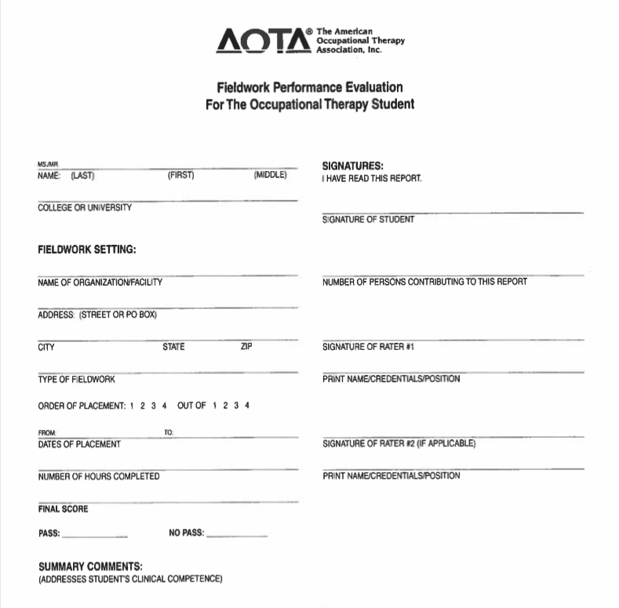
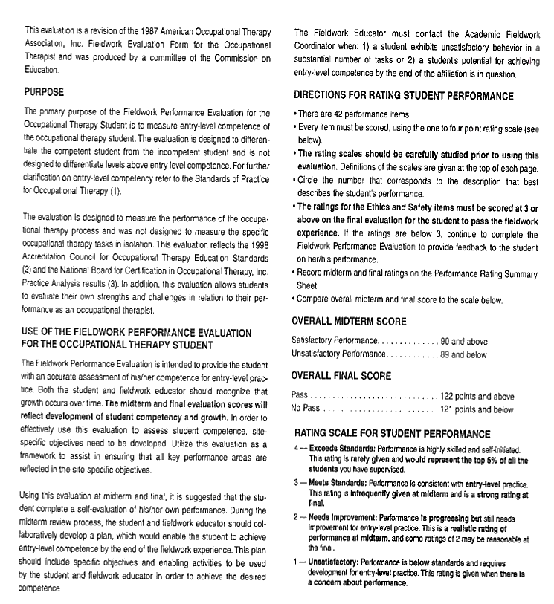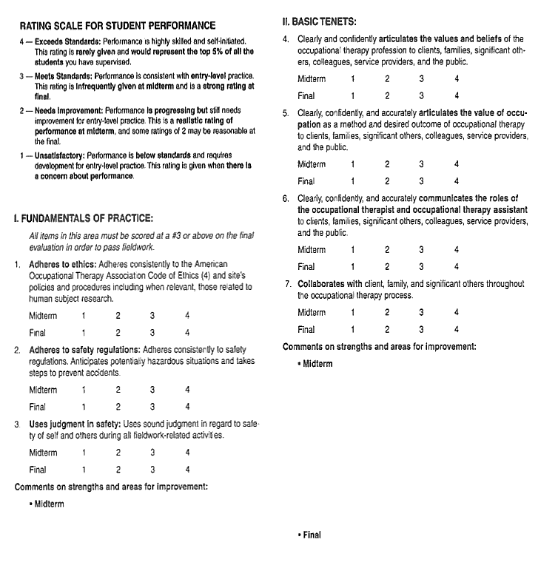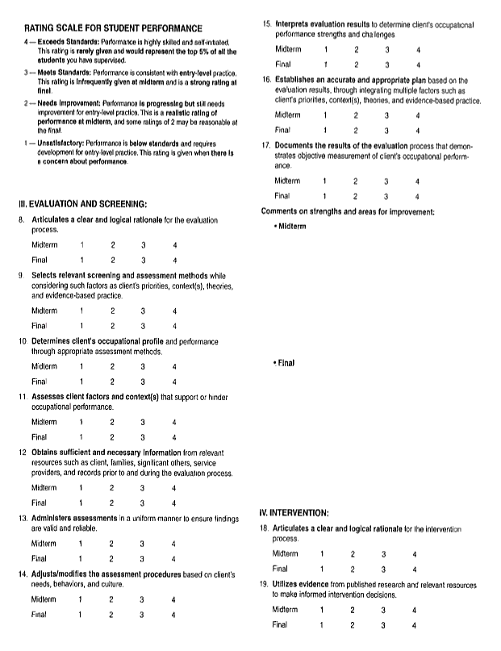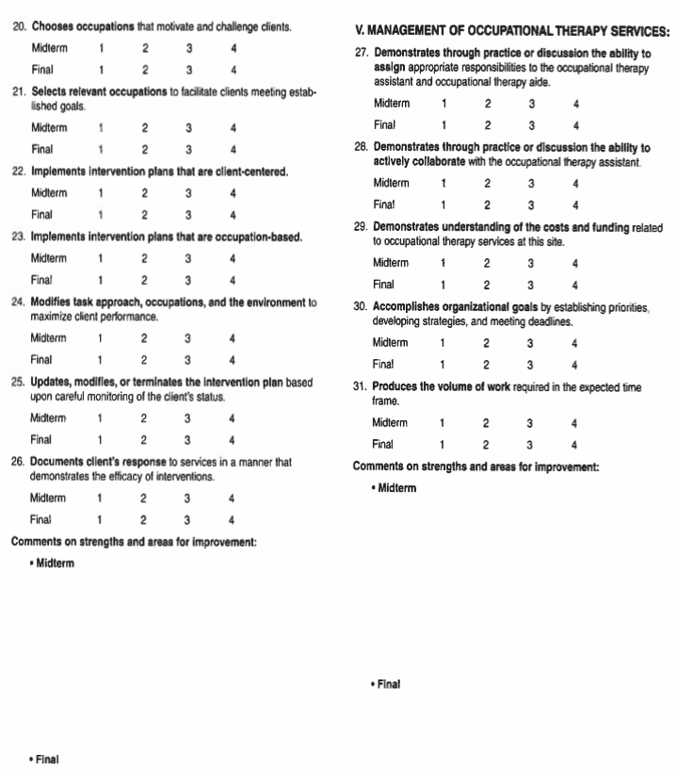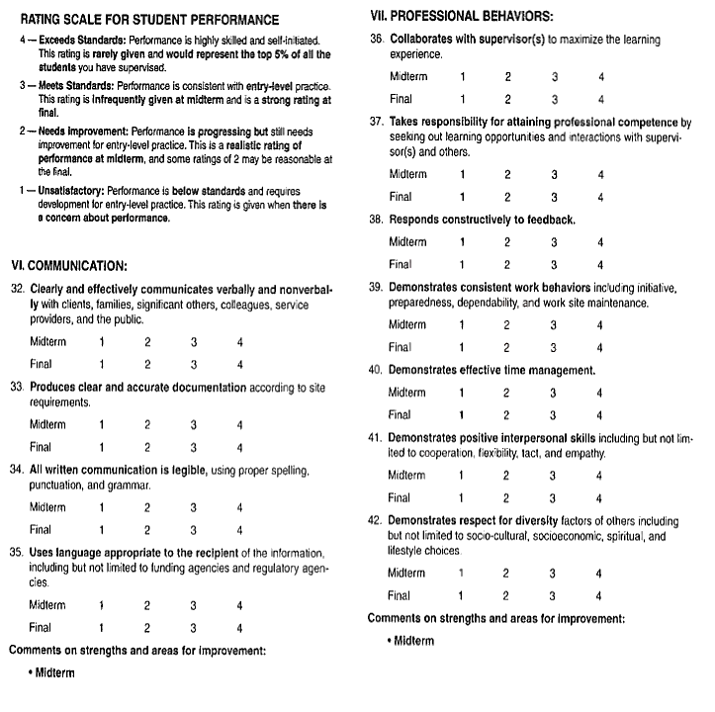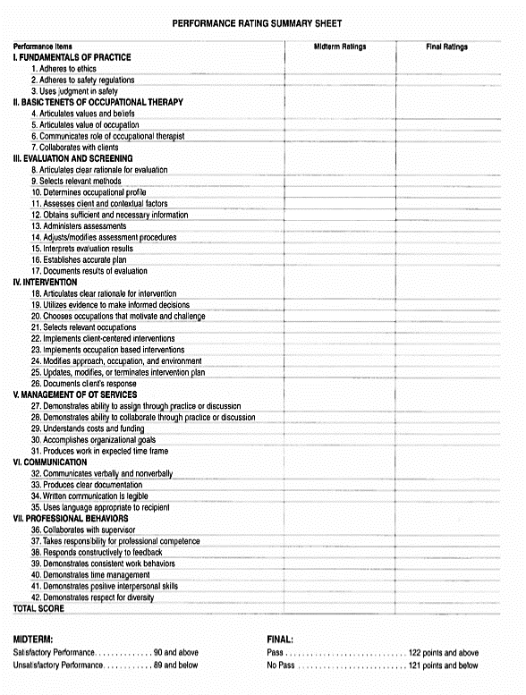
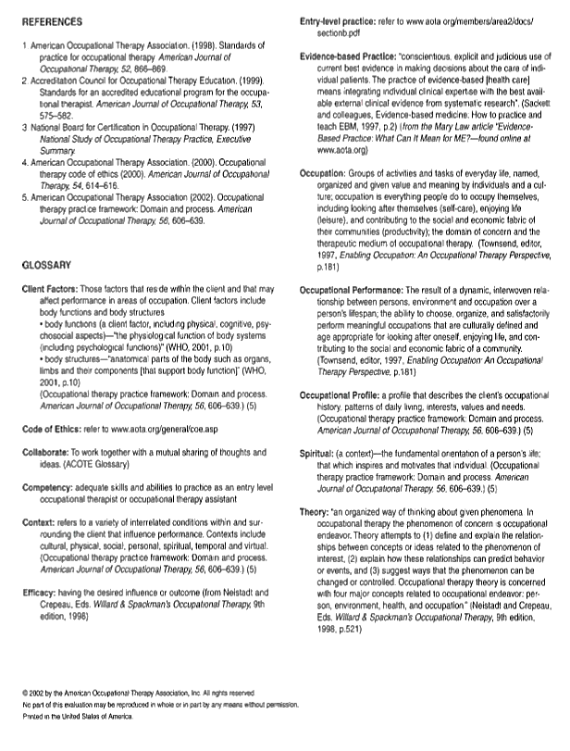

Appendix I: AOTA Student Evaluation of Fieldwork Experience (SEWFE)
Purpose:
This evaluation serves as a tool for fieldwork sites, academic programs, and students. The main objectives of this evaluation are to:
- Enable the Level II fieldwork student who is completing a placement at the site to evaluate and provide feedback to the supervisor and fieldwork setting;
- Enable academic programs, fieldwork sites, and fieldwork educators to benefit from student feedback in order to develop and refine their Level II fieldwork programs;
- Ensure that all aspects of the fieldwork program reflect the sequence, depth, focus, and scope of content of the curriculum design;
- Provide objective information to students who are selecting sites for future Level II fieldwork; and
- Provide a means of evaluation to ensure that fieldwork is performed in settings that provide educational experiences applicable to the academic program.
This form is designed to offer each program the opportunity to gather meaningful and useful information. Sections outlined with thick black double borders are designed to be customized by your program as needed. Pages involving evaluation of individual fieldwork educators have been positioned at the end of the form to allow academic programs to easily remove these pages before making them available for student review, if they choose to do so.
STUDENT EVALUATION OF THE FIELDWORK EXPERIENCE (SEFWE)
Instructions to the Student:
Complete this STUDENT EVALUATION OF THE FIELDWORK EXPERIENCE (SEFWE) form before your
final meeting with your fieldwork supervisor(s). It is imperative that you review the form with your supervisor and that both parties sign on page 1. Copy the form so that a copy remains at the site and a copy is forwarded to your Academic Fieldwork Coordinator at your educational program. This information may be reviewed by future students as well. The evaluation of the student (FWPE) should be reviewed first, followed by the student’s evaluation of the fieldwork experience (SEFWE), allowing the student to be honest and constructive.

Fieldwork Site _____________________________________ Site Code ________
Address ___________________________________________________________
Placement Dates: from _________________________ to _______________________
Order of Placement: [ ] First [ ] Second [ ] Third [ ] Fourth
Living Accommodations: (include type, cost, location, condition)

Public transportation in the area:
Please write your e-mail address here if you don’t mind future students contacting you to ask you about your experience at this site: ______________________________________
We have mutually shared and clarified this Student Evaluation of the Fieldwork Experience report.

_______________________________________ ________________________________________
Student's Signature FW Educator's Signature
_______________________________________ ________________________________________
Student's Name (Please Print) FW Educator’s Name and credentials (Please Print)
FW Educator’s years of experience ____________
ORIENTATION FW Educator’s years of experience ____________
Indicate your view of the orientation by checking "Satisfactory" (S) or "Needs Improvement” (I) regarding the three factors of adequacy, organization, and timeliness.
TOPIC | Adequate |  | Organized |  | Timely |  | NA
 | S | I | S | I | S | I
Site-specific fieldwork objectives
Student supervision process
Requirements/assignments for students
Student schedule (daily/weekly/monthly)
Staff introductions
Overview of physical facilities
Agency/Department mission
Overview of organizational structure
Services provided by the agency
Agency/Department policies and procedures
Role of other team members
Documentation procedures
Safety and emergency procedures
Confidentiality/HIPAA
OSHA—Standard precautions
Community resources for service recipients
Department model of practice
Role of occupational therapy services
Methods for evaluating OT services
Other
Comments or suggestions regarding your orientation to this fieldwork placement: _______________________________________________________________________________________________________________________________________________________________________________________________________________________________________________________________CASELOAD
List approximate number of each age List approximate number of each primary
in your caseload. Condition/problem/diagnosis in your caseload
Age | Number
0–3 years old
3–5 years old
6–12 years old
13–21 years old
22–65 years old
> 65 years old
Condition/Problem | Number

OCCUPATIONAL THERAPY PROCESS
Indicate the approximate number of screenings/evaluations you did; also indicate their value to your learning experience by circling the appropriate number with #1 being least valuable and #5 being the most valuable.
 | REQU  Yes | IRED  No | HOW MANY | EDUCATIONAL VALUE
1. Client/patient screening |  |  |  | 1 2 3 4 5
2. Client/patient evaluations
(Use specific names of evaluations)
 |  |  |  | 1 2 3 4 5
 |  |  |  | 1 2 3 4 5
 |  |  |  | 1 2 3 4 5
 |  |  |  | 1 2 3 4 5
 |  |  |  | 1 2 3 4 5
 |  |  |  | 1 2 3 4 5
 |  |  |  | 1 2 3 4 5
 |  |  |  | 1 2 3 4 5
 |  |  |  | 1 2 3 4 5
3. Written treatment/care plans |  |  |  | 1 2 3 4 5
4. Discharge summary |  |  |  | 1 2 3 4 5

List major therapeutic interventions frequently used and indicate whether it was provided in group, individually, Co-Treatment, or consultation. List other professionals involved.
Therapeutic Interventions | Individual | Group | Co-Tx | Consultation
Occupation-based activity, i.e., play, shopping, ADL, IADL, work, school activities, etc. (within client’s own context with his or her goals)
1.
2.
3.
4.
Purposeful activity (therapeutic context leading to occupation)
1.
2.
3.
4.
Preparatory methods, i.e., sensory, PAMs, splinting, exercise, etc. (preparation for occupation-based activity)

1.
2.
3.
4.
THEORY—FRAMES OF REFERENCE—MODELS OF PRACTICE

Indicate frequency of theory/frames of reference used
 | Never | Rarely | Occasionally | Frequently
Model of Human Occupation
Occupational Adaptation
Ecology of Human Performance
Person–Environment–Occupation Model
Biomechanical Frame of Reference
Rehabilitation Frame of Reference
Neurodevelopmental Theory
Sensory Integration
Behaviorism
Cognitive Theory
Cognitive Disability Frame of Reference
Motor Learning Frame of Reference
Other (list)

FIELDWORK ASSIGNMENTS
List the types of assignments required of you at this placement (check all that apply), and indicate their educational value (1 = not valuable ------- 5 = very valuable)

Case study applying the Practice Framework 1 2 3 4 5 N/A

Evidence-based practice presentation: 1 2 3 4 5 N/A

Topic:

Revision of site-specific fieldwork objectives 1 2 3 4 5 N/A

Program development 1 2 3 4 5 N/A

Topic:

In-service/presentation 1 2 3 4 5 N/A

Topic:

Research 1 2 3 4 5 N/A

Topic:

Other (list) 1 2 3 4 5

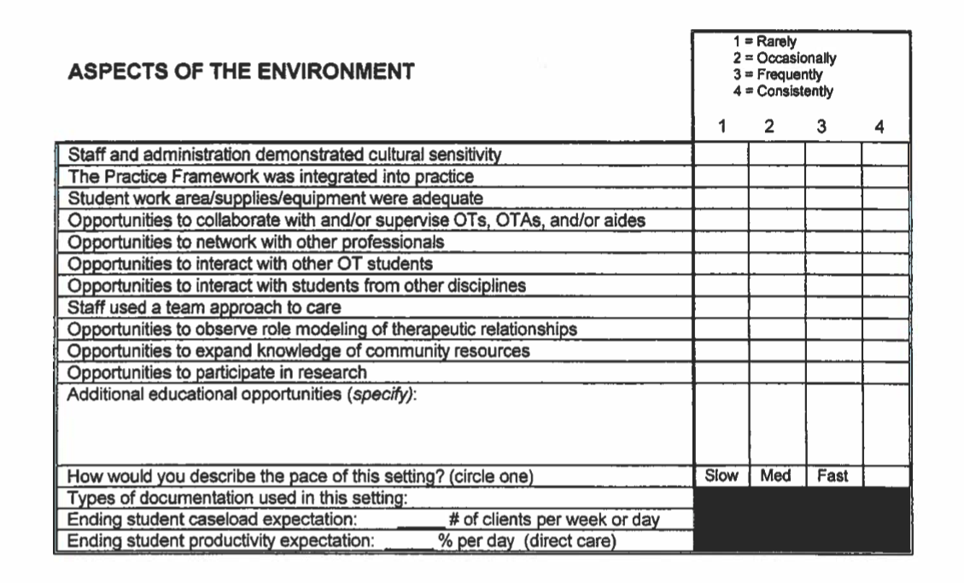
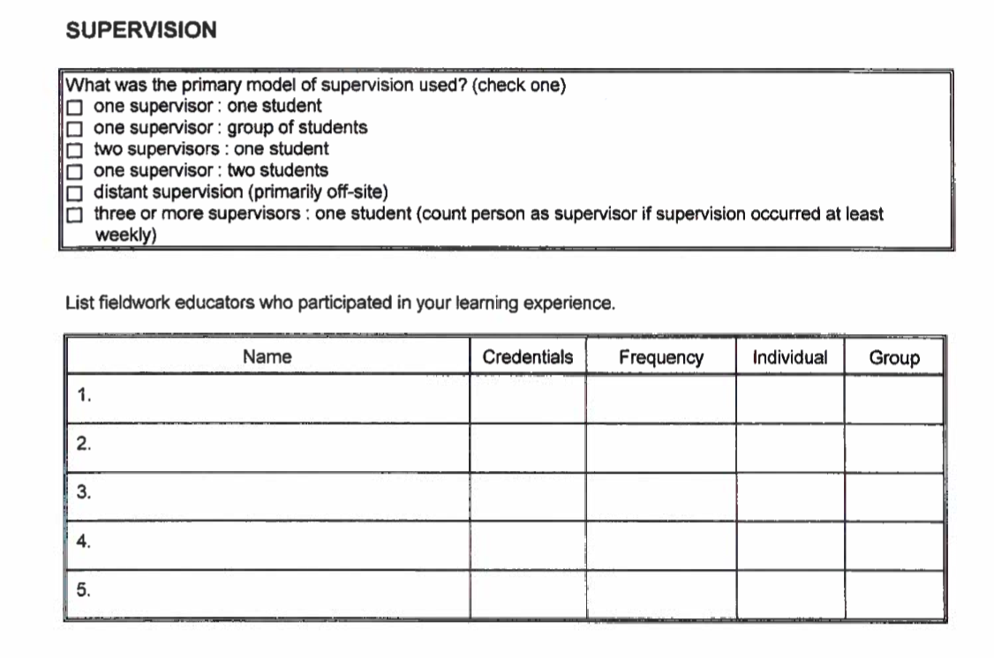
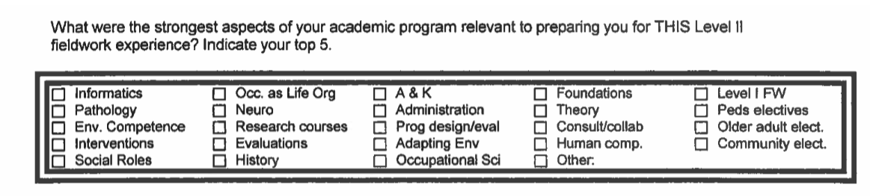
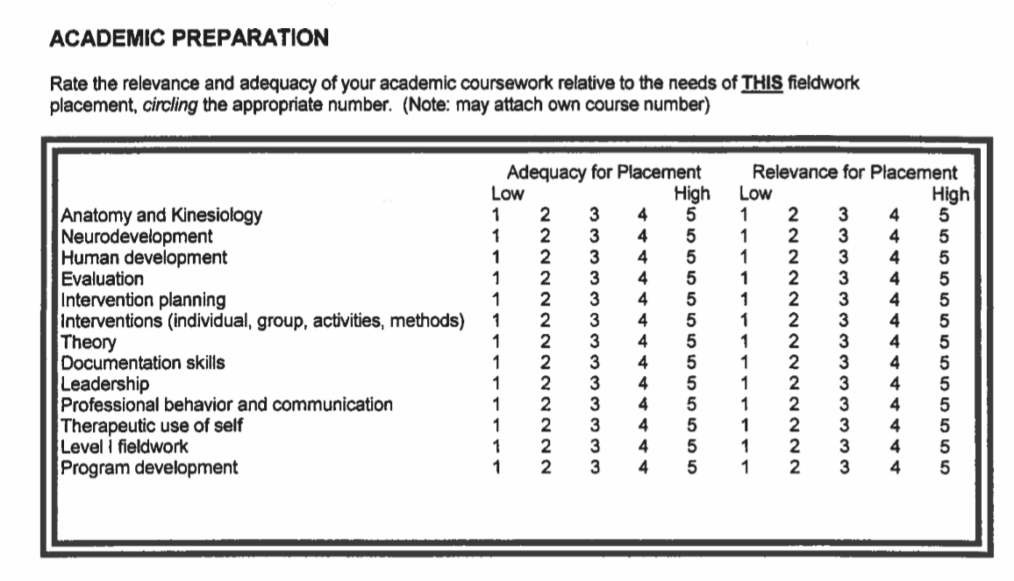
What changes would you recommend in your academic program relative to the needs of THIS Level II fieldwork experience?
_______________________________________________________________________________________________________________________________________________________________________________________________________________________________________
SUMMARY | - = Strongly disagree  - = Disagree  - = No Opinion  - = Agree  - = Strongly agree  1 2 3 4 |  |  |  | 5
Expectations of fieldwork experience were clearly defined
Expectations were challenging but not overwhelming
Experiences supported student's professional development
Experiences matched student's expectations
What particular qualities or personal performance skills do you feel that a student should have to function successfully on this fieldwork placement?
____________________________________________________________________________________________________________________________________________________________________________________________________________________________________________________________

What advice do you have for future students who wish to prepare for this placement?

Study the following evaluations:
________________________________________________________________________________________________________________________________________________________________________
____________________________________________________________________________________

Study the following intervention methods:
________________________________________________________________________________________________________________________________________________________________________
____________________________________________________________________________________

Read up on the following in advance:
________________________________________________________________________________________________________________________________________________________________________
___________________________________________________________________________________

Overall, what changes would you recommend in this Level II fieldwork experience?
____________________________________________________________________________________
________________________________________________________________________________________________________________________________________________________________________
____________________________________________________________________________________

Please feel free to add any further comments, descriptions, or information concerning your fieldwork at this center.
____________________________________________________________________________________
____________________________________________________________________________________
____________________________________________________________________________________
____________________________________________________________________________________

Indicate the number that seems descriptive of each fieldwork educator. Please make a copy of this page for each individual.  FIELDWORK EDUCATOR NAME:___________________________________  FIELDWORK EDUCATOR YEARS OF EXPERIENCE: __________ | - = Strongly Disagree  - = Disagree  - = No opinion  - = Agree  - = Strongly agree  1 2 3 4 5
Provided ongoing positive feedback in a timely manner
Provided ongoing constructive feedback in a timely manner
Reviewed written work in a timely manner
Made specific suggestions to student to improve performance
Provided clear performance expectations
Sequenced learning experiences to grade progression
Used a variety of instructional strategies
Taught knowledge and skills to facilitate learning and challenge student
Identified resources to promote student development
Presented clear explanations
Facilitated student’s clinical reasoning
Used a variety of supervisory approaches to facilitate student performance
Elicited and responded to student feedback and concerns
Adjusted responsibilities to facilitate student's growth
Supervision changed as fieldwork progressed
Provided a positive role model of professional behavior in practice
Modeled and encouraged occupation-based practice
Modeled and encouraged client-centered practice
Modeled and encouraged evidence-based practice

Frequency of meetings/types of meetings with supervisor (value/frequency):
____________________________________________________________________________________
____________________________________________________________________________________________________________________________________________________________________________________________________________________________________________________________

General comments on supervision: ________________________________________________________________________________________________________________________________________________________________________________________________________________________________________________________________________________________________________________________________________________

AOTA SEFWE Task Force, June 2006

