

Title Page
Program Revision Changes That Affect Program Content
B.A. Recreational Therapy (25306)

- TITLE PAGE

Program Title: B.A. Recreational Therapy (25306)

School Offering Program: School of Health and Human Performance

Proposed Implementation: Fall 2026

Date of Document: December 2, 2025

Description of Proposed Revisions and Objectives/Rationale for Proposed Revisions

General Rationale and Objectives for Program Changes:
Program description has minor wording changes to better align with the assessment needs

Program Description (minor changes)
In New Jersey's only Recreational Therapy program, students will gain the knowledge and skills to work with individuals with disabilities, illnesses, injuries or limitations so that they can participate in life activities. Recreational therapists may work with a wide range of individuals including adults and children with physical disabilities, behavioral health disorders, substance use disorders, intellectual and developmental disabilities, and the geriatric aging population.
Kean recreational therapy majors learn how to plan, manage and administer recreation-based treatment interventions. Our graduates are employed by in-patient hospitals, physical rehabilitation facilities, behavioral health facilities, substance abuse centers, long-term and residential care facilities, adult day programs, community-based programs, schools and camps, and in private practice.
Recreational therapy graduates also pursue advanced degrees in recreational therapy, counseling, occupational therapy, physical therapy, and other health professions. Faculty advisers provide guidance in the completion of the prerequisites for these graduate school programs.
In New Jersey's only Recreational Therapy degree program, students will gain practical skills that will prepare them to work in a variety of settings. Recreational Therapy students will learn how to:
- Conduct leisure and functional assessments to determine their clients' strengths and areas in need of improvement
- Plan, manage and administer recreation-based treatment interventions and programs
- Participate in hands-on experiences through labs and multiple fieldwork experiences
- Assist clients in developing the ability to adapt to their disability for overall health and wellness
- Collaborate with other health professionals including therapists, behavioral health counselors and physicians as well as with psychologists, social workers and teachers
Moreover, Kean University’s Recreational Therapy program prepares students to sit for the Certified Therapeutic Recreation Specialist exam administered by The National Council for Therapeutic Recreation Certification.
Removed from bottom of description page
“The Recreational Therapy program is offered at both the Kean Union and Kean Ocean campuses

- Description: Replace TR 2030 Introduction to Recreational Therapy with TR 3020 Introduction to Recreational Therapy

Objective: TR 2030 was revised several years ago to a 3000-level course in B.A. Recreational Therapy curriculum

Rationale: The current curriculum sheet does not reflect this change previously made

- Description: Add REC 3820 Fieldwork Seminar (1 credit)

Objective: REC 3820 will enhance the fieldwork experience by providing resume writing, job search and interview skills, interview etiquette, and goal writing skills.

Rationale: A similar course was offered previously. We have noticed a decline in the students’ abilities to search for jobs. This class will enhance those skills and streamline the fieldwork process.

- Description: Add course TR 3931 Practicum in Recreational Therapy (2 credits)

Rationale: TR 3931 will replace the existing TR 3930 Practicum in Recreational Therapy (3 credits) in order to keep the current credits for the program.

In the case of Certification Program Revisions Mandated by the State of New Jersey: Approval Documentation from the New Jersey Department of Education
- Revisions are not mandated by the State of New Jersey

Content of the Academic Program, Option, Minor, etc.
- Schematic of Curriculum Plan
SIDE by SIDE comparison of the existing right side of the curriculum sheet and the proposed right side of the curriculum sheet

CURRENT RIGHT SIDE CURRICULUM PROPOSED RIGHT SIDE OF CURRICULUM
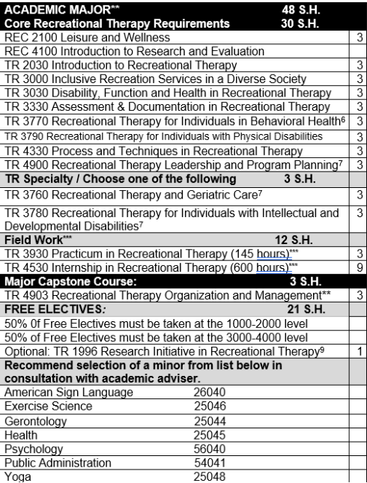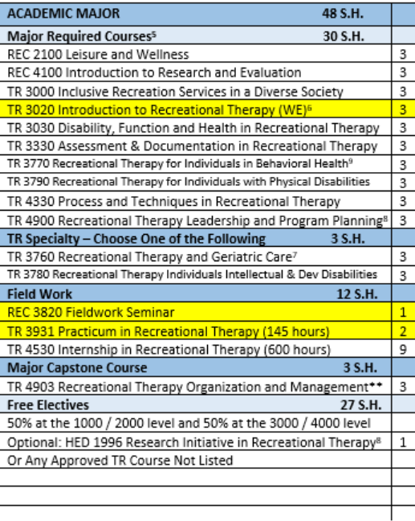

Effects/Changes Related to SLOs for the program and its assessment plan

Program Learning Outcomes (PLOs) and Student Learning Outcomes (SLOs) Proposed Revisions

The PLOs and SLOs were revised to ensure compliance with the updated Program Accreditation Standards (PAS) format, which provides a consistent and structured framework for articulating learning expectations across accredited programs. This alignment enhances clarity, measurability, and transparency in assessing student achievement.

Additionally, the revisions were made to reflect the most recent National Council for Therapeutic Recreation Certification (NCTRC) core competencies, which define the essential knowledge, skills and abilities required for professional practice in the field. By integrating these competencies into the PLOs and the SLOs, the program ensures that graduates are adequately prepared to meet current industry standards and professional certification requirements. This alignment not only strengthens the academic rigor of the curriculum but also supports students’ readiness for successful entry into the profession and ongoing professional development.

Proposed Program Learning Outcomes (PLOs)
The six program learning objectives for B.A. in Recreational Therapy are in line with the core competencies from The National Council of Therapeutic Recreation. These PLOs are broad foundations that each student must learn about and be able to demonstrate proficiency in by program completion.

PLO # & Name | Description
PLO #1 Client Assessment & Planning | By program completion, candidates will demonstrate the ability to assess client needs and develop individualized, goal-oriented treatment plans using evidence-based practices
PLO #2 Intervention & Facilitation | By program completion, candidates will be able to implement and adapt therapeutic recreation interventions that promote client engagement, functional improvement, and quality of life
PLO #3 Evaluation & Documentation | By program completion, candidates will be able to evaluate client progress and program effectiveness and document all phases of service delivery using professional standards
PLO #4 Administration & Leadership | By program completion, candidates will be able to apply principles of program management, supervision, and leadership within therapeutic recreation settings
PLO #5 Professionalism & Ethics | By program completion, candidates will be able to demonstrate ethical decision-making, cultural competence, and adherence to legal and professional stands in recreational therapy practice
PLO #6 Advocacy, Research & Lifelong Learning | By program completion, candidates will be able to advocate for clients and profession, engage in research-informed practice, and pursue ongoing professional development

Proposed Student Learning Outcomes (SLOs)

SLOs for PLO #1 Client Assessment & Planning
- Identifying client needs through leisure and functional assessments
- Interpreting assessment data to inform treatment planning
- Applying knowledge of disability, function and health to assessment practices
- Utilizing evidence-based practices in client assessment and planning

SLOs for PLO #2 Intervention & Facilitation
- Designing and implementing therapeutic recreation interventions for diverse populations
- Facilitating individual and group sessions that promote client engagement and
functional improvement
- Adapting interventions to meet the evolving needs of clients across various settings
- Integrating inclusive practices into intervention planning and delivery

SLOs for PLO #3 Evaluation & Documentation
- Evaluating client progress using standardized and informal assessment tools
- Documenting treatment plans, progress notes and discharge summaries in accordance with professional standards
- Analyzing program effectiveness through data collection and outcome measures
- Using documentation to inform future treatment planning and interdisciplinary communication

SLOs for PLO #4 Administration & Leadership
- Applying principles of program management and supervision in therapeutic recreation settings
- Demonstrating leadership in planning and implementing recreation programs
- Managing administrative tasks including scheduling, documentation and reporting
- Evaluating administrative practices for continuous improvement and client satisfaction

SLOs for PLO #5 Professionalism & Ethics
- Demonstrating ethical decision-making in therapeutic recreation practice
- Applying cultural competence in service delivery to diverse populations
- Adhering to legal and professional standards, including confidentiality and informed consent
- Reflecting on personal and professional values to guide ethical practice

SLOs for PLO #6 Advocacy, Research & Lifelong Learning
- Advocating client’s rights and access to therapeutic recreation services
- Engaging in research-informed practice through literature review and project development
- Participating in professional development activities and organizations
- Promoting the value of recreational therapy within healthcare and community settings

Curriculum & Assessment Map

PLO | Program | Introduced | Practiced | Mastered
PLO #1 Client Assessment & Planning | BA in Recreational Therapy | REC2100  TR3020  TR3030 | TR3330  TR4330 TR3930  REC4100 | TR4530
PLO #2 Intervention & Facilitation | BA in Recreational Therapy | TR3000 | TR3790  TR4330 TR3760  TR3770 TR3780 TR3930 | TR4530
PLO #3 Evaluation & Documentation | BA in Recreational Therapy | TR3330 | TR4330 TR4900 TR3930 REC4100 | TR4530
PLO #4 Administration & Leadership | BA in Recreational Therapy | TR4900 | TR4903  REC4100 | TR4530
PLO #5 Professionalism & Ethics | BA in Recreational Therapy | TR3020 | TR3000  TR4900 | TR4903
PLO #6 Advocacy, Research & Lifelong Learning | BA in Recreational Therapy | TR3020 | TR4330 TR4903 REC4100 | TR4530

Impact Statement in Collaboration with the Dean(s)

Additional Faculty –

Effect of revision(s) on enrollment
The proposed course revisions are not expected to impact current or future enrollment in the program. However, the introduction of REC 3820: Fieldwork Seminar is expected to strengthen the enrollment process for fieldwork courses by streamlining registration into the fieldwork courses and equipping students with the necessary preparation for their fieldwork experiences.

Effect of Revision(s) in terms of additional resources, including space, computer equipment, software, offices, laboratories, etc.
N/A

APPENDIX A: Current Curriculum Sheet (Effective Fall 2021)

Kean University - College of Education
(25306) B.A. in Recreational Therapy 120 credits
Minimum GPA Required for Declaration; Major and Graduation: 2.5
GENERAL EDUCATION: 38 S.H. |  | ACADEMIC MAJOR** 48 S.H.
Foundation Requirements¹ 13 S.H. |  | Core Recreational Therapy Requirements 30 S.H.
GE 1000 Trans to Kean² or GE 3000² Transfer Transitions | 1 | REC 2100 Leisure and Wellness | 3
ENG 1030 College Composition | 3 | REC 4100 Introduction to Research and Evaluation
MATH 1000;1010;1016; or 1030 | 3 | TR 2030 Introduction to Recreational Therapy | 3
COMM 1402 Speech Communication | 3 | TR 3000 Inclusive Recreation Services in a Diverse Society | 3
GE 2022 Research & Technology | 3 | TR 3030 Disability, Function and Health in Recreational Therapy | 3
Disciplinary and Interdisciplinary Distribution Requirements |  | TR 3330 Assessment & Documentation in Recreational Therapy | 3
Humanities: (From different areas) 9 S.H. |  | TR 3770 Recreational Therapy for Individuals in Behavioral Health⁶ | 3
ENG 2403 World Literature* | 3 | TR 3790 Recreational Therapy for Individuals with Physical Disabilities | 3
Take two “GE Approved” course from 2 areas below: |  | TR 4330 Process and Techniques in Recreational Therapy | 3
Fine Arts/Art History | 3 | TR 4900 Recreational Therapy Leadership and Program Planning⁷ | 3
Philosophy | 3 | TR Specialty / Choose one of the following 3 S.H.
Foreign Languages (Must take I and II for credit) | 3 | TR 3760 Recreational Therapy and Geriatric Care⁷ | 3
Music | 3 | TR 3780 Recreational Therapy for Individuals with Intellectual and Developmental Disabilities⁷ | 3
Interdisciplinary | 3 | Field Work*** 12 S.H.
Social Sciences: (from different areas) 9 S.H. |  | TR 3930 Practicum in Recreational Therapy (145 hours)*** | 3
HIST 1062 Worlds of History* | 3 | TR 4530 Internship in Recreational Therapy (600 hours)*** | 9
PSY 1000 General Psychology ⁵ |  | Major Capstone Course: 3 S.H.
Take one GE approved course from the following: | 3 | TR 4903 Recreational Therapy Organization and Management** | 3
SOC 1000 Sociology | 3 | FREE ELECTIVES: 21 S.H.
ANTH 1800 Cultural Anthropology |  | 50% 0f Free Electives must be taken at the 1000-2000 level
Science and Mathematics: 7 S.H. | 3 | 50% of Free Electives must be taken at the 3000-4000 level
MATH 1010;1016;1030;1054 or CPS 1032;1231 | 4 | Optional: TR 1996 Research Initiative in Recreational Therapy⁹ | 1
BIO 1000 Principles of Biology ^{3**} | 3 | Recommend selection of a minor from list below in  consultation with academic adviser.
Additional Required Courses 13 S.H. |  | American Sign Language 26040
EXSC 1500 Introduction to Motor Learning | 3 | Exercise Science 25046
BIO 2402 Human Physiology & Anatomy | 4 | Gerontology 25044
OR BIO 2403 A&P I^{4, 8**} (Must take both BIO 2403 & BIO 2404) |  | Health 25045
PSY 3110 Life Span^{4,5} | 3 | Psychology 56040
PSY 3540 Abnormal Psychology ^{4,5} | 3 | Public Administration 54041
 |  | Yoga 25048
EFFECTIVE DATE: Fall 2021
Recreational Therapy Comments
¹ See pre-requisites and equivalencies (on page 2)
² University Requirement for Graduation for all undergraduate students that must be satisfied in one of two ways: Complete GE 1000
(all freshmen and transfers entering with 0-29 credits) OR complete GE 3000 (transfers entering with 30 credits or more)
³ Prerequisite for BIO 2402, 2403 and 2404
^{4.} Required for CTRS certification
^{5.} PSY 1000 is the prerequisite for PSY 3110 and PSY 3540
⁶ Indicates this course is offered only during the Spring semester.
^{7.} Indicates this course is offered only during the Fall semester.
^{8.} Students applying for OT or PT should take BIO 2403 Anatomy and Physiology I and BIO 2404 Anatomy and Physiology II
as approved by the RT program coordinator. RT students must take either BIO 2402 OR BIO 2403 and BIO 2404
⁹ Optional courses for first year students. Discuss with the advisor.
* GE Distribution Courses required for all students
**Students must maintain a C or better in all major required courses, all additional Required Courses, and the Capstone Course.
***Student must be a declared major and have a 2.5 GPA to register for Fieldwork Classes
APPENDIX B: Revised (proposed) Curriculum Sheet Effective Fall 2026

Kean University – College of Health Professions and Human Services
25306 B.A. IN RECREATIONAL THERAPY 120 Semester Hours Minimum
GPA Required for Declaration – Major and Graduation 2.5

Effective: Fall 2026
GENERAL EDUCATION 32 S.H. |  | ACADEMIC MAJOR 48 S.H.
Foundation Requirements¹ 13 S.H. |  | Major Required Courses⁵ 30 S.H.
GE 1000 Transition to Kean² or GE 3000² Transfer Transition | 1 | REC 2100 Leisure and Wellness | 3
ENG 1030 College Composition³ (or equivalent) | 3 | REC 4100 Introduction to Research and Evaluation | 3
MATH 1000; 1010; 1016; 1030⁴ | 3 | TR 3000 Inclusive Recreation Services in a Diverse Society | 3
COMM 1402 Speech Communication | 3 | TR 3020 Introduction to Recreational Therapy (WE)⁶ | 3
GE 2022 Research & Technology | 3 | TR 3030 Disability, Function and Health in Recreational Therapy | 3
DISCIPLINARY & INTERDISCIPLINARY DISTRIBUTION REQUIREMENTS |  | TR 3330 Assessment & Documentation in Recreational Therapy | 3
Distribution Requirements¹ 19 S.H. |  | TR 3770 Recreational Therapy for Individuals in Behavioral Health⁹ | 3
Humanities 3 S.H. |  | TR 3790 Recreational Therapy for Individuals with Physical Disabilities | 3
*ENG 2403 World Literature | 3 | TR 4330 Process and Techniques in Recreational Therapy | 3
Take ONE “GE APPROVED” Humanities course from one area below |  | TR 4900 Recreational Therapy Leadership and Program Planning⁸ | 3
Fine Arts/Art History | 3 | TR Specialty – Choose One of the Following 3 S.H.
Philosophy or Religion | 3 | TR 3760 Recreational Therapy and Geriatric Care⁷ | 3
Foreign Language (Must take I and II for credit) | 3 | TR 3780 Recreational Therapy Individuals Intellectual & Dev Disabilities | 3
Music or Theatre | 3 | Field Work 12 S.H.
Interdisciplinary | 3 | REC 3820 Fieldwork Seminar | 1
Social Sciences 6 S.H. |  | TR 3931 Practicum in Recreational Therapy (145 hours) | 2
*HIST 1062 Worlds of History | 3 | TR 4530 Internship in Recreational Therapy (600 hours) | 9
PSY 1000 General Psychology¹³ | 3 | Major Capstone Course 3 S.H.
Science and Mathematics 7 S.H. |  | TR 4903 Recreational Therapy Organization and Management** | 3
MATH 1010; 1016; 1030; 1054 or CPS 1032; 1231 | 3 | Free Electives 27 S.H.
BIO 1000 Principles of Biology³ | 4 | 50% at the 1000 / 2000 level and 50% at the 3000 / 4000 level
ADDITIONAL REQUIRED COURSES 13 S.H. |  | Optional: HED 1996 Research Initiative in Recreational Therapy⁸ | 1
BIO 2402 Human Physiology & Anatomy^{3,10} OR |  | Or Any Approved TR Course Not Listed
**BIO 2403 Anatomy and Physiology I (Must take both BIO 2403 & 2404) | 4
EXSC 1500 Introduction to Motor Learning | 3
PSY 3110 Lifespan Development Psychology | 3
PSY 3540 Abnormal Psychology | 3
SPECIAL NOTES:
*GE distribution courses required of all students
**Students applying for OT or PT should take BIO 2403 Anatomy and Physiology I and BIO 2404 Anatomy and Physiology II
¹ See pre-requisites and equivalencies in the course catalog
² University requirements for graduation for all undergraduate students must be satisfied in one of two ways: Complete GE 1000:
Complete GE 1000 (all freshmen and transfers entering with 0-29 credits) OR complete 3000 (transfers entering with >30 credits)
³ Requires a grade of a C or higher
⁴ With advisement
⁵ All major courses require a grade of a C or higher
⁶ (WE) Writing Emphasis Course
⁷ Optional – Research Initiative in Recreational Therapy
⁸ Indicates this course is only offered during the Fall Semester
⁹ Indicates this course is only offered during the Spring Semester
¹⁰Prerequisite(s): BIO 1000 Principles of Biology
¹¹Prerequisite(s): BIO 2403 Human Anatomy and Physiology I
¹²Prerequisite(s): PSY 3200 Psychology Statistics
¹³Prerequistie(s): PSY 1000 General Psychology

